Information for Agencies and Bodies

Information Security Leads
Part 4 of the Privacy and Data Protection Act 2014 (Vic) (PDP Act) applies to the majority of Victorian Public Sector (VPS) agencies or bodies (regulated organisations) delivering unique services or functions on behalf of government.
Regulated organisations have an obligation to protect public sector information and systems by adhering to the Victorian Protective Data Security Standards (the Standards). Accountability for compliance with the Standards rests with the public sector body Head of the regulated organisation, who requires support from personnel who are appropriately skilled, resourced and empowered.
An information security lead (ISL) acts as a central point of contact for OVIC to deliver important information security messages and updates relating to the Victorian Protective Data Security Framework (the Framework) and Standards. An ISL can support their public sector body head and help guide the implementation of the Standards on behalf of the organisation by coordinating a Protective Data Security Plan (PDSP) submission.

Managing an information security work program and organisational reporting
Given the broad nature of the Standards, it is likely that the person coordinating the organisations information security program will need input and assistance from a wide variety of stakeholders. Where possible, this should include representation from across the business, as well as external bodies and third parties (including contracted service providers). Organisations should take a holistic approach the management of their information security risk and leverage subject matter experts to help implement aspects of the various Standards and input into the development of a PDSP submission.
Given the diverse nature of the VPS, OVIC does not prescribe a specific role or group that should be tasked with managing information security, or organisational reporting obligations, however an ISL may be well positioned to do so.

Establishing a cross-functional information security committee or workgroup
OVIC encourages organisations to establish a cross functional workgroup with representatives who can contribute subject-matter expertise unique to their security domain or functional work area. This may include specialist knowledge and capabilities drawn from:
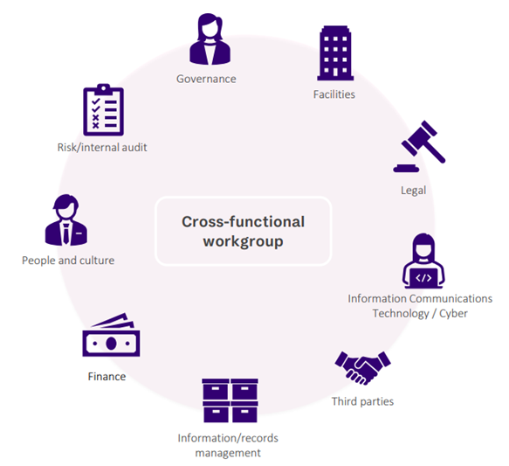
- Executive, corporate, legal or procurement groups responsible for addressing security governance requirements, third-party arrangements and contractual arrangements
- Risk managers who assist with integrating information security risks into the organisation’s overall risk management framework
- Chief Information Officers (CIOs), information or records managers who assist with identifying information holdings across the organisation
- HR representatives who provide advice and input into personnel security matters
- IT teams that support the delivery of ICT security initiatives
- Internal auditors responsible for managing assurance programs on behalf of the organisation and
- Facilities managers who provide advice and input into the physical security needs of the business.

Nominating an information security lead
Element E1.050 of the Standards outlines that each public sector body Head should nominate an information security lead (lead) for their organisation, and notify OVIC of any changes to the lead. If there are changes, OVIC requests the organisation provide the Information Security Unit an alternative point of contact if they move roles or cease working for the organisation. Email security@ovic.vic.gov.au with any changes to the ISL.

Standard 1 (Information Security Management Framework), Element E1.050

