

2026 | How-to Guide: Protective Data Security Plan (PDSP) for Class B Cemetery Trusts
Version 1.2


If you need help in completing the Protective Data Security Plan, call 1300 006 842 or email security@ovic.vic.gov.au
Document details
Document details | 2026 | How-to Guide: Protective Data Security Plan (PDSP) for Class B Cemetery Trusts
Publication date | December 2025
Review date | December 2027
Protective Marking | OFFICIAL
CM ref / location | D25/5739
Document status | Published
Authority | Office of the Victorian Information Commissioner (OVIC)
Author | Information Security Unit

Version | Author | Date | Additions/changes
1.0 | Information Security Unit | January 2022 | Initial version for cemetery trusts
1.1 | Information Security Unit | December 2023 | Updates to reflect 2024 Class B Cemetery Trust PDSP form
1.2 | Information Security Unit | December 2025 | Updates to reflect 2026 Class B Cemetery Trust PDSP form

Disclaimer
The information in this document is general in nature and does not constitute legal advice.

Copyright
You are free to re-use this work under a Creative Commons Attribution 4.0 licence, provided you credit the State of Victoria (Office of the Victorian Information Commissioner) as author, indicate if changes were made and comply with the other licence terms. The licence does not apply to any branding, including Government logos. Copyright queries may be directed to communications@ovic.vic.gov.au


How will the information in the PDSP be used and managed?
In-line with OVIC’s functions under the PDP Act, content from PDSP submissions may form the basis of reporting back to organisations and the Victorian Government including the Victorian Government Chief Information Security Officer.
OVIC will collect some personal information as part of the PDSP form including the name and contact details of the public sector body Head and nominated contact (Information Security Lead). OVIC will use this information to communicate with these contacts about the PDSP, broader security initiatives and activities, distributing information security-related content, or collecting feedback.
OVIC will not disclose personal information without consent, except where required to do so by law. For more information about how OVIC handles personal information, please see OVIC’s Privacy Policy.
The information provided in the PDSP will be managed in accordance with the protective marking assigned. The contents of the PDSP are exempt from the Freedom of Information Act 1982 (Vic).
Table of Contents
Background 4
About this guide and the Class B Cemetery Trust PDSP form 5
Instructions for completing the PDSP 6
Part A: Contact information (mandatory) 7
Part B: Self-assessment against the 14 requirements (mandatory) 8
Part C: Attestation (mandatory) 11
Part D: Reporting on behalf of multiple cemetery trusts (optional) 12
Submitting a copy of the completed PDSP to OVIC 14
Need help? 14

Background
The Office of the Victorian Information Commissioner (OVIC) has developed the Victorian Protective Data Security Standards (the Standards or VPDSS) as required under the Privacy and Data Protection Act 2014 (Vic) (PDP Act).
The Standards prescribe requirements designed to protect information across the Victorian public sector, including the information of Class B Cemetery Trusts. Under Part 4 of the PDP Act, Class B cemetery trusts must submit a Protective Data Security Plan (PDSP) to OVIC to fulfill this legislative information security obligation.
Class B Cemetery Trusts manage various types of important information such as:
- applications for right of interment
- applications for interment authorisation
- applications for approval to inter cremated human remains
- applications to establish or alter a memorial or place of interment
- right of interment and interment registers and
- trust records, such as correspondence, financial statements, policies and procedures.
In OVIC’s discussions with trust members, it is clear there is a passion to protect paper (hard copy) and electronic (digital or soft copy) information, and where required, sensitive verbal discussions.
OVIC appreciates that Class B cemetery trust members and employees (most of whom are volunteers) spend countless hours ensuring trust records are accurate and complete.
This dedication by trust members helps build community confidence in the accuracy and availability of this information when it is most needed. The historical value of these records reflects the importance the community places in the material you manage on the trust’s behalf.
As a Class B Cemetery Trust member, have you considered:
- what you can do to protect trust records in the event of a fire or flood
- what would happen if a cemetery trust member retires, steps down or passes, and how the knowledge that has been built up over the years is then transferred to the next member
- what would have helped you when you became a trust member
Documenting some of those practices could assist in the ongoing management and future handover of the cemetery trust. Strong information management practices can also support good financial record keeping and help cemetery trust members manage their time and efforts relative to any risks.

About this guide and the Class B Cemetery Trust PDSP form
There are 2 key documents you need to reference to enable you to submit a completed PDSP to OVIC:
Document 1 - This guide  2026 | How-to Guide: Protective Data Security Plan (PDSP) for Class B Cemetery Trusts  This guide provides you with instructions and assistance on how to complete and submit the PDSP form. | 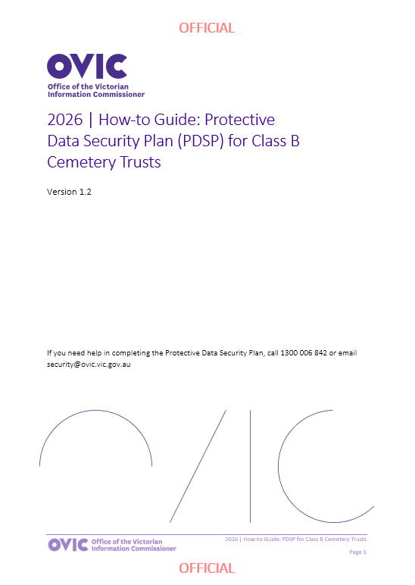
Document 2 - PDSP form    2026 | Class B Cemetery Trust Protective Data Security Plan (PDSP)  This form must be completed, and a copy returned to OVIC, by 31 August 2026. | 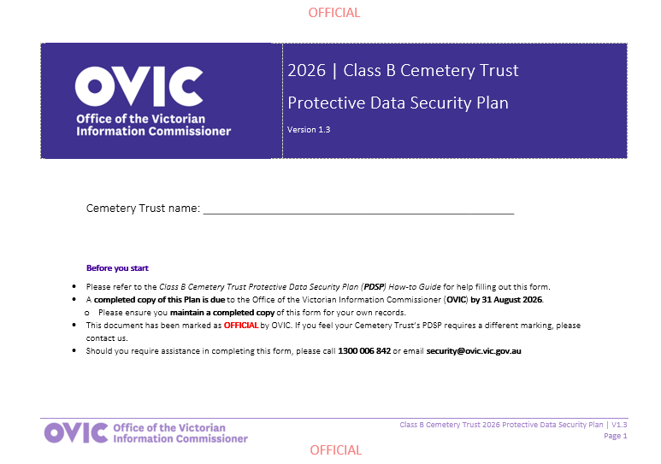
The 14 requirements in the PDSP set out good information security management practices to ensure the protection of cemetery trust records.
The PDSP has been created to address the specific needs of Class B Cemetery Trusts. By completing the 2026 PDSP and submitting a signed copy to OVIC, your trust will have satisfied its PDSP reporting obligation to OVIC for 2026.

Instructions for completing the PDSP
The Class B Cemetery Trust PDSP is made up of 5 parts:
2026 Protective Data Security Plan for Class B Cemetery Trusts
Document details |  | This part includes:  - versioning of the document (PDSP form)  - reference to Part 4 PDP Act obligations  - mapping between the 14 requirements for Class B Cemetery Trusts and the VPDSS.
Part A | Contact information | This part records basic information that will assist OVIC in identifying the key contacts for the Class B Cemetery Trust.
Part B | Self-assessment against the requirements | OVIC has specified 14 requirements (aligned to the VPDSS) that will enable Class B Cemetery Trusts to manage information in a consistent and secure way.  This part provides OVIC with information on how the cemetery trust is tracking against the 14 requirements and provides some recommended supporting activities to help the trust address these.
Part C | Attestation | The attestation must be signed by the Chairperson of the Class B Cemetery Trust or their authorised representative (as specified in Part A of the PDSP form).
Part D | Reporting on behalf of multiple Class B Cemetery Trusts | If you wish to report on behalf of your cemetery trust and other cemetery trusts in a single consolidated PDSP submission, you must have written authorisation from the other cemetery’s Chairperson in order to include them. OVIC will use the responses you have provided for each of the 14 requirements as a reflection of both yours, and the other listed cemetery trusts’ status and practices.

You have 2 options for completing the 2026 PDSP form:
 | Option 1 – Soft copy (on the computer): You will need to type responses into the fields and click the appropriate box to mark with an ‘X’. If you have selected a box by mistake, you can clear it by simply clicking it again. You can request a soft copy (digital version) of this form by emailing security@ovic.vic.gov.au
 | Option 2 - Hard copy (printed): You will need to note your responses using a pen on the PDSP form. Once completed, post or email a copy of the signed PDSP back to OVIC. Keep a copy (either photocopy or scanned) of your PDSP form for the trust’s record/ reference.

Part A: Contact information (mandatory)
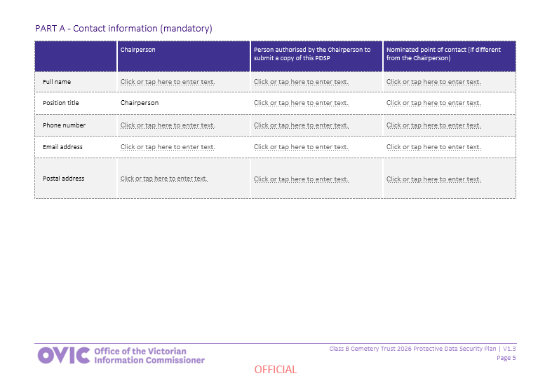
Section description
Under Part A of the PDSP form, please provide basic information that will assist OVIC in identifying the key contacts for your Class B Cemetery Trust.
How to complete Part A of the PDSP form:
- Provide the relevant contact information of your cemetery trust’s Chairperson.
- Provide the contact information of the person who is authorised by the Chairperson to submit a copy of the PDSP on behalf of the Chairperson (this might be the Secretary or another volunteer). If this is the same person, simply note this. If there is no authorised person, please leave this section blank.
- Provide the details of the main point of contact for your cemetery trust. This person may be contacted by OVIC if there are any questions relating to your cemetery trust. This may be the Chairperson or Secretary, or an additional point of contact. If it’s the same person, simply note that.
Please include a postal address as OVIC may mail material to your cemetery trust.
If there are adjustments to these details outside the standard reporting cycle remember to update OVIC of any changes.

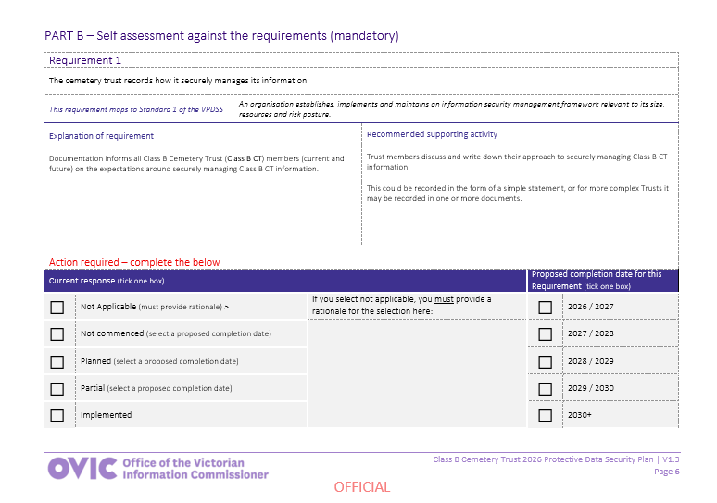
Part B: Self-assessment against the 14 requirements (mandatory)
Section description
OVIC has specified 14 requirements that will assist the trust in managing Class B Cemetery Trust information in a consistent and secure way.
Part B of the PDSP form offers the cemetery trust an opportunity to outline how it is tracking against each of the 14 requirements and sets out some suggested activities to help the trust address these.
Each of the 14 requirements are presented using the following structure:
- Requirement number
- The requirement itself (i.e. what the Cemetery Trust is reporting against)
- Mapping of the requirement back to a Standard
- An explanation of the requirement
- A recommended supporting activity to assist in implementing the requirement and
- A current response
  - Note: If you select ‘not applicable’ as the response, you must provide a rationale outlining a reason why this requirement does not apply to your cemetery trust
- Proposed completion date for the requirement if it is not implemented
How to complete Part B of the PDSP form:
Step 1 | Read | the requirement carefully.
Step 2 | Read | the explanation of the requirement to gain further understanding of what the requirement is asking of the cemetery trust.
Step 3 | Read | the recommended supporting activity to understand what steps can be taken to meet the related requirement. If you are unsure or need assistance, please contact OVIC.
Step 4 | Provide | a current response (implementation status) by ticking the relevant box for each requirement.  Your response should be based on an assessment of whether the cemetery trust is undertaking, or has undertaken, the required activity or a similar activity.  Each response and an outline of what this means is offered below –  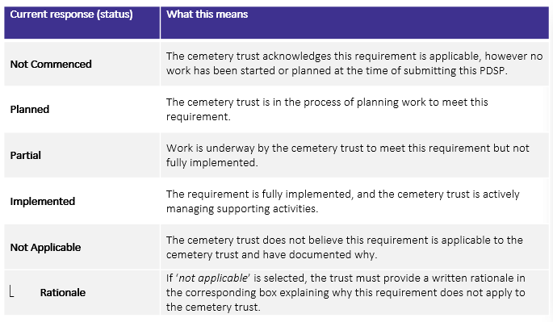  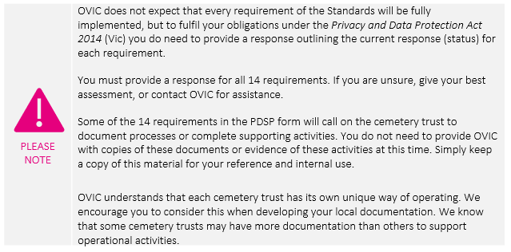
Step 5 | Provide | a proposed completion date for the requirement. A proposed completion date is:  - needed if you have selected the status of ‘not commenced’, planned’, or ‘partial’,  - not needed if you have selected the status of ‘implemented’ or ‘not applicable’.
Step 6 | Repeat | the above steps for each of the 14 requirements.

Part C: Attestation (mandatory)
Section Description
The Attestation must be signed by the Chairperson of the Class B Cemetery Trust or their authorised representative.
Note: If an authorised representative intends to sign the Attestation, their details must be specified in Part A of the PDSP form.
How to complete Part C of the PDSP form:
- Ensure the Chairperson has reviewed and authorised the PDSP.
- Complete each field including the full name of the person providing the attestation, the name of the cemetery trust, their signature, position, and the date.
- If you are completing this PDSP on behalf of more than one cemetery trust, check the box marked and proceed to Part D.
Note: If this PDSP only captures your cemetery trust, you can leave Part D blank.
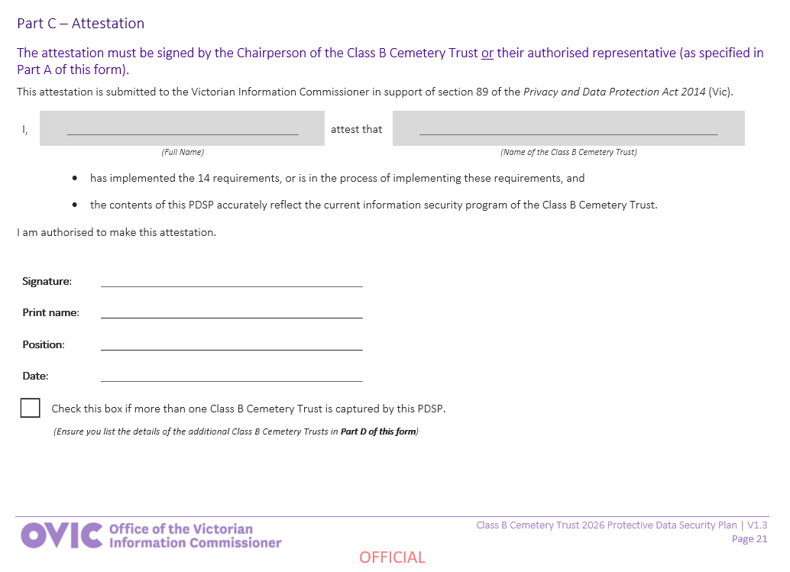

Part D: Reporting on behalf of multiple cemetery trusts (optional)
Section Description
Some cemeteries may have equivalent risk profiles, handle the same types of information and implement the same security measures, and have the same responses as other similar cemetery trusts. If multiple Class B Cemetery Trusts have the same:
- risk profiles
- types of information
- security practices and
- responses to each of the 14 requirements,
it may be appropriate to bundle these responses in a consolidated Class B Cemetery Trust PDSP submission to OVIC.
If you wish to report on behalf of your trust and other cemetery trusts in a consolidated PDSP submission, you must have written authorisation from the other cemetery’s Chairperson in order to include it in this PDSP submission.
If authorised, simply list the names and contact information of the other cemetery trusts in Part D of the PDSP.
OVIC will use the responses you have provided for each of the 14 requirements as a reflection of your cemetery trust and any other listed cemetery trust’s current responses.
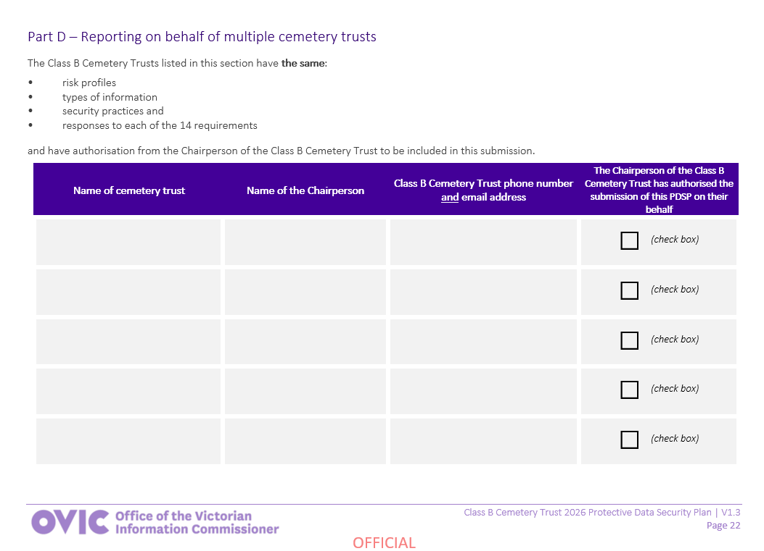
How to complete Part D of the PDSP form:
To be included on a PDSP by a different trust, please ensure you:
- speak to the submitting trust to ensure they are in agreement to submit on your trust’s behalf.
- provide written authorisation to the submitting trust, outlining that your trust is equivalent in all the criteria outlined in the page above.
To assist with this process, OVIC has provided an example of this written authorisation below:

I, [insert chairperson name], authorise [insert cemetery trust’s name] to be listed on the [submitting cemetery trust’s] 2026 Protective Data Security Plan (PDSP).
I confirm that my cemetery trust has the same:
a. risk profile
b. types of information
c. security practices
d. responses to each of the 14 requirements listed on the PDSP
to that of the cemetery trust submitting on behalf of my trust.

As the submitting trust, you should:
- obtain written authorisation from the Chairperson of each cemetery trust that you intend to list in this PDSP submission.
- once authorised, list the name of each cemetery trust, the relevant Chairperson and the contact details for that trust.
- check the box to indicate that each cemetery trust’s Chairperson is aware that they are being reported on behalf of and included in this PDSP submission.

Submitting a copy of the completed PDSP to OVIC
When: Submissions are due to OVIC by 31 August 2026.
How: Once you have completed all parts of the trust’s PDSP form, you need to supply a completed and signed copy to OVIC. This can be done via email or post.
 | Email a copy of your PDSP to OVIC’s Information Security Unit at security@ovic.vic.gov.au
 | Mail a copy of your PDSP using the following details:  Attention: Information Security Unit, OVIC  PO Box 24274  Melbourne Victoria 3001
It is good practice to keep a record and copies of any forms (including the PDSP) that you submit to OVIC.

Need help?
We understand that some of the requirements described in this document may be new, unfamiliar, or confusing, and we are here to assist you in complying with the PDP Act.
Please contact us to discuss any material you do not know how to address.
 | Phone us on 1300 006 842
 | Email us at security@ovic.vic.gov.au

The feedback we get back from you and other trust members, will assist us in building a network of likeminded people that care about Class B Cemetery Trust information and are able to share their knowledge and experience to assist others.


www.ovic.vic.gov.au

To access the Standards, visit OVIC’s website - https://ovic.vic.gov.au/information-security/standards/

