Guide:  How to build an Information Asset Register | - This guide is designed for use by Class B Cemetery Trusts.  Version 1.3



Background

Cemetery information is important to the community and to the State. Not only does cemetery information commemorate the lives of community members but it also provides important genealogical records that preserve a profound and personal history of Australia. Following the steps in this guide will help to ensure the secure maintenance of records for generations to come.

The activities in the Information Asset Register (IAR) form the basis of good information security practices. These steps will support the effective and secure management of cemetery information.

Note:
Please keep your completed IAR as an internal record for the Class B Cemetery Trust (Class B CT). You may be requested to supply a copy to OVIC as required.
OVIC has marked the IAR template as OFFICIAL. If you feel the entries in your IAR need a different marking, please update the template or contact the Information Security Unit (ISU) for help.

To help protect cemetery information, it is good practice to know and document the following:

- The types of information your cemetery generates, holds and manages
- Where your information is located or stored
- Who is responsible for the different types of information
- How sensitive and/or important this information is
- Whether the information is suitable for unlimited public release or publication

Developing and maintaining an IAR will help cemetery trusts keep a consistent record of the information it manages for future generations.

How to use this guide
This guide has been designed to support you in completing an IAR for your Class B CT. This guide contains:
- instructions on how to complete each section
- descriptions of each section of the register
- example entries that a Class B CT might record in their register, reflecting the types of information a Cemetery Trust may hold.

Accessing a copy of the IAR template:
If you haven’t already accessed a copy of the Class B CT IAR template, you can either:
- Download it by going to https://go.vic.gov.au/3VFX4KD
- Request the ISU send you a copy via email or mail. You can contact the ISU by emailing security@ovic.vic.gov.au or phone 1300 006 842.

To get started:
- Read the instructions on how to complete the register template
- Carefully read the descriptions of each register section
- Use the blank Class B CT IAR template to complete your own register
You can print the template out and fill it in with a pen or complete a digital copy on your computer.

What is an information asset?
An information asset is described as

a body of information, defined and practically managed so it can be understood, shared, protected and used to its full potential. Information assets support business processes and are stored across a variety of media and formats (i.e. both paper and electronic material).

Information assets have a recognisable and manageable value, risk, content and lifecycle.

An information asset can be a specific report, meeting minutes, statements of accounts, a collection of reports, information about a specific function, subject or process.


Instructions on how to complete an information asset register
1 | Read through this entire guide before you start. | 
2 | Decide if your IAR will be stored/completed in hardcopy (paper) or softcopy (digital on computer). | 
3 | Refer to the example IAR entries in this guide as you work through each section to develop your own IAR. | 
4 | Once you have completed your IAR, file/store it in a location that is accessible to anyone within the cemetery trust who is authorised to access it.
5 | Schedule an annual review with relevant stakeholders, considering the currency and relevance of content and assets in the register. | 

Descriptions of each section in the information asset register
There are 12 sections to complete in the IAR template.
Each section of the IAR template has been given a corresponding letter to help reference your place in this guide and assist you in completing your own register.
Read each section description in the template and refer to the corresponding instructions in this guide on how to complete the relevant parts.
If you would like more information, contact the OVIC Information Security Unit by emailing security@ovic.vic.gov.au or phone 1300 006 842.

Section A:

“What is the information asset name?”
Description
The name or title of the information asset. The name may reflect the contents contained in the asset or be based on an outline of the components of that information asset.
How to complete this section:
- List the name of the information asset.


 | Handy Tip  The information asset name should be meaningful to you and your cemetery trust. Use strong keywords which will help with searching for the asset in the register.  It may also be useful to include in the information asset name to use full words as abbreviations to enable future searches.

Section B:

“What types of information are held in this information asset?”
Description
Provide a detailed description of the different types of information that make up the asset.
How to complete this section:
- Use the free text box to describe the information types in this asset.
- Select the relevant Yes or No boxes to indicate if the asset contains any of the following information types:
- Law enforcement information
- Financial information
- Health records
- Personal information
(see the Annex at the end of this guide for definitions of each information type)
Depending on the contents of the asset you may need to select multiple types of information.
Note – if an asset contains personal information, you then need to indicate whether it also meets the criteria of containing sensitive [personal] information. An explanation of what constitutes sensitive [personal] information is outlined on the following page of this guide.
Sensitive [personal] information means information that is also about someone’s
- racial or ethnic origin | - membership of a trade union
- political opinions | - criminal record
- membership of a political association | - sexual orientation or practices
- religious beliefs or affiliations | - philosophical beliefs
- membership of a professional or trade association


Handy Tip
If you circled ‘Yes’ for any of these information types, consider any additional regulatory requirements surrounding the management of this information, and whether any additional protection is required for this material.

Section C:

“Where do you store this information asset?”
Description
Describe the location where the information asset is regularly stored or used.
How to complete this section:
- List and describe the location of the information asset.
This location may be a physical address (i.e., reference to filing cabinets at a specific physical location) and/or a digital location where the information is regularly stored or used
(e.g., computer systems, specific digital device, with a vendor).


Handy Tip
When storing Class B CT information, think about potential environmental factors that could impact information assets such as flood, fire, humidity, or pests. These factors can have an adverse effect on the security of the information if any of these were to occur.

Section D:
“What format is this information asset in?”
Description
Describe the format of the information asset.
How to complete this section:
- Select whether the material is in:
- Soft / digital copy
- Hard / physical copy
- Both (soft and hard copy)

- Select the format of the information:
- Documents | - Audio files
- Email | - Photos / Images
- Spreadsheets | - Other (specify in box provided)



Handy Tip
A single information asset may be made up of records split across multiple formats.

Section E:
“Who created this information asset?”
Description
The person, role or organisation responsible for creating the information asset.
How to complete this section:
- Fill in the name of the originator.
For example:
- Secretary or member of the cemetery trust
- an external contractor or agency
- the Department of Health


Handy Tip
Keep in mind that this person or organisation is also responsible for helping decide the security value of the information, and whether it needs a protective marking (refer to Sections H-K of the IAR and guide).

Section F:
“Who is the owner of this information asset?”
Description
This refers to the owner who is likely to be a nominated role or organisation accountable for the secure management of the information asset.
How to complete this section:
- Note the role or position title of the individual (including the organisation and business unit)

Handy Tip
Listing position titles (such as Chairperson or Secretary) rather than a full name where appropriate not only supports good information privacy but creates a ‘fixed’ point of responsibility in case individuals change roles or leave the trust.
List any alternate contact methods for the owner (e.g., position-based email, phone).

Section G:

“Who holds this information asset?”
Description
This refers to the position or organisation that manages and is responsible for the information asset on behalf of the owner.
How to complete this section:
- Outline who (i.e., role/title, business unit or agency, third party, vendor) has custody of the information asset.


Handy Tip
‘Custody’ refers to the role who has the information asset in their care or control.
Keep in mind the Handy Tip from Section F and use the person’s role or title instead of their name.

Section H:

“If the CONFIDENTIALITY of this information were compromised, would it cause…”
Description
This section asks you to assess the impact if the Confidentiality of the information asset were compromised. Each impact level is presented in numerical form (i.e. 0, 1, 2, or 3 - where 0 is equal to no impact, and 3 is equal to major impact).
How to complete this section:
- Conduct an assessment for each asset, focusing on the Confidentiality attributes of the asset.
- Select the impact level for each asset from the options in the register:
Corresponding impacts - Confidentiality
0 – No impact
1 – Minor: Compromise of the information would be expected to cause minor harm/damage to organisations or individuals
2 – Limited: Compromise of the information would be expected to cause limited harm/damage to organisations or individuals
3 – Major: Compromise of the information would be expected to cause major harm/damage to organisations or individuals
For example, if the cemetery trust meeting minutes were exposed to people or parties who should not have had access to this material, this would be considered a compromise to the confidentiality of the information. The degree of harm/damage that could result from this exposure will be based on an understanding of the content (type of information) and context (intended usage, setting, circumstances).

Note: If you think your cemetery trust holds information with a Confidentiality level of 3, please contact OVIC’s Information Security Unit.
Handy Tip
When conducting your assessment, consider the Confidentiality aspects and attributes of the information asset and ask yourself:

“What would happen if:
- an unauthorised person accessed this material, or
- it was disclosed to someone who wasn’t supposed to see or hear it?”

“Would it result in some degree of harm or damage to government operations, organisations or individuals?”

Section I:

“Based on your response to Section H, you will need to label your asset with the following labels (protective markings). Select the relevant marking.”
Description
Protective markings are security labels assigned to information. The labels are directly linked to the confidentiality impact level (Section H) and are an easy way to visually signal that there are certain handling, management and disclosure requirements needed to maintain the confidentiality of the information.
How to complete this section:
- Based on the impact level rating (from Section H), select the corresponding Protective Marking that you need to label that information asset with.
Note: If you selected an impact of 0, a protective marking is not required.
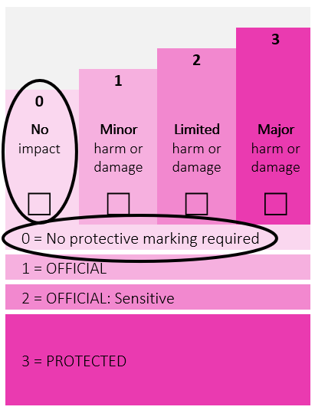

If you selected an impact of 1, the protective marking is OFFICIAL. Cemetery Trusts can choose to leave material at this level unlabelled, or you can choose to apply the marking of OFFICIAL to the relevant information.
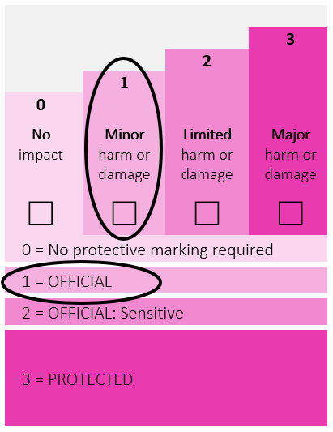
If you selected an impact of 2, the protective marking is OFFICIAL: Sensitive – your documents must be labelled with this label.
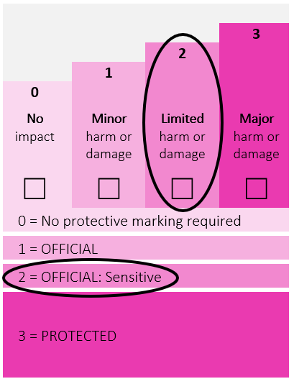
If you selected an impact of 3, the protective marking is PROTECTED. Documents must be labelled with this marking.
Remember, if you think your cemetery trust holds information with a Confidentiality level of 3, please contact OVIC’s Information Security Unit.
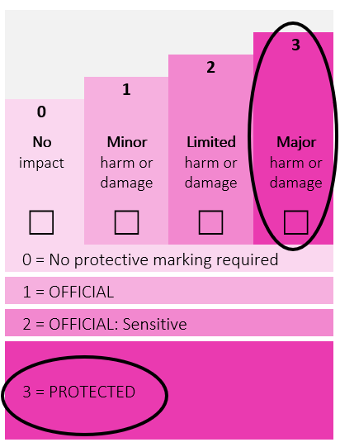

Section J:

“If the INTEGRITY of this information were compromised, would it cause…”
Description
This section asks you to assess the impact if the Integrity of the information asset were compromised. Each impact level is presented in numerical form (i.e. 0, 1, 2, or 3 - where 0 is equal to no impact, and 3 is equal to major impact).
How to complete this section:
- Conduct an assessment for each information asset, focusing on the Integrity attributes of the material.
- In the register select the relevant impact level for each asset from the options presented:
Corresponding Impacts - Integrity
0 – No impact
1 – Minor: Compromise of the information would be expected to cause minor harm/damage to organisations or individuals
2 – Limited: Compromise of the information would be expected to cause limited harm/damage to organisations or individuals
3 – Major: Compromise of the information would be expected to cause major harm/damage to organisations or individuals
For example, if the cemetery trust meeting minutes were modified to reflect that a decision was made when it wasn’t, this would be considered a compromise to the integrity of the information.
The degree of harm/damage resulting from this compromise is for the trust to determine based on their understanding of the content and context of the material.



Handy Tip
When conducting your assessment, consider the Integrity aspects of the information asset and ask yourself:

“What would happen if the information were adjusted, modified, or changed without being authorised?”

“Would it result in some degree of harm or damage to government operations, organisations or individuals?”

Section K:
“If the AVAILABILITY of this information were compromised, would it cause…”
OFFICIAL
Description
This section asks you to assess the impact if the Availability of the information asset were compromised. Each impact level is presented in numerical form (i.e. 0, 1, 2, or 3 - where 0 is equal to no impact, and 3 is equal to major impact).
How to complete this section:
- Conduct an assessment for each asset, focusing on the Availability attributes of the material.
- In the register select the relevant impact level for each asset from the options presented:
Corresponding Impacts – Availability
0 – No impact
1 – Minor: Compromise of the information would be expected to cause minor harm/damage to organisations or individuals
2 – Limited: Compromise of the information would be expected to cause limited harm/damage to organisations or individuals
3 – Major: Compromise of the information would be expected to cause major harm/damage to organisations or individuals
For example: If burial maps were rendered unavailable as a result of damage or loss, this would be considered a compromise to the availability of the information.
The degree of harm/damage resulting from this compromise is for the trust to determine based on their understanding of the content and context of the material.



Handy Tip
When conducting your assessment, consider the Availability aspects and attributes of the information asset and ask yourself:

“What would happen if the information were rendered unavailable when it needs to be?”

“Would it result in some degree of harm or damage to government operations, organisations or individuals?”

Section L:
“Is this information asset suitable for public release?”
Description
This section asks you to indicate whether the information asset has been authorised and is suitable for unlimited public release. This is based on an assessment of the individual merits and content of the information asset.
If suitable, this section also asks you to record who has authorised this release, and the date the information asset was publicly released.

Some reasons where you might not authorise unlimited public release could be due to:

- privacy | - public health
- public safety | - regulatory compliance
- security and law enforcement
- other parties having rights over Intellectual Property
- where there are legislative restrictions on release of the information before a certain date

How to complete this section:
- Select Yes or No
If yes, you are signalling that the information asset is deemed SUITABLE for unlimited public release.
- Write in the date that this version of the information asset was published/provided
- Note the role or position title of the individual (including if relevant the organisation and unit) who authorised the release
If no, you are signalling that the information asset is NOT SUITABLE for unlimited public release.
- If no, please briefly note the reasons why.



Handy Tip

You should consult with the creator (identified in Section E) of the individual records or associated information elements to determine whether the content is appropriate for unlimited public release.


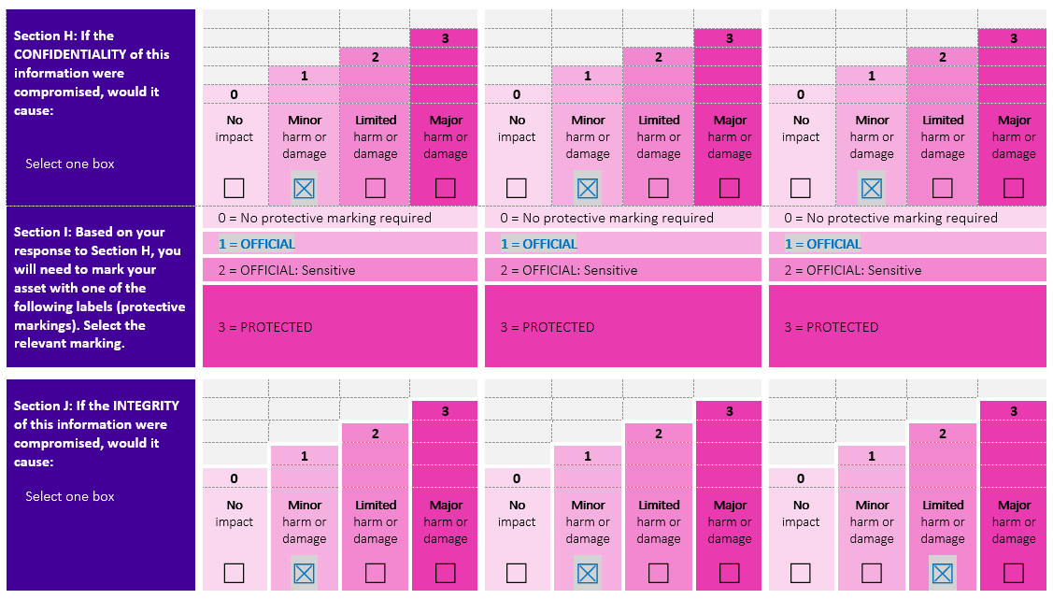
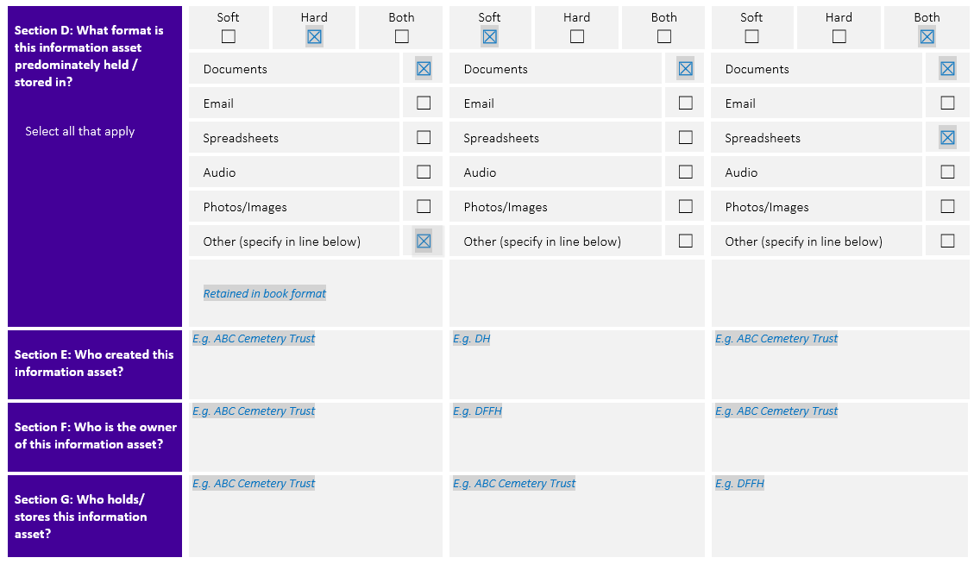
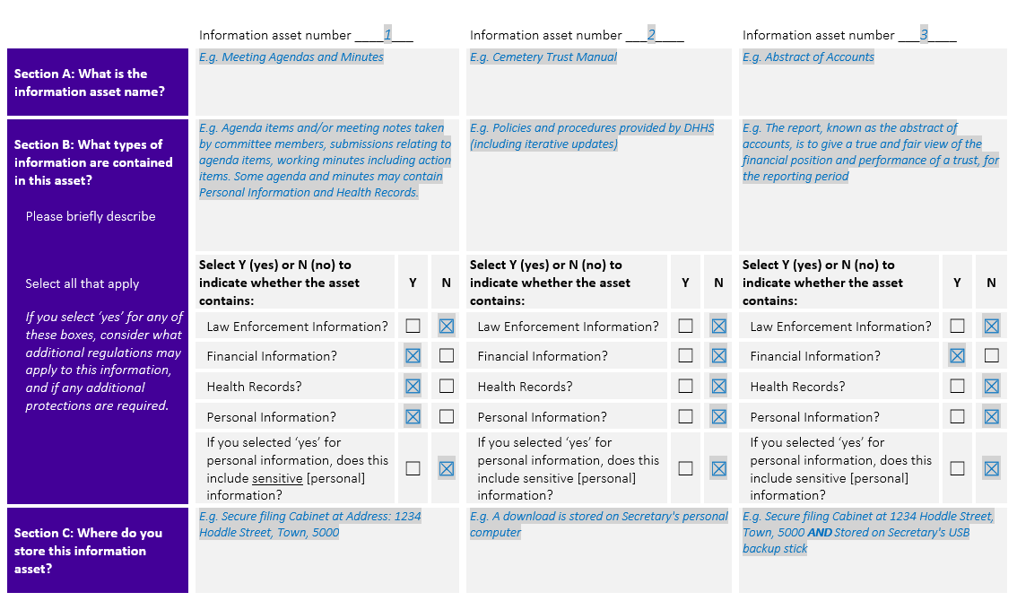
Example cemetery trust information asset register

The following pages show an example of a Class B CT IAR with fields containing sample entries of information commonly held by a cemetery.

The example pages are marked with this picture.

Accessing a copy of the IAR template:
If you haven’t already accessed a copy of the Class B CT IAR template, you can either:
- Download it by going to https://go.vic.gov.au/3VFX4KD
- Request the ISU send you a copy via email or hard copy. You can contact the ISU by emailing security@ovic.vic.gov.au or phone 1300 006 842.

As referenced earlier in this guide, the IAR template is spread across 4 pages, and contains space for 3 information assets to be listed if printed in its current layout. This is due to the sizing of an A4 sheet of paper. Please print out as many blank template pages as needed to account for all your information assets.

If completing the register on a computer, you may need to copy all the relevant sections and replicate these on blank pages.

 | Information asset number ____1___ |  |  |  |  |  |  |  |  | Information asset number ___2____ |  |  |  |  |  |  |  |  |  | Information asset number ___3____
Section A: What is the information asset name? | E.g. Meeting Agendas and Minutes |  |  |  |  |  |  |  |  | E.g. Cemetery Trust Manual |  |  |  |  |  |  |  |  |  | E.g. Abstract of Accounts
Section B: What types of information are contained in this asset?  Please briefly describe  Select all that apply  If you select ‘yes’ for any of these boxes, consider what additional regulations may apply to this information, and if any additional protections are required. | E.g. Agenda items and/or meeting notes taken by trust members, submissions relating to agenda items, working minutes including action items. Some agenda and minutes may contain Personal Information and Health Records. |  |  |  |  |  |  |  |  | E.g. Policies and procedures provided by the Department of Health (including iterative updates) |  |  |  |  |  |  |  |  |  | E.g. The report, known as the abstract of accounts, is to give a true and fair view of the financial position and performance of a trust, for the reporting period
 | Select Y (yes) or N (no) to indicate whether the asset contains: |  |  |  |  |  | Y |  | N | Select Y (yes) or N (no) to indicate whether the asset contains: |  |  |  |  |  | Y |  | N |  | Select Y (yes) or N (no) to indicate whether the asset contains: |  |  |  |  |  | Y |  | N
 | Law Enforcement Information? |  |  |  |  |  | ☐ |  | ☒ | Law Enforcement Information? |  |  |  |  |  | ☐ |  | ☒ |  | Law Enforcement Information? |  |  |  |  |  | ☐ |  | ☒
 | Financial Information? |  |  |  |  |  | ☒ |  | ☐ | Financial Information? |  |  |  |  |  | ☐ |  | ☒ |  | Financial Information? |  |  |  |  |  | ☒ |  | ☐
 | Health Records? |  |  |  |  |  | ☒ |  | ☐ | Health Records? |  |  |  |  |  | ☐ |  | ☒ |  | Health Records? |  |  |  |  |  | ☐ |  | ☒
 | Personal Information? |  |  |  |  |  | ☒ |  | ☐ | Personal Information? |  |  |  |  |  | ☐ |  | ☒ |  | Personal Information? |  |  |  |  |  | ☐ |  | ☒
 | If you selected ‘yes’ for personal information, does this include sensitive [personal] information? |  |  |  |  |  | ☐ |  | ☒ | If you selected ‘yes’ for personal information, does this include sensitive [personal] information? |  |  |  |  |  | ☐ |  | ☒ |  | If you selected ‘yes’ for personal information, does this include sensitive [personal] information? |  |  |  |  |  | ☐ |  | ☒
Section C: Where do you store this information asset? | E.g. Secure filing Cabinet at Address: 1234 Hoddle Street, Town, 5000 |  |  |  |  |  |  |  |  | E.g. A download is stored on Secretary's personal computer |  |  |  |  |  |  |  |  |  | E.g. Secure filing Cabinet at 1234 Hoddle Street, Town, 5000 AND stored on trust Treasurer's USB backup stick
Section D: What format is this information asset predominately held / stored in?  Select all that apply | Soft  ☐ |  | Hard  ☒ |  | Both  ☐ |  |  |  |  | Soft  ☒ |  | Hard  ☐ |  | Both  ☐ |  |  |  |  |  | Soft  ☐ |  | Hard  ☐ |  | Both  ☒
 | Documents |  |  |  |  |  |  | ☒ |  | Documents |  |  |  |  |  |  | ☒ |  | Documents |  |  |  |  |  |  |  | ☒
 | Email |  |  |  |  |  |  | ☐ |  | Email |  |  |  |  |  |  | ☐ |  | Email |  |  |  |  |  |  |  | ☐
 | Spreadsheets |  |  |  |  |  |  | ☐ |  | Spreadsheets |  |  |  |  |  |  | ☐ |  | Spreadsheets |  |  |  |  |  |  |  | ☒
 | Audio |  |  |  |  |  |  | ☐ |  | Audio |  |  |  |  |  |  | ☐ |  | Audio |  |  |  |  |  |  |  | ☐
 | Photos/Images |  |  |  |  |  |  | ☐ |  | Photos/Images |  |  |  |  |  |  | ☐ |  | Photos/Images |  |  |  |  |  |  |  | ☐
 | Other (specify in line below) |  |  |  |  |  |  | ☒ |  | Other (specify in line below) |  |  |  |  |  |  | ☐ |  | Other (specify in line below) |  |  |  |  |  |  |  | ☐
 | Retained in book format
Section E: Who created this information asset? | E.g. ABC Cemetery Trust Secretary |  |  |  |  |  |  |  |  | E.g. Divisional Portfolio Entity and Appointments Advisory Unit  People, Operations, Legal and Regulation of the Department of Health |  |  |  |  |  |  |  |  |  | E.g. DH and ABC Cemetery Trust Treasurer
Section F: Who is the owner of this information asset? | E.g. ABC Cemetery Trust Chairperson |  |  |  |  |  |  |  |  | E.g. DH |  |  |  |  |  |  |  |  |  | E.g. ABC Cemetery Trust Chairperson
Section G: Who holds/ stores this information asset? | E.g. ABC Cemetery Trust Secretary |  |  |  |  |  |  |  |  | E.g. ABC Cemetery Trust Secretary |  |  |  |  |  |  |  |  |  | E.g. DH, Chairperson and Treasurer
Section H: If the CONFIDENTIALITY of this information were compromised, would it cause:

Select one box

 |  |  |  |  |  | 3 |  |  |  |  |  |  |  |  | 3 |  |  |  |  |  |  |  |  |  | 3
 |  |  |  | 2 |  |  |  |  |  |  |  |  | 2 |  |  |  |  |  |  |  |  |  | 2
 |  | 1 |  |  |  |  |  |  |  |  | 1 |  |  |  |  |  |  |  |  |  | 1
 | 0 |  |  |  |  |  |  |  |  | 0 |  |  |  |  |  |  |  |  |  | 0
 | No impact  ☐ | Minor harm or damage  ☒ |  | Limited harm or damage  ☐ |  | Major harm or damage  ☐ |  |  |  | No impact  ☒ | Minor harm or damage  ☐ |  | Limited harm or damage  ☐ |  | Major harm or damage  ☐ |  |  |  |  | No impact  ☐ | Minor harm or damage  ☒ |  | Limited harm or damage  ☐ |  | Major harm or damage  ☐
Section I: Based on your response to Section H, you will need to mark your asset with one of the following labels (protective markings). Select the relevant marking. | 0 = No protective marking required |  |  |  |  |  |  |  |  | 0 = No protective marking required |  |  |  |  |  |  |  |  |  | 0 = No protective marking required
 | 1 = OFFICIAL |  |  |  |  |  |  |  |  | 1 = OFFICIAL |  |  |  |  |  |  |  |  |  | 1 = OFFICIAL
 | 2 = OFFICIAL: Sensitive |  |  |  |  |  |  |  |  | 2 = OFFICIAL: Sensitive |  |  |  |  |  |  |  |  |  | 2 = OFFICIAL: Sensitive
 | 3 = PROTECTED |  |  |  |  |  |  |  |  | 3 = PROTECTED |  |  |  |  |  |  |  |  |  | 3 = PROTECTED
Section J: If the INTEGRITY of this information were compromised, would it cause:
Select one box

 |  |  |  |  |  | 3 |  |  |  |  |  |  |  |  | 3 |  |  |  |  |  |  |  |  |  | 3
 |  |  |  | 2 |  |  |  |  |  |  |  |  | 2 |  |  |  |  |  |  |  |  |  | 2
 |  | 1 |  |  |  |  |  |  |  |  | 1 |  |  |  |  |  |  |  |  |  | 1
 | 0 |  |  |  |  |  |  |  |  | 0 |  |  |  |  |  |  |  |  |  | 0
 | No impact  ☐ | Minor harm or damage  ☒ |  | Limited harm or damage  ☐ |  | Major harm or damage  ☐ |  |  |  | No impact  ☐ | Minor harm or damage  ☒ |  | Limited harm or damage  ☐ |  | Major harm or damage  ☐ |  |  |  |  | No impact  ☐ | Minor harm or damage  ☐ |  | Limited harm or damage  ☒ |  | Major harm or damage  ☐
Section K: If the AVAILABILITY of this information were compromised, would it cause:
Select one box

 |  |  |  |  |  | 3 |  |  |  |  |  |  |  |  | 3 |  |  |  |  |  |  |  |  |  | 3
 |  |  |  | 2 |  |  |  |  |  |  |  |  | 2 |  |  |  |  |  |  |  |  |  | 2
 |  | 1 |  |  |  |  |  |  |  |  | 1 |  |  |  |  |  |  |  |  |  | 1
 | 0 |  |  |  |  |  |  |  |  | 0 |  |  |  |  |  |  |  |  |  | 0
 | No impact  ☐ | Minor harm or damage  ☒ |  | Limited harm or damage  ☐ |  | Major harm or damage  ☐ |  |  |  | No impact  ☐ | Minor harm or damage  ☒ |  | Limited harm or damage  ☐ |  | Major harm or damage  ☐ |  |  |  |  | No impact  ☐ | Minor harm or damage  ☐ |  | Limited harm or damage  ☒ |  | Major harm or damage  ☐
Section L: Is this information asset suitable for public release?  Select one box, and provide supporting comments if relevant | Yes ☐ |  |  | No ☒ |  |  |  |  |  | Yes ☒ |  |  | No ☐ |  |  |  |  |  |  | Yes ☐ |  |  | No ☒
 | If yes, who approved this?  e.g. As the minutes are a matter of public record, they may need to be produced as evidence of trust decisions – public release to be assessed on a case-by-case basis. |  |  |  |  |  |  |  |  | If yes, who approved this?  e.g. DH |  |  |  |  |  |  |  |  |  | If yes, who approved this?  e.g. Supplied to DH as part of the financial year reporting cycle.
 | Date of Approval: e.g. N/A |  |  |  |  |  |  |  |  | Date of Approval: e.g. 29 November 2024 |  |  |  |  |  |  |  |  |  | Date of Approval: e.g. N/A

Annexure - Definitions
OFFICIAL
Law Enforcement Data  Privacy and Data Protection Act 2014 (Vic) | Health Information  Health Records Act 2001 (Vic)
Law enforcement data means any information obtained, received or held by Victoria Police—  - for the purpose of one or more of its, or any other law enforcement agency's law enforcement functions or activities; or  - for the enforcement of laws relating to the confiscation of the proceeds of crime; or  - in connection with the conduct of proceedings commenced, or about to be commenced, in any court or tribunal; or  - for the purposes of its community policing functions; | Health information means—  - information or an opinion about—  - the physical, mental, or psychological health (at any time) of an individual; or  - a disability (at any time) of an individual; or  - an individual's expressed wishes about the future provision of health services to him or her; or  - a health service provided, or to be provided, to an individual  — that is also personal information; or  - other personal information collected to provide, or in providing, a health service; or  - other personal information about an individual collected in connection with the donation, or intended donation, by the individual of his or her body parts, organs or body substances; or  - other personal information that is genetic information about an individual in a form which is or could be predictive of the health (at any time) of the individual or of any of his or her descendants—  but does not include health information, or a class of health information or health information contained in a class of documents, that is prescribed as exempt health information for the purposes of this Act generally or for the purposes of specified provisions of this Act.

Personal Information
Privacy and Data Protection Act 2014 (Vic)
Personal information means
information or an opinion (including information or an opinion forming part of a database), that is recorded in any form and whether true or not, about an individual whose identity is apparent, or can reasonably be ascertained, from the information or opinion, but does not include information of a kind to which the Health Records Act 2001 applies;

Contact OVIC
t: 1300 00 6842
e: security@ovic.vic.gov.au
w: ovic.vic.gov.au
OFFICIAL

