

2026 | How-to Guide: Protective Data Security Plan (PDSP) for Committees of Management of Crown land reserves
Version 1.0


If you need help in completing the Protective Data Security Plan, call 1300 006 842 or email security@ovic.vic.gov.au
Document details
Document details | 2026 | How-to Guide: Protective Data Security Plan (PDSP) for Committees of Management of Crown land reserves
Publication date | December 2025
Review date | December 2027
Protective Marking | OFFICIAL
CM ref / location | D25/5896
Document status | Published
Authority | Office of the Victorian Information Commissioner (OVIC)
Author | Information Security Unit

Version | Author | Date | Additions/changes
1.0 | Information Security Unit | December 2025 | Initial version for committees of management

Disclaimer
The information in this document is general in nature and does not constitute legal advice.

Copyright
You are free to re-use this work under a Creative Commons Attribution 4.0 licence, provided you credit the State of Victoria (Office of the Victorian Information Commissioner) as author, indicate if changes were made and comply with the other licence terms. The licence does not apply to any branding, including Government logos. Copyright queries may be directed to communications@ovic.vic.gov.au

Table of Contents
Background 4
About this guide and the Committee of Management PDSP form 5
Instructions for completing the PDSP 6
Part A: Contact information (mandatory) 7
Part B: Self-assessment against the 14 requirements (mandatory) 8
Part C: Attestation (mandatory) 11
Part D: Reporting on behalf of multiple CoMs (optional) 12
Submitting a copy of the completed PDSP to OVIC 14
Need help? 14

Background
The Office of the Victorian Information Commissioner (OVIC) has developed the Victorian Protective Data Security Standards (the Standards or VPDSS) as required under the Privacy and Data Protection Act 2014 (Vic) (PDP Act).
The Standards prescribe requirements designed to protect information across the Victorian public sector, including the information of committees of management of Crown land reserves (CoMs). Under Part 4 of the PDP Act, CoMs must submit a Protective Data Security Plan (PDSP) to OVIC to fulfill this legislative information security obligation.
Committees of management handle various types of important information such as:
- Committee meeting minutes/notes
- Committee records, such as correspondence, financial statements, policies and procedures.
- Copies of annual returns
- Policies and procedures
- Records of maintenance/repairs
- Registers of volunteers
In OVIC’s discussions with the Department of Energy, Environment and Climate Action (DEECA) it is clear the CoMs are passionate about protecting paper (hard copy) and electronic (digital or soft copy) information, and where required, sensitive verbal discussions.
OVIC appreciates that CoM members and employees (most of whom are volunteers) spend countless hours ensuring committee records are accurate and complete.
This dedication by committee members helps build community confidence in the accuracy and availability of this information when it is most needed. The historical value of these records reflects the importance the community places in the material you manage on the committee’s behalf.
As a CoM member, have you considered:
- what you can do to protect committee records in the event of a fire or flood
- what happens when a committee member’s appointment ends, including how the knowledge that has been built up over the years is then transferred to the next member
- what would have helped you when you became a committee member
Documenting some of those practices could assist in the ongoing administration and future handover of the CoM. Strong information management practices can also support good financial record keeping and help CoM members manage their time and efforts relative to any risks.

About this guide and the Committee of Management PDSP form
There are 2 key documents you need to reference to enable you to submit a completed PDSP to OVIC:
Document 1 - This guide  2026 | How-to Guide: Protective Data Security Plan (PDSP) for Committee of management of Crown land reserves  This guide provides you with instructions and assistance on how to complete and submit the PDSP form. | 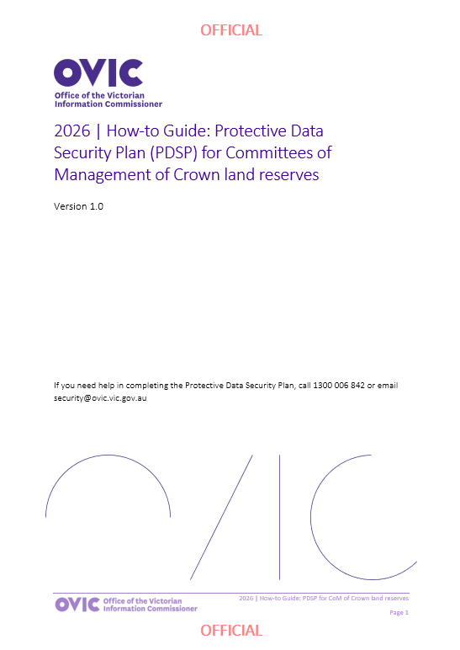
Document 2 - PDSP form    2026 | Committee of management of Crown land reserves Protective Data Security Plan (PDSP)  This form must be completed, and a copy returned to OVIC, by 31 August 2026. | 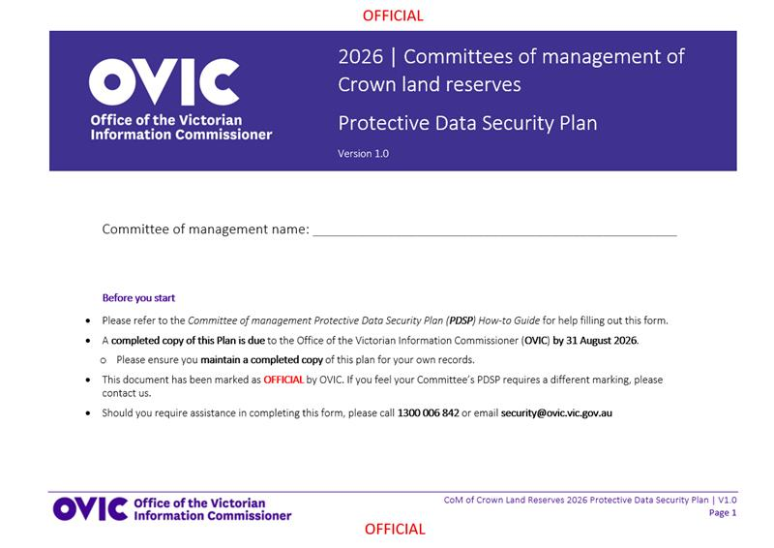
The 14 requirements in the PDSP set out good information security management practices to ensure the protection of committee of management records.
The PDSP has been created to address the specific needs of committees of management. By completing the 2026 PDSP and submitting a signed copy to OVIC, your CoM will have satisfied its PDSP reporting obligation to OVIC for 2026.

Instructions for completing the PDSP
The committee of management PDSP is made up of 5 parts:
2026 Protective Data Security Plan for committees of management
Document details |  | This part includes:  - versioning of the document (PDSP form)  - reference to Part 4 PDP Act obligations  - mapping between the 14 requirements for CoMs and the VPDSS.
Part A | Contact information | This part records basic information that will assist OVIC in identifying the key contacts for the CoM.
Part B | Self-assessment against the requirements | OVIC has specified 14 requirements (aligned to the Standards) that will enable the CoM to manage information in a consistent and secure way.  This part provides OVIC with information on how the CoM is tracking against the 14 requirements and provides some recommended supporting activities to help the CoM address these.
Part C | Attestation | The attestation must be signed by the Chairperson of the CoM or their authorised representative (as specified in Part A of the PDSP form).
Part D | Reporting on behalf of multiple committees of management | If you wish to report on behalf of your committee and other committees of management in a single consolidated PDSP submission, you must have written authorisation from the other committee’s Chairperson in order to include them. OVIC will use the responses you have provided for each of the 14 requirements as a reflection of both yours, and the other listed committees’ status and practices.
You have 2 options for completing the 2026 PDSP form:
 | Option 1 – Soft copy (on the computer): You will need to type responses into the fields and click the appropriate box to mark with an ‘X’. If you have selected a box by mistake, you can clear it by simply clicking it again. You can request a soft copy (digital version) of this form by emailing security@ovic.vic.gov.au
 | Option 2 - Hard copy (printed): You will need to note your responses using a pen on the PDSP form. Once completed, post or email a copy of the signed PDSP back to OVIC. Keep a copy (either photocopy or scanned) of your PDSP form for the committee’s record/ reference.

Part A: Contact information (mandatory)
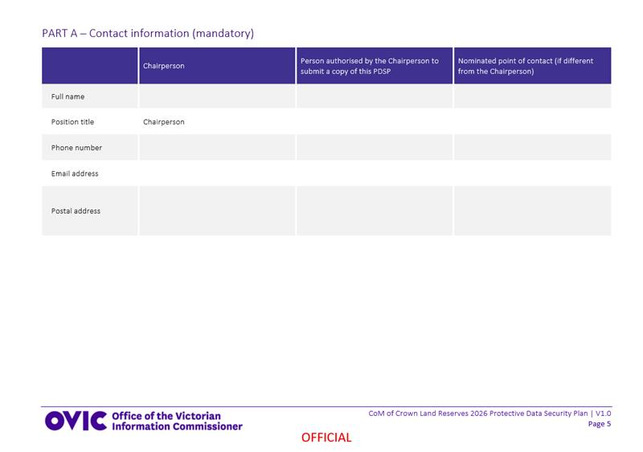
Section description
Under Part A of the PDSP form, please provide basic information that will assist OVIC in identifying the key contacts for your CoM.
How to complete Part A of the PDSP form:
- Provide the contact information of your committee’s Chairperson.
- Provide the contact information of the person who is authorised by the Chairperson to submit a copy of the PDSP on behalf of the Chairperson (this might be another member or volunteer). If this is the same person, simply note this. If there is no authorised person, please leave this section blank.
- Provide the details of the main point of contact for your CoM. This person may be contacted by OVIC if there are any questions relating to your CoM. This may be the Chairperson or another member, or an additional point of contact. If it’s the same person, simply note that.
Please include a postal address as OVIC may mail material to your CoM.
If there are adjustments to these details outside the standard reporting cycle remember to update OVIC of any changes.

Part B: Self-assessment against the 14 requirements (mandatory)
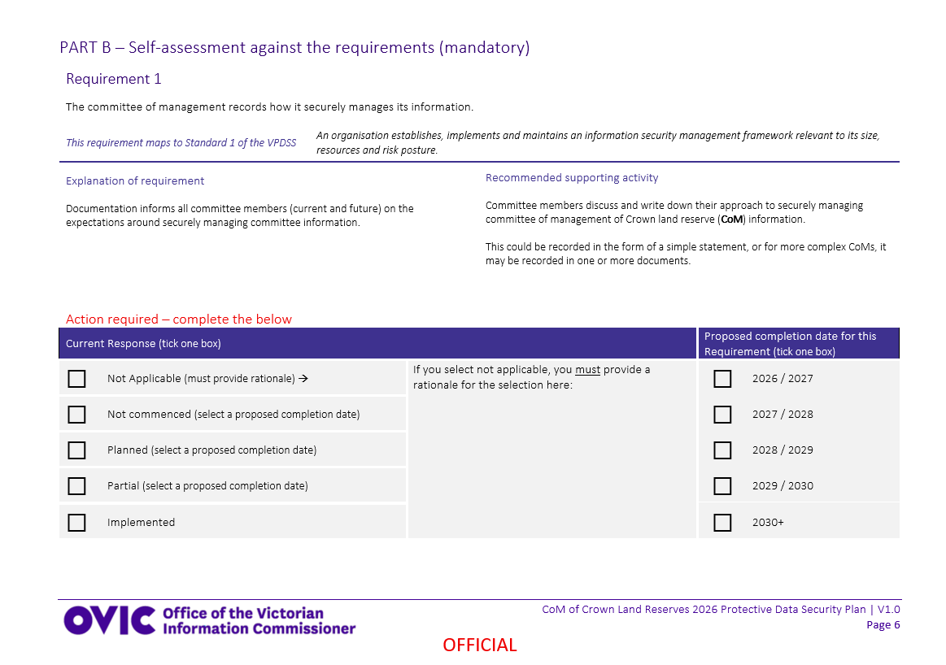
Section description
OVIC has specified 14 requirements that will assist committee members in CoM information in a consistent and secure way.
Part B of the PDSP form offers the CoM an opportunity to outline how it is tracking against each of the 14 requirements and sets out some suggested activities to help the CoM address these.
Each of the 14 requirements are presented using the following structure:
- Requirement number
- The requirement itself (i.e. what the CoM is reporting against)
- Mapping of the requirement back to the Standards
- An explanation of the requirement
- A recommended supporting activity to assist in implementing the requirement and
- A current response
  - Note: If you select ‘not applicable’ as the response, you must provide a rationale outlining a reason why this requirement does not apply to your CoM
- Proposed completion date for the requirement if it is not implemented
How to complete Part B of the PDSP form:
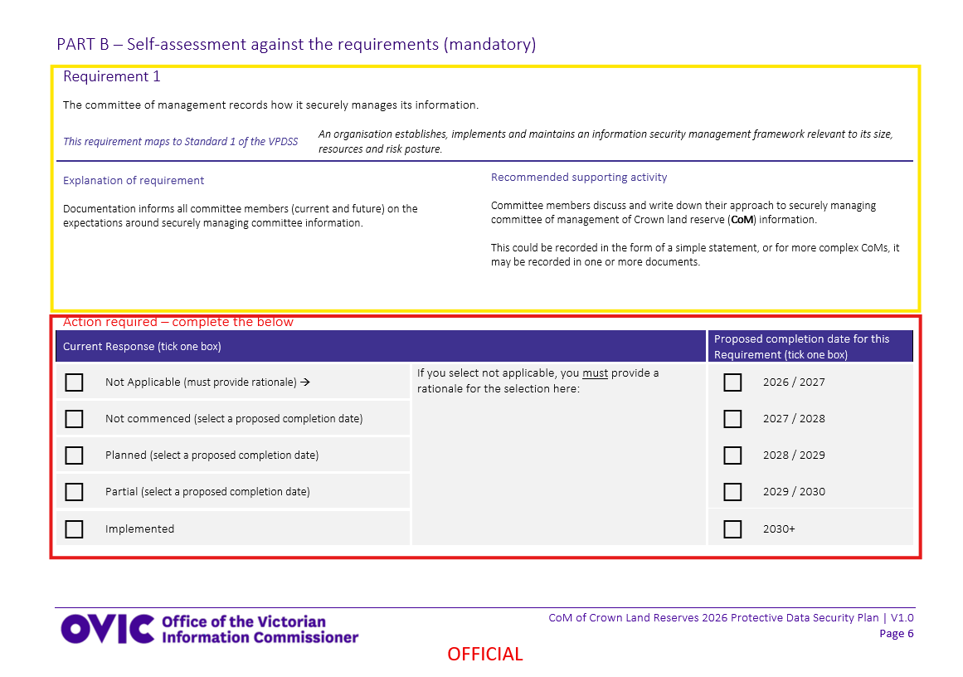

Step 1 | Read | the requirement carefully.
Step 2 | Read | the explanation of the requirement to gain further understanding of what the requirement is asking of the CoM.
Step 3 | Read | the recommended supporting activity to understand what steps can be taken to meet the related requirement. If you are unsure or need assistance, please contact OVIC.
Step 4 | Provide | a current response (implementation status) by ticking the relevant box for each requirement.  Your response should be based on an assessment of whether the CoM is undertaking, or has undertaken, the required activity or a similar activity.  Each response and an outline of what this means is offered below –  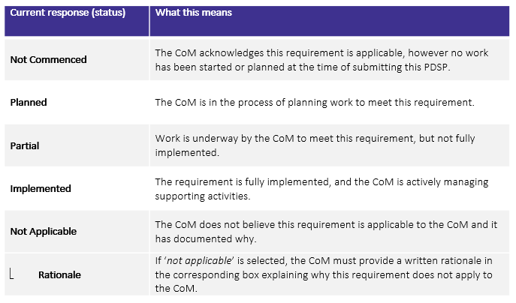  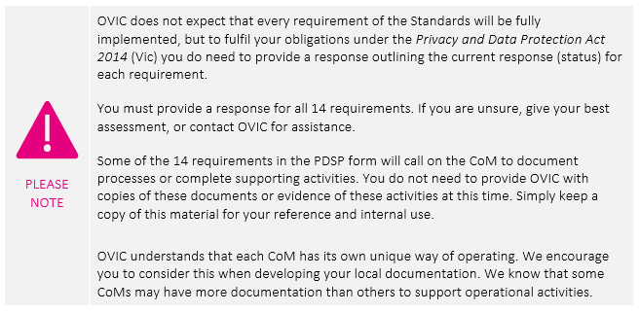
Step 5 | Provide | a proposed completion date for the requirement. A proposed completion date is:  - needed if you have selected the status of ‘not commenced’, planned’, or ‘partial’,  - not needed if you have selected the status of ‘implemented’ or ‘not applicable’.
Step 6 | Repeat | the above steps for each of the 14 requirements.

Part C: Attestation (mandatory)
Section description
The Attestation must be signed by either the Chairperson of the CoM or their authorised representative.
Note: If an authorised representative intends to sign the Attestation, their details must be specified in Part A of the PDSP form.
How to complete Part C of the PDSP form:
- Ensure the Chairperson has reviewed and authorised the PDSP.
- Complete each field including the full name of the person providing the attestation, the name of the CoM, their signature, position, and the date.
- If you are completing this PDSP on behalf of one or more CoM of Crown land reserves, check the box marked and proceed to Part D.
Note: If this PDSP only captures your CoM, you can leave Part D blank.

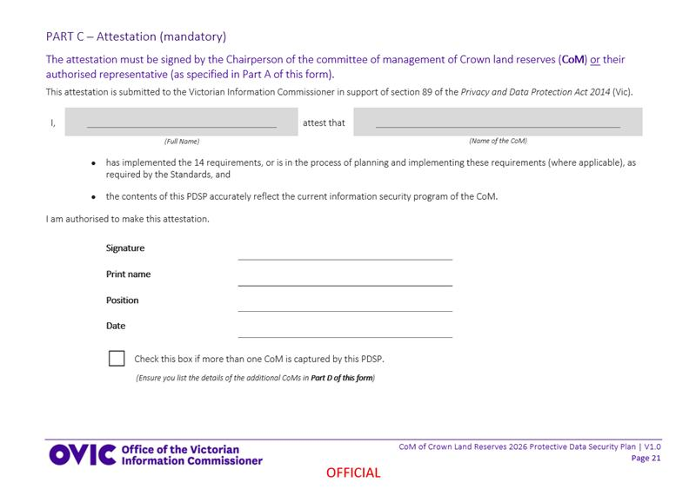

Part D: Reporting on behalf of multiple CoMs (optional)
Section description
Some CoMs may have equivalent risk profiles, handle the same types of information and implement the same security measures, and have the same responses as other similar committees. If multiple committees have the same:
- risk profiles
- types of information
- security practices and
- responses to each of the 14 requirements
it may be appropriate to bundle these responses in a consolidated CoM PDSP submission to OVIC.
If you wish to report on behalf of your CoM and other CoMs in a consolidated PDSP submission, you must have written authorisation from the other committee’s Chairperson in order to include it in this PDSP submission.
If authorised, simply list the names and contact information of the other CoMs in Part D of the PDSP.
OVIC will use the responses you have provided for each of the 14 requirements as a reflection of your CoM and any other listed CoM’s current responses.
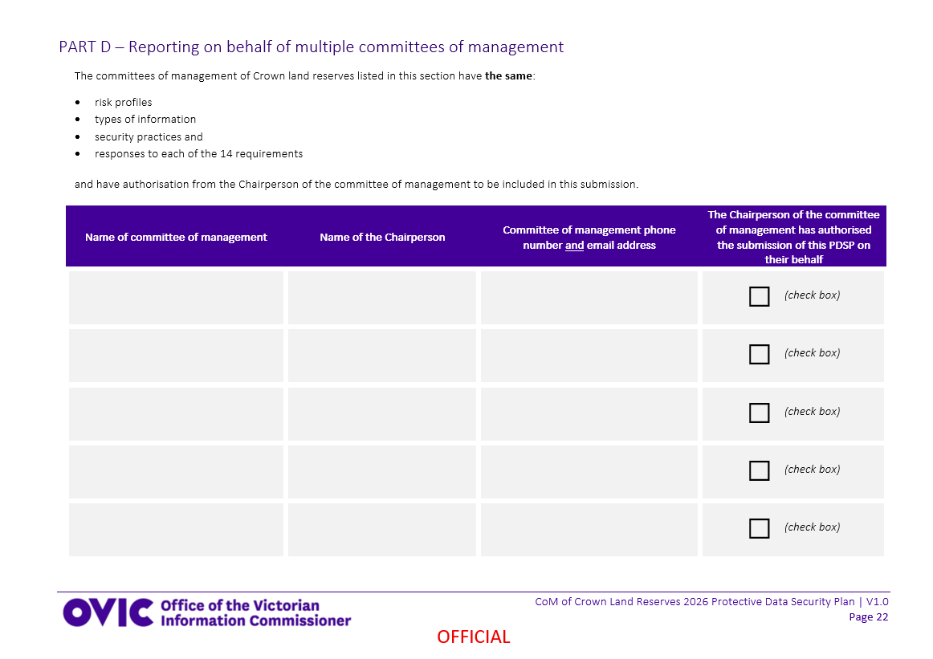
How to complete Part D of the PDSP form:
To be included on a PDSP by a different CoM, please ensure you:
- speak to the submitting CoM to ensure they are in agreement to submit on your committee’s behalf.
- provide written authorisation to the submitting CoM, outlining that your committee is equivalent in all the criteria outlined in the page above.
To assist with this process, OVIC has provided an example of this written authorisation below:

I, [insert chairperson name], authorise [insert committee of management’s name] to be listed on the [submitting committee of management’s] 2026 Protective Data Security Plan (PDSP).
I confirm that my committee has the same:
a. risk profile
b. types of information
c. security practices
d. responses to each of the 14 requirements listed on the PDSP
to that of the committee of management submitting on behalf of my committee.
As the submitting CoM, you should:
- obtain written authorisation from the Chairperson of each CoM that you intend to list in this PDSP submission.
- once authorised, list the name of each CoM, the relevant Chairperson and the contact details for that committee.
- check the box to indicate that each CoM’s Chairperson is aware that they are being reported on behalf of and included in this PDSP submission.

Submitting a copy of the completed PDSP to OVIC
When: Submissions are due to OVIC by 31 August 2026.
How: Once you have completed all parts of the CoM’s PDSP form, you need to supply a completed and signed copy to OVIC. This can be done via email or post.
 | Email a copy of your PDSP to OVIC’s Information Security Unit at security@ovic.vic.gov.au
 | Mail a copy of your PDSP using the following details:  Attention: Information Security Unit, OVIC  PO Box 24274  Melbourne Victoria 3001
It is good practice to keep a record and copies of any forms (including the PDSP) that you submit to OVIC.

Need help?
We understand that some of the requirements described in this document may be new, unfamiliar, or confusing, and we are here to assist you in complying with the PDP Act.
Please contact us to discuss any material you do not know how to address.
 | Phone us on 1300 006 842
 | Email us at security@ovic.vic.gov.au
The feedback we get back from you and other committee members, will assist us in building a network of likeminded people that care about CoM of Crown land reserves’ information and are able to share their knowledge and experience to assist others.


www.ovic.vic.gov.au

To access the Standards, visit OVIC’s website - https://ovic.vic.gov.au/information-security/standards/

