2024 Protective Data Security Plan (PDSP) How-to Guide
  - Class B Cemetery Trusts
Version 1.1

If you need help in completing the Protective Data Security Plan, please call 1300 006 842 or email security@ovic.vic.gov.au
Document details
Document details | 2024 Protective Data Security Plan (PDSP) How-to Guide  Class B Cemetery Trusts
Publication date | December 2023
Review date | December 2025
Protective Marking | OFFICIAL
CM ref / location | D23/8639
Document status | Authorised for public release
Authority | Office of the Victorian Information Commissioner (OVIC)
Author | Information Security Unit

Version | Author | Date | Additions/changes
1.0 | Information Security Unit | January 2022 | Initial version for cemetery trusts
1.1 | Information Security Unit | December 2023 | Updates to reflect 2024 PDSP form

Disclaimer
The information in this document is general in nature and does not constitute legal advice.

Copyright
You are free to re-use this work under a Creative Commons Attribution 4.0 licence, provided you credit the State of Victoria (Office of the Victorian Information Commissioner) as author, indicate if changes were made and comply with the other licence terms. The licence does not apply to any branding, including Government logos. Copyright queries may be directed to communications@ovic.vic.gov.au
Table of Contents
BACKGROUND 4
ABOUT THIS DOCUMENT AND THE CLASS B PDSP FORM 5
INSTRUCTIONS FOR COMPLETING THE PDSP FORM 6
Part A: Contact Information 7
Part B: Self-assessment against the 14 requirements 8
Part C: Attestation 11
Part D: Reporting on behalf of multiple cemetery trusts 12
SUBMITTING THE PDSP FORM TO OVIC 13
I NEED HELP COMPLETING THE PDSP FORM 13

BACKGROUND
The Office of the Victorian Information Commissioner (OVIC) has developed the Victorian Protective Data Security Standards (the Standards) as required under the Privacy and Data Protection Act 2014 (PDP Act).
The Standards prescribe requirements designed to protect information across the Victorian public sector, including Class B Cemetery Trusts.
Class B Cemetery Trusts manage various types of important information such as:
- applications for right of interment;
- applications for interment authorisation;
- applications for approval to inter cremated human remains;
- applications to establish or alter a memorial or place of interment;
- right of interment and interment registers; and
- trust records, such as correspondence, financial statements, policies and procedures.
During OVIC’s discussions with trust members, it was clear there is a passion to protect paper and electronic information (and where required, sensitive verbal discussions).
OVIC appreciates that Class B Cemetery Trust members and employees (most of whom are volunteers) spend countless hours ensuring trust records are accurate and complete.
This dedication by trust members helps build community confidence in the accuracy and availability of this information when it’s most needed.
As a Class B Cemetery Trust member, have you considered:
- what you can do to protect trust records in the event of a fire or flood?
- what would happen if a cemetery trust member retires or passes? How is the knowledge that has built up over the years transferred to the next member?
- what would have helped you when you became a trust member? Documenting some of those practices could assist in the ongoing management and future handover of the cemetery trust.
Strong information management practices can support good financial record keeping and help cemetery trust members manage their time and efforts relative to any risks.

ABOUT THIS DOCUMENT AND THE CLASS B PDSP FORM
There are two key documents you need to complete this submission to OVIC:
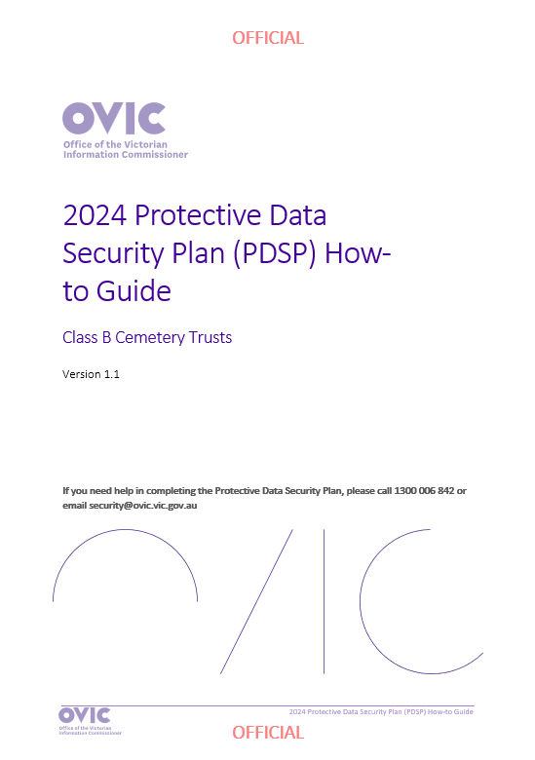 | 2024 Protective Data Security Plan (PDSP) How-to Guide (this document) for Class B Cemetery Trusts  This provides you with instructions and guidance on how to complete the PDSP form (second document).
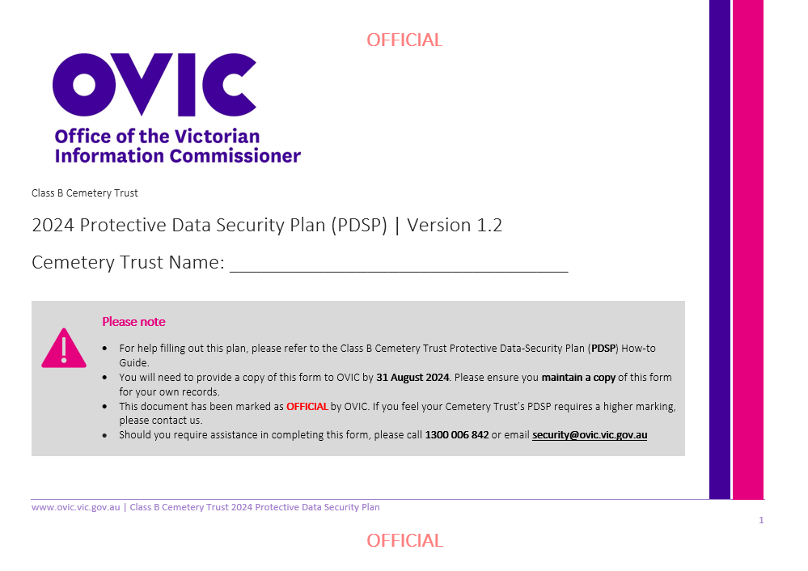 | Class B Cemetery Trust 2024 Protective Data Security Plan (PDSP) form  This must be completed, and a copy returned to OVIC by 31 August 2024.
The requirements set out in the PDSP form recommend good information security management practices to ensure the protection of cemetery trust records.
The PDSP form has been created to meet the specific needs of Class B Cemetery Trusts. By completing the 2024 PDSP and submitting it to OVIC, you will have satisfied your PDSP reporting obligation to OVIC for 2024.
When completing the 2024 Class B Cemetery Trust PDSP, consider the activities undertaken during the 1 July 2022 – 30 June 2024 reporting period.
Organisations are expected to submit a copy of a PDSP to OVIC between 1 July 2024 – 31 August 2024.

INSTRUCTIONS FOR COMPLETING THE PDSP FORM
The Class B Cemetery Trust PDSP form is made up of four parts:
2024 Protective Data Security Plan for Class B Cemetery Trusts
PART A | Contact information | This part records basic information that will assist OVIC in identifying the key contacts for your Class B Cemetery Trust.
PART B | Self-assessment against the requirements | This part provides us with information on how your cemetery trust is tracking against the requirements and provides some suggested activities to help you address these requirements.  OVIC has specified 14 core requirements (aligned to the Standards) that will assist you in managing Class B Cemetery Trust information in a consistent and secure way.
PART C | Attestation | The Attestation must be signed by the person authorised to submit a copy of the PDSP to OVIC.
PART D | Reporting on behalf of multiple Class B Cemetery Trusts | If you wish to report on behalf of yourself and other cemetery trusts in a consolidated submission, simply add the names and contact details of the other cemetery trusts in this section. OVIC will use the responses you have provided for each of the requirements as a reflection of the other listed cemetery trusts status.

You have two options for completing the 2024 PDSP form:
Option 1 - Hard copy (printed): You will need to photocopy or scan a copy of your completed form and post or email this copy back to OVIC. Keep a copy (either original or copy) of your form for your records/ reference.
Option 2- Soft copy (on the computer): You will need to type responses into the fields and click the appropriate box to mark with an ‘X’. If you have selected a box by mistake, you can clear it by simply clicking it again. You can request a soft copy of this form by emailing security@ovic.vic.gov.au

Part A: Contact Information
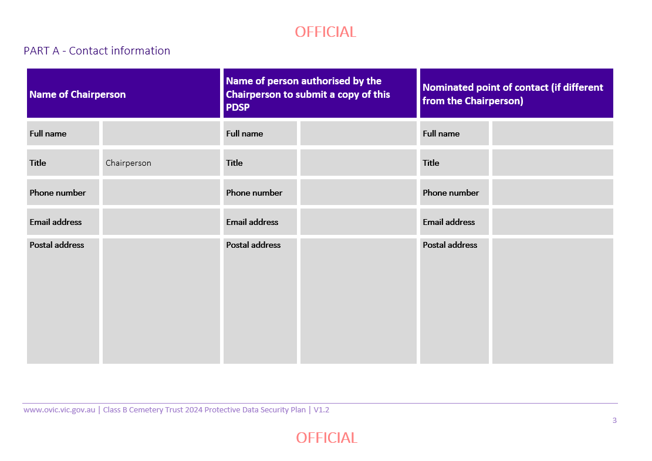
Section Description
Under Part A record basic information that will assist OVIC in identifying the key contacts for your Class B Cemetery Trust.
How to complete this section:
- Write the contact information of your cemetery trust’s Chairperson.
- Write the contact information of the person who is authorised by the Chairperson to submit the PDSP on the Chairperson’s behalf (this might be the Secretary). If this is the same person, simply note this.
- Write the contact information of the main point of contact for your cemetery trust. This person may be contacted by OVIC if there are any questions relating to your cemetery trust and the address to where any postal material will be sent. This may be the Chairperson or Secretary, or an additional point of contact. If it’s the same person, simply note that.

Part B: Self-assessment against the 14 requirements
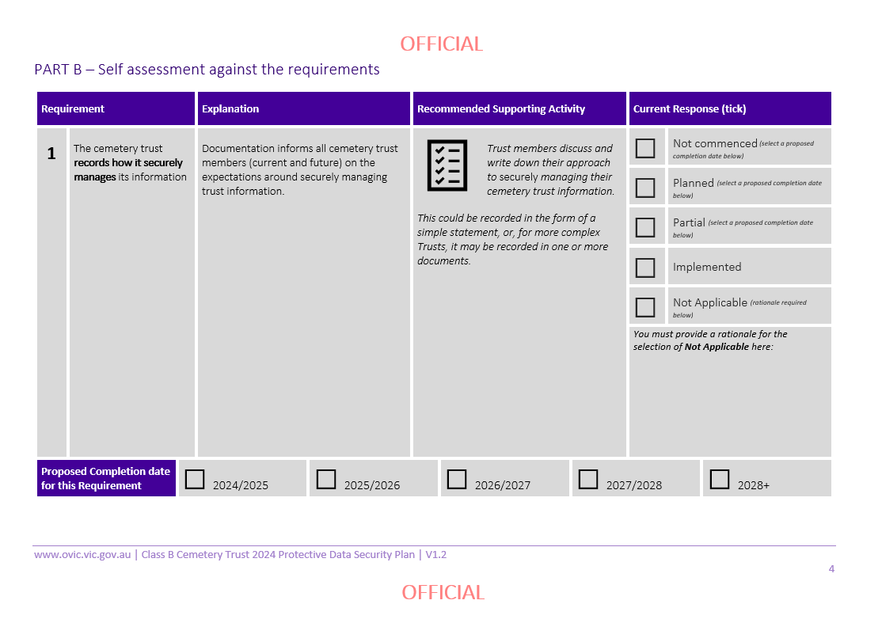
Section Description
Under Part B provide OVIC with information on how your cemetery trust is tracking against the requirements and provides some suggested activities to help you address these requirements.
OVIC has specified 14 core requirements (aligned to the Standards) that will assist you in managing Class B Cemetery Trust information in a consistent and secure way.
Each requirement has:
- a number;
- an explanation;
- a recommended supporting activity to assist in implementing this requirement; and
- a response.
The recommended supporting activities are included as a guide to help you meet the requirements.
The ‘Current Response’ column is mandatory for each of the 14 requirements.

How to complete this section:
- Read the description of each requirement carefully.
- Think about how the recommended supporting activity could help the cemetery trust meet the related requirement. If you are unsure or need assistance, please contact OVIC.
- Consider whether your cemetery trust is undertaking/has undertaken the activity or a similar activity and tick the appropriate response for each of the 14 requirements.
- If you’ve ticked ‘Not Applicable’ for any of the requirements, you must include a rationale in the box provided.
- If you’ve ticked ‘Not commenced’, ‘Planned’, or ‘Partial’, you must nominate a date for proposed completion of this requirement by ticking the appropriate box.

The responses should be read in the following manner:
Your response | What this means
Not Commenced | Our cemetery trust acknowledges this requirement is applicable, however no work has been commenced or planned at this stage.
Planned | Our cemetery trust is in the process of planning our work to meet this requirement.
Partial | Work is underway by our cemetery trust to meet this requirement.
Implemented | The requirement is fully implemented, and our cemetery trust is actively managing supporting activities.
Not Applicable | We do not believe this requirement is applicable to our cemetery trust and will document why.
- Rationale | If you ticked ‘Not Applicable’ you will need to provide a written rationale for this selection in the box provided.

PLEASE NOTE | OVIC does not expect that every requirement of the Standards will be fully implemented, but to fulfil your obligations under the Privacy and Data Protection Act 2014 you do need to provide a response outlining your current status.  You must provide a response for all 14 requirements.  If you are unsure, give your best assessment, or contact OVIC for assistance.  By providing current responses to OVIC, we can develop appropriate resources and guidance material to help trust members protect information in a way that makes sense to you and is practical.  You will note some of the requirements in the PDSP form require processes to be documented, however you do not need to provide OVIC with copies of these documents at this time. Simply keep a copy for your reference.  OVIC understands that each Class B Cemetery Trust has its own unique way of operating. We encourage you to consider this when developing your local documentation. We know that some Class B Cemetery Trusts may have more documentation than others to support operational activities.

Part C: Attestation
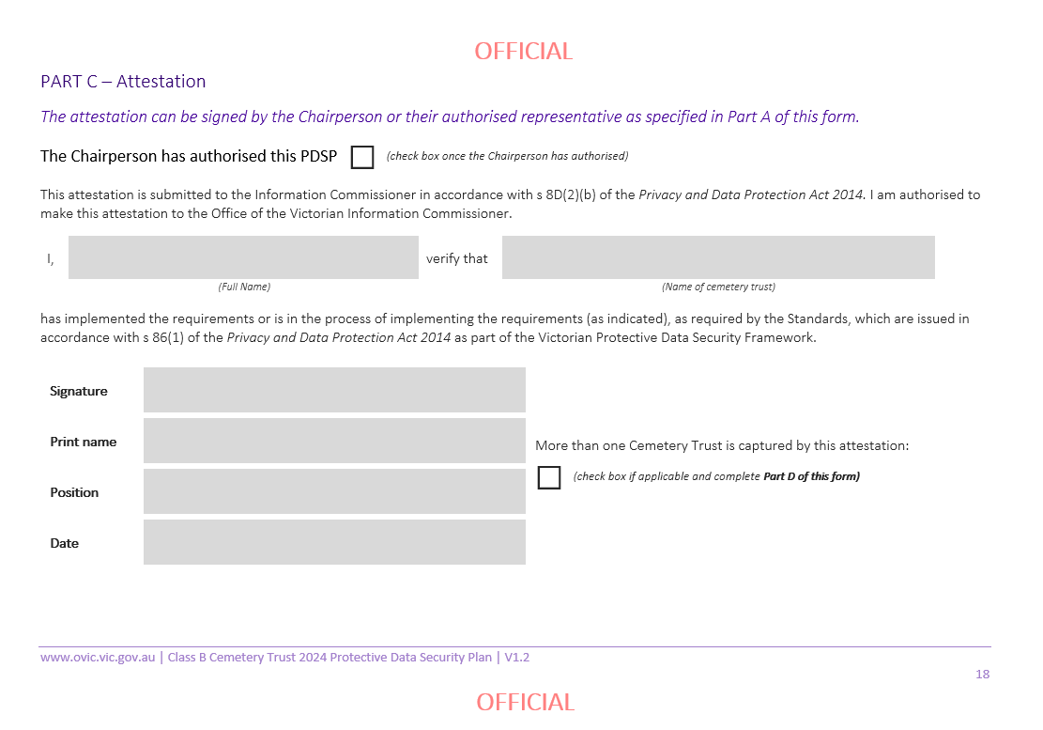
Section Description
The Attestation must be signed by the person authorised to submit a copy of the PDSP to OVIC.
How to complete this section:
- Ensure the Chairperson has reviewed and authorised the form.
- Tick the box to signify that the Chairperson has reviewed and authorised the form.
- Complete the sections including the name and role of the signatory, the name of your cemetery trust, and the date.
- Sign the document.
- If you are completing this form on behalf of yours and other cemetery trusts, tick the box marked “More than one cemetery trust is captured by this attestation” and proceed to Part D.
- If this form only captures your cemetery trust, you can leave Part D blank.

Part D: Reporting on behalf of multiple cemetery trusts

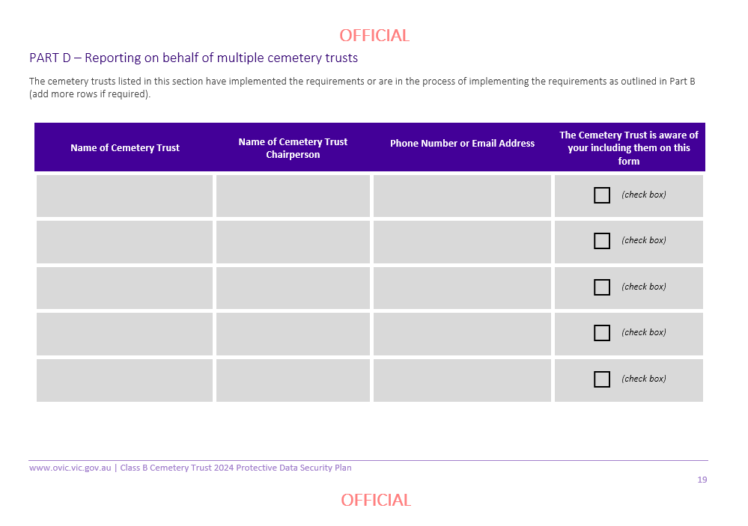
Section Description
Many small Cemeteries handle similar information, and have the same security practices to protect this material.
Where Class B Cemetery Trusts have the same:
- practices; and,
- answers to the 14 requirements
it may be appropriate to bundle these responses in a single (report) submission to OVIC.
If you wish to report on behalf of yourself and other cemetery trusts in a consolidated submission, simply add the names of the other cemetery trusts in this section.
By doing so, OVIC will use the responses you have provided for each of the requirements as a reflection of the other cemetery trusts status.
How to complete this section:
- List the name of each cemetery trust, the relevant Chairperson and their contact details.
- Tick the box to indicate that each cemetery trust’s Chairperson is aware that they are being reported on behalf of you.

SUBMITTING THE PDSP FORM TO OVIC
Once you have completed all parts of the PDSP form, you need to supply a copy to OVIC. This can be done via email or post.
Email a copy of your form to OVIC’s Information Security Unit at security@ovic.vic.gov.au
Mail a copy of your form using the following details:
Attention: Information Security Unit, OVIC
PO Box 24274
Melbourne Victoria 3001

It is good practice to keep a record and copies of any forms (including the PDSP) that you submit to OVIC.

I NEED HELP COMPLETING THE PDSP FORM
We understand that some of the requirements described in this document may be new, unfamiliar, or confusing, and we are here to assist you in complying with the law.
Please contact us to discuss any material you don’t know how to address.
Phone us on 1300 006 842
Email us at security@ovic.vic.gov.au
The feedback we get back from you and other trust members, will assist us in building a network of likeminded people that care about Class B Cemetery Trust information and are able to share their knowledge and experiences to assist others.

www.ovic.vic.gov.au

To access the Standards, visit OVIC’s website - https://ovic.vic.gov.au/data-protection/standards/

