Official

Victorian Protective Data Security Framework V2.1
  - Version 2.1

Document details
Document details | Victorian Protective Data Security Framework V2.1
Publication date | 2023/09/27
Review date | 2024/09/27
Security classification | OFFICIAL
CM ref / location | D22/797
Document status | Authorised for public release
Authority | Office of the Victorian Information Commissioner (OVIC)
Author | Information Security Unit

Version | Author | Date | Additions/changes
1.0 | Information Security Unit | 2016/06/30 | N/A
1.1 | Information Security Unit | 2018/03/01 | - Change references of ‘Commissioner for Privacy and Data Protection’ to ‘Office of the Victorian Information Commissioner’  - Change references of ‘CPDP’ to ‘OVIC’  - Change references of ‘PDPA’ to ‘PDP Act’  - Replace ‘Foreword’ with new Deputy Commissioner’s foreword  - Insert new section on Victoria Police and the Crime Statistics Agency  - Removed reference to annual security attestation in section 12  - Change ‘protocol’ descriptor  - Insert reference to ‘elements’  - Insert reference to Part 5 – Assurance Model in section 17 for more information  - Insert reference to Enterprise Solutions Branch in Section 19  - Remove ‘sensitive and significant (valuable)’ in section 20  - Updates to some control references  - Change Part 5 – Assurance Model – various including revised reporting obligations  - Insert new section on single/multiple organisation reporting  - Insert new section on the 5-step action plan
2.0 | Information Security Unit | 2020/02/01 | - Content amended to reflect the monitoring and assurance activities of VPS organisations and OVIC.  - Relevant content from V1.0 of the Framework is available under the VPDSF Resources section of the OVIC website.
2.1 | Information Security Unit | 2023/09/27 | - Where relevant, explicitly expanded the term “public sector information” to include “public sector information” and “information systems”  - Updated references to the current version of the Privacy and Data Protection Act 2014 (No. 60 of 2014 -2 September 2022)  - Grammatical enhancements  - Updated Commissioner’s Foreword

Disclaimer
The information in this document is general in nature and does not constitute legal advice.

Copyright
You are free to re-use this work under a Creative Commons Attribution 4.0 licence, provided you credit the State of Victoria (Office of the Victorian Information Commissioner) as author, indicate if changes were made and comply with the other licence terms. The licence does not apply to any branding, including Government logos. Copyright queries may be directed to communications@ovic.vic.gov.au
Table of Contents
Commissioner’s foreword 5
Part One: Introduction to the Framework 6
1. Commencement of the PDP Act 6
2. What is protective data security? 6
3. What is the Framework? 7
4. Applicability of the Framework 8
5. The Framework in context 10
6. Roles, responsibilities, and relationships 12
Part Two: Monitoring and assurance by VPS organisations 15
7. VPS organisations’ obligations 15
8. Accountability of the public sector body Head 15
9. Obligations of VPS organisations 16
10. Developing an organisational monitoring and assurance program 17
11. Undertaking organisational monitoring and assurance activities 19
Part Three: OVIC monitoring and assurance 20
12. OVIC’s regulatory approach 20
13. Overview of OVIC’s monitoring and assurance activities 20
14. Outline of OVIC’s monitoring activities 21
15. Risk-prioritised monitoring and assurance activities 22

Commissioner’s foreword
The Victorian Protective Data Security Framework (the Framework) and accompanying Victorian Protective Data Security Standards (the Standards) were released and issued to Victorian Public Sector (VPS) agencies and bodies (VPS organisations) in 2016. Adherence to the Standards is mandatory for all organisations within the scope of Parts 4 and 5 of the Privacy and Data Protection Act 2014 (Vic) (PDP Act). This update has been developed to harmonise some terms, and to conform to minor amendments to the PDP Act.
This framework update has been timed for release after the due date for attestations for 2023. Most organisations have now submitted two rounds of completed PDSPs and several biennial attestations. OVIC sees slow but continued improvement in the maturity of most submissions. While there is no such thing as perfect security, your continued attention to the Framework and your information security responsibilities will help to reduce risk and provide the public with some confidence that public sector information is being managed effectively.
My office looks forward to continuing to assist the VPS to deliver efficient, effective and secure outcomes for all. As always, I encourage you to engage with OVICs information security team and ensure that the Framework and Standards remain a useful regulatory tool.

Rachel Dixon
Acting Information Commissioner
September 2023

Part One: Introduction to the Framework
This document is intended for VPS organisations (including employees, contractors, and external parties) that are subject to the protective data security provisions under Part 4 of Victoria’s PDP Act.
This document is primarily written to inform executives and designed to support information security practitioners.

Commencement of the PDP Act
In 2014, the PDP Act was passed by the Parliament, ushering in Australia’s first broad-based legislated information security requirements.
The PDP Act significantly changed the information security regulatory landscape, empowering the Victorian Information Commissioner to:
- develop the Framework for monitoring and assuring public sector data security; and
- issue the Standards.

What is protective data security?
Protective data security is a risk management process designed to safeguard information assets and information systems in a way that is proportionate to threats and supportive of business outcomes.
It uses a combination of procedural, physical, personnel, information and ICT security measures designed to provide government (organisations) information, functions, resources, employees and clients with protection against security threats.
The Framework and the Standards rely on protective data security principles, to maintain the confidentiality, integrity, and availability of public sector information and information systems.
In this document, ‘protective data security’ and ‘information security’ are used interchangeably.

What is the Framework?
Established under Part 4 of the PDP Act, the Framework has been developed to monitor and assure the security of public sector information and information systems, across the VPS.
The monitoring and assurance activities outlined in the Framework are based on:
- the compliance requirements of VPS organisations; and
- OVIC’s responsibilities, powers, and functions.
The Framework provides a model to monitor and measure the extent to which VPS organisations implement the Standards and comply with the requirements under Part 4 of the PDP Act. It employs a risk-based approach, seeking to enhance information security capability and maturity of VPS organisations, using existing risk management principles and guidelines.
The Framework is based on an outcome focused regulatory model that concentrates on high-level assurance principles, supported by risk-informed monitoring activities. It is intended to reflect the sector’s unique operating requirements and delivers scalable, efficient, effective, and economic security outcomes.
The monitoring and assurance activities set out in the Framework are formulated from statutory obligations of VPS organisations and OVIC’s statutory responsibilities, powers, and functions in the PDP Act. The monitoring and assurance activities are designed to assist VPS organisations mitigate information security risks and provides OVIC with insight into information security practices across the VPS.
The Framework draws on intelligence feeds and insights from Protective Data Security Plans (PDSPs), information security incidents, research projects, enquiries, Regulatory Action Policy (RAP) activities, and referrals. OVIC uses these insights to report back to Government.
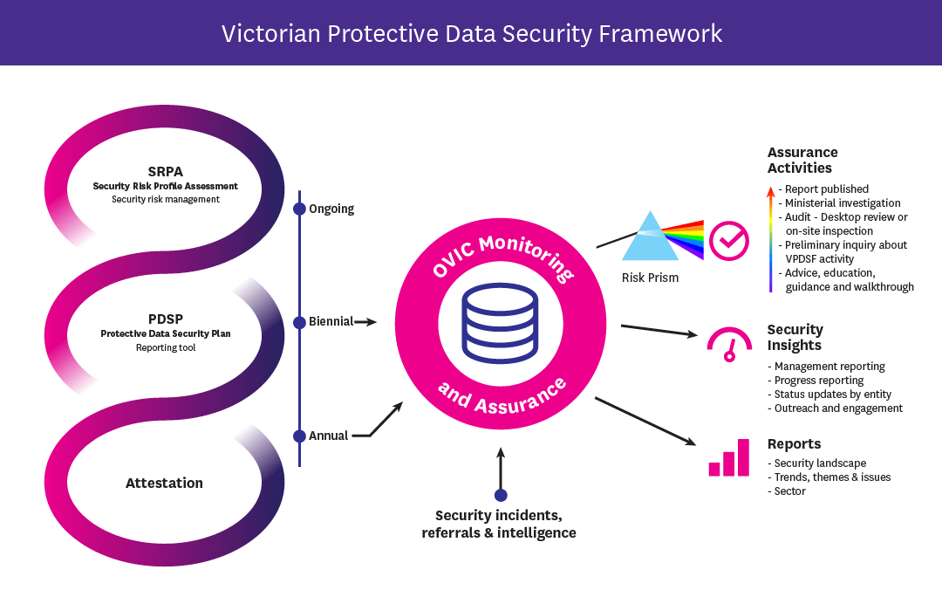
Figure 1 - Depiction of the monitoring and assurance activities of the Framework

Applicability of the Framework

Information covered by the Framework
The Framework captures ‘public sector data’ and ‘public sector data system’ that are broadly defined in section 3 of the PDP Act as:
public sector data - any information (including personal information) obtained, received or held by an agency or body which Part 4 applies, whether or not the agency or body obtained, received or holds that information in connection with the functions of that agency or body.
public sector data system includes—
(a) information technology for storage of public sector data, including hardware and software; and
(b) non-electronic means for storage of public sector data; and
(c) procedures for dealing with public sector data, including by use of information technology and non-electronic means;
The definition of public sector data includes information collected or held by contracted service providers of the VPS organisation such as contractors and consultants.
In this document, ‘public sector data’ is also referred to as ‘public sector information’ or ‘information’.

VPS Organisations covered by the Framework (Part 4 of the PDP Act)
The Framework regulates applicable Victorian public sector agencies and bodies identified in section 84 of the PDP Act. This includes departments, public entities, Victoria Police, and the Crime Statistics Agency. The Framework generally excludes councils, universities, ambulance services, public hospitals, public health services and multipurpose services under the Health Services Act 1988 (Vic). While Section 84 (2) provides exemptions from Part 4 of the PDP Act, these exemptions need to be applied with care. If exempt entities perform a public function on behalf of a regulated VPS organisation, they may have obligations under the Part 4 of the PDP Act.
For more information on whether the Framework and Standards apply to your VPS organisation, refer to the Information Security Resources section of the OVIC website.
Extract of Part 4, section 84, PDP Act
(1) | Subject to subsection (2), this Part applies to –  - a public sector agency; and  - a body that is a special body, within the meaning of section 6 of the Public Administration Act 2004; and  - a body declared under subsection (3) to be a body to which this Part applies.
(2) | This Part does not apply to the following –  - a Council;  - a university within the meaning of the Education and Training Reform Act 2006;  - a body to which, or to the governing body of which, the government of another jurisdiction, or a person appointed, or body established under the law of another jurisdiction, has the right to appoint a member, irrespective of how that right arises;  - a public hospital within the meaning of the Health Services Act 1988;  - a public health service within the meaning of the Health Services Act 1988;  - a multi-purpose service within the meaning of the Health Services Act 1988;  - an ambulance service, within the meaning of the Ambulance Services Act 1986.
(3) | The Governor in Council, by Order published in the Government Gazette, may declare a body to be a body to which this Part applies.

Victoria Police and Crime Statistics Agency (Part 5 of the PDP Act)
Part 5 of the PDP Act describes the information security responsibilities of Victoria Police and the Crime Statistics Agency.
In 2017, OVIC wrote to Victoria Police and the Crime Statistics Agency informing them they are covered by the Framework and the Standards, in line with other VPS organisations to which Part 4 of the PDP Act applies. The purpose of this was to avoid duplication of the Standards for both Part 4 and Part 5.

Contracted Service Providers/Third Parties
Part 4 of the PDP Act applies to all staﬀ, contractors and consultants of VPS organisations identified in Section 84(1) of the PDP Act.
Section 88(2) of the PDP Act extends the information security obligations of VPS organisations to contracted service providers (CSPs), which states:
A public sector body Head for an agency or a body to which this Part applies must ensure that a contracted service provider of the agency or body does not do an act or engage in a practice that contravenes a protective data security standard, in respect of public sector data collected, held, used, managed, disclosed or transferred by the contracted service provider for the agency or body.
VPS organisations must include assessments of CSPs in their Security Risk Profile Assessment (SRPA) process.

The Framework in context
The Framework has been developed to monitor and assure the security of public sector information and information systems.
To do this, OVIC monitors and measures VPS organisations’:
- implementation of the Standards; and
- compliance with the PDP Act.
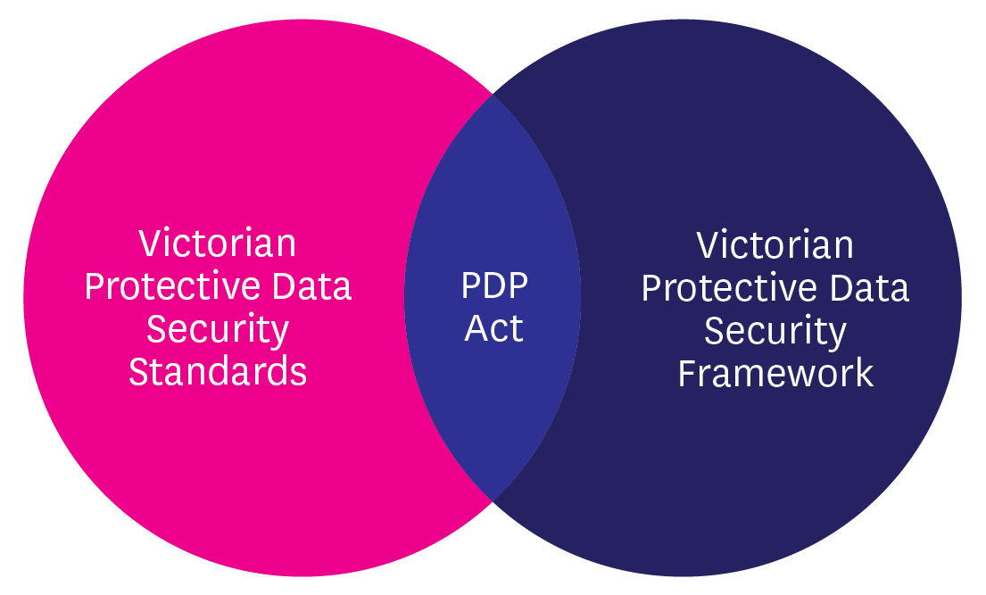
Figure 2 - Visual representation of the interlinked nature of the PDP Act, Standards and Framework
The monitoring and assurance activities outlined in this Framework are complemented by the regulatory actions outlined in OVIC’s Regulatory Action Policy, available on the OVIC website.

How the Framework interacts with other legal obligations
VPS organisations have a variety of legal, regulatory, and administrative obligations governing the access, use, security, and preservation of their information. As such, VPS organisations should read the Framework and accompanying Standards in conjunction with existing requirements and consider how these may intersect with obligations under Part 4 of the PDP Act.
Where relevant legislation mandates lower requirements than those of the Framework or the Standards, VPS organisations are encouraged to meet the highest applicable standard.
Where VPS organisations handle information of “national interest” or information generated by, or on behalf of, a Commonwealth Government agency or body, the Commonwealth Protective Security Policy Framework (PSPF) requirements remain mandatory.
To access a current copy of the Standards and guidance material, refer to the Information Security Resources section of the OVIC website.

Roles, responsibilities, and relationships
The Victorian Public Sector is made up of a diverse range of organisations, each delivering specific services or functions. Due to the distinct nature of these services and functions, different VPS organisations face different threats to their information assets and information systems. The Framework recognises that these threats cannot be eliminated and that VPS organisations have operational responsibilities and finite resources, but encourages VPS organisations to mitigate information security risks as much as possible by using risk management principles and guidelines.
Given this complex operational landscape, coupled with the varied nature of the threats facing VPS organisations, it is essential that all parties work together to foster a strong information security culture based on robust information security work practices. By building these relationships, we can establish governance arrangements that support the protection of public sector information and information systems.
In support of these efforts and to illustrate these connections, the following section describes the roles and responsibilities of:
- OVIC;
- VPS organisations; and
- partnering entities.

Office of the Victorian Information Commissioner
The PDP Act details the functions and powers of OVIC as they relate to the monitoring and assurance activities for the security of public sector information and information systems. These functions and powers include:
- developing a protective data security framework for monitoring and assuring the security of public sector information and information systems;
- promoting responsible information security practices in the public sector;
- conducting monitoring and assurance activities, including audits, to ascertain compliance with information security standards;
- formal reporting and recommendations regarding information security;
- referring findings of monitoring and assurance activities, including audits, to an appropriate person or body for further action;
- undertaking research relevant to information security in the VPS; and
- retaining copies of protective data security plans.
These functions and powers enable OVIC to provide reasonable assurance to Government that VPS organisations’ information security risks are being managed eﬀectively, whilst still providing them the autonomy to determine how to achieve their business objectives in an eﬃcient, effective and economic manner.

VPS organisations
When implementing the Standards and performing assurance activities in accordance with the Framework, VPS organisations should remain mindful of the broader context in which they operate, and how these requirements intersect with their obligations under Part 4 of the PDP Act.
All VPS organisations identified in section 84 of the PDP Act must monitor their information security practices and provide assurance around the measures they take to protect public sector information and information systems.
Under the PDP Act, VPS organisations are specifically required to:
- adhere to the Standards;
- undertake a SRPA;
- develop, implement, and maintain a PDSP;
- provide OVIC free and full access to public sector information and information systems, when requested, including participating in any monitoring and assurance activities conducted by OVIC; and
- ensure that a CSP of a VPS organisation, does not do an act or engage in a practice that contravenes the Standards, regarding public sector information collected, held, used, managed, disclosed, or transferred by the provider for the VPS organisation.
Further, the Standards require VPS organisations to:
- provide an annual attestation to OVIC; and
- notify OVIC of information security incidents.

Partnering entities that also have a role in information security
OVIC’s information security efforts are supported by a range of partnering entities. A brief outline of these entities is depicted below.
For more information on the relationship between these entities and the Framework and the Standards, refer to the Information Sheet Partnering Entities in the Information Security Resources section of the OVIC website.
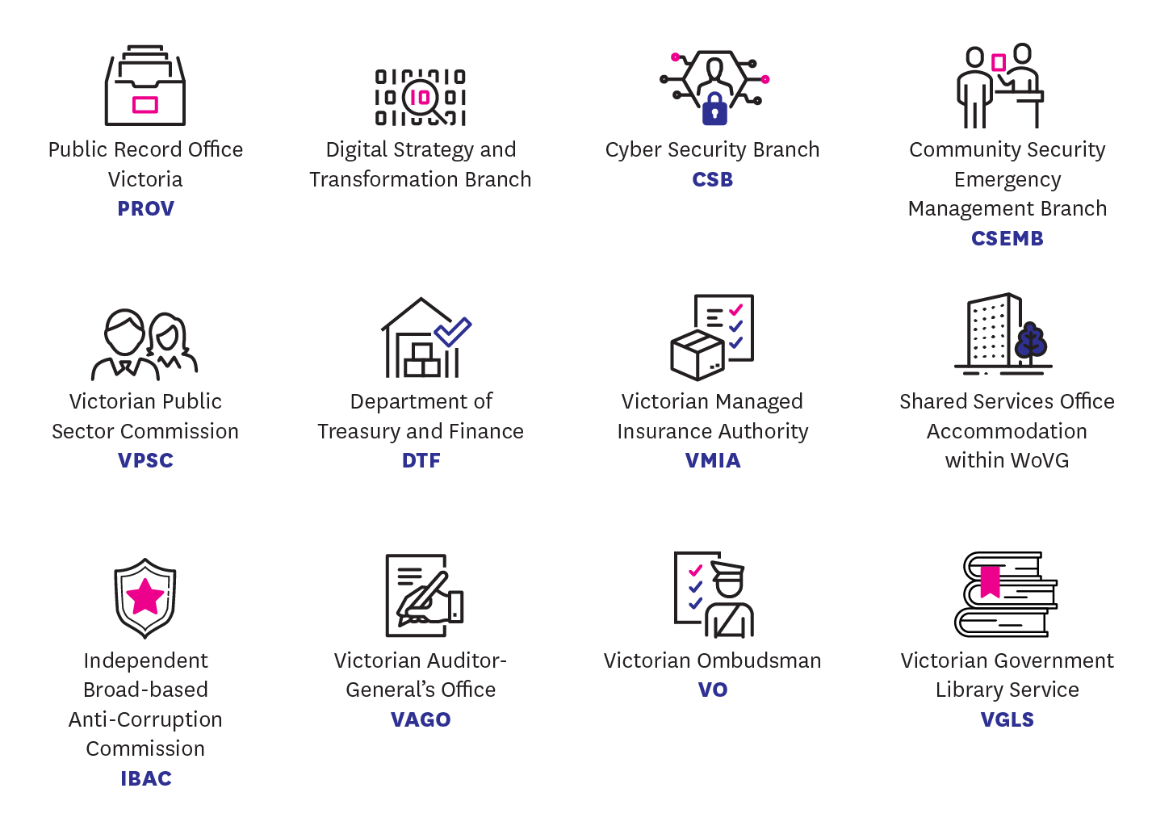
Figure 3 - Partnering entities

Part Two: Monitoring and assurance by VPS organisations

VPS organisations’ obligations
VPS organisations are required to conduct their own monitoring and assurance activities in accordance with the:
- PDP Act;
- Standards; and
- Framework.
These monitoring and assurance activities track a VPS organisation’s exposure to information security risks and articulate how they plan to assess and treat risks.

Accountability of the public sector body Head
Public sector body Heads are accountable for the monitoring and assurance activities of their VPS organisation.
The public sector body Head is also required to seek their own form of assurance from any CSP/ third party with access to the VPS organisation’s public sector information and information systems.
When developing a monitoring and assurance program, the public sector body Head (or delegate) should seek input from internal subject matter experts and relevant external stakeholders. These stakeholders could include:
- originators of information assets, information owners, stewards, custodians, users or administrators;
- local work unit managers;
- procurement teams / managers;
- risk managers; internal / external auditors;
- information security practitioners; information security leads;
- contracted service providers; and
- partnering organisations.

Obligations of VPS organisations
Section 88 and section 89 of the PDP Act outline the compliance obligations of VPS organisations with respect to the Standards, and require VPS organisations to:
- undertake a SRPA and
- develop a PDSP and submit a copy to OVIC.
OVIC also requires VPS organisations to assist OVIC in performing any monitoring and assurance activities. This includes assisting OVIC by providing free and full access, at all reasonable times, to public sector information or information systems.

What is a Security Risk Profile Assessment (SRPA)?
A SRPA is a four-stage process that enables VPS organisations to identify, analyse, evaluate, and treat information security risks.
A VPS organisation should undertake a SRPA regularly (at least annually). PDP Act 2014, section 89 (2) notes that the SRPA process must include assessments of third parties that collects, holds, uses, manages, discloses or transfers public sector information and information systems for the VPS organisation, for example, contracted service providers.
The outcomes of a SRPA should be documented in a VPS organisation’s risk register.
The SPRA process facilitates efficient, effective, and economic investment decisions to meet both business objectives and in the selection and implementation of controls.
For more information about how to undertake the SRPA process, refer to Practitioner Guide: Information Security Risk Management available under the Information Security Resources section of the OVIC website.

What is a Protective Data Security Plan (PDSP)?
A PDSP is a reporting tool, used by VPS organisations to:
- advise OVIC of their maturity level (where required), and implementation status of the Standards, referencing information security risks as identified as part of the SRPA process;
- articulate the VPS organisation’s security profile (where required); and
- attest to the implementation activities as required by the Standards.
This formally endorsed document is OVIC’s primary information source, to assess the state of information security across the VPS. Consequently, it is essential for VPS organisations to accurately self-report in their PDSPs.
To download a current copy of the most appropriate PDSP template, refer to the Agency reporting obligations page on the OVIC website.

Timeframes and deliverables in practice
VPS organisations operate under a reporting cycle that provides them time to complete the necessary deliverables in accordance with the PDP Act and the Standards. The following table sets out the reporting cycle with associated timeframes and deliverables.
Deliverable | Timeframe
Undertake (and/or) update a SRPA for the organisation. | Annual  (at least)
Provide OVIC with an Attestation by the public sector body Head. | Annual
Submit a PDSP (including an Attestation) by the public sector body Head. | Biennial  (every 2 years)
Submit an updated PDSP to OVIC within an agreed timeframe, if there is significant change to the:  - operating environment of the VPS organisation; or  - security risks relevant to the VPS organisation. | In consultation with OVIC
Notify OVIC of incidents that have an adverse impact on the confidentiality, integrity, or availability of public sector information with a business impact level (BIL) of 2 (limited) or higher. | As soon as practical and no later than 30 days once an incident has been identified

Developing an organisational monitoring and assurance program
Information security monitoring and assurance programs will differ depending on the VPS organisation. There are a variety of factors that can influence the scope and subsequent delivery of these activities, including the size, nature, and complexity of the VPS organisation.

Scoping an organisational monitoring and assurance program
In order for a VPS organisation to develop a robust monitoring and assurance plan, they should assess:
- the security value of their information assets;
- the risks posed to these information assets; and
- the effectiveness of the security controls that are in place.
VPS organisations should remain mindful of the ongoing need to continually monitor:
- their information security programs;
- their adherence to the Standards;
- CSPs’ adherence to the Standards;
- obligations under the Framework; and
- compliance with the PDP Act.
In support of these requirements, OVIC recommends VPS organisations reference the Five Step Action Plan.
Five Step Action Plan
01 | 02 | 03 | 04 | 05
Identify your information assets | Determine the ‘value’ of this information | Identify any risks to this information | Apply security measures to protect the information | Manage risks across the information cycle
For more information on the Five Step Action Plan, refer to the Information Security resources section of the OVIC website.

Contracted service provider/third party assurance
VPS organisations should seek advice and input from partnering entities and relevant stakeholders (including CSPs and other government organisations) who have direct, or in-direct access to the VPS organisation’s information assets. These parties can introduce new risks when handling public sector information which need to be identified and captured as part of the VPS organisation’s SRPA, and subsequently managed via the VPS organisation’s PDSP.
VPS organisations may consider taking a risk-prioritised approach when scoping third-party assurance activities. Prior to entering any third-party arrangement, it is expected that the VPS organisation undertakes an information security risk assessment of the third party's service offering and addresses any residual risks prior to finalising the arrangement.
When undertaking this assessment, VPS organisations should consider:
- the type, nature, and priority of the third-party arrangement;
- the security value of the information accessed or used under that arrangement; and
- the level of access and ongoing oversight of the CSP or third-party throughout the arrangement.
Once an arrangement is in place, VPS organisations may seek ongoing assurance via scalable activities such as:
- obtaining a ‘letter of comfort’/annual confirmation letter/self-assessment;
- conducting a desktop audit of processes and practices;
- conducting an onsite audit; and/or
- undertaking an investigation.

Undertaking organisational monitoring and assurance activities
VPS organisations are expected to perform the following monitoring and assurance activities to help demonstrate their adherence to the Standards and Framework, as well as their compliance with the requirements in the PDP Act. These activities include:
- assessing the security value of their information assets;
- undertaking a SRPA (at least annually);
- reviewing, validating and updating internal control libraries (including validating the appropriateness of security controls);
- developing a PDSP that:
  - assesses the information security capability of the VPS organisation;
  - summarises their progress towards implementation of the Standards; and
  - provides a level of assurance to OVIC that they are making progress towards improving information security;
- reviewing their PDSP at least every two years (or sooner if there is significant organisational change);
- monitoring for information security incidents and notifying OVIC if required under the Information Security Incident Notification Scheme; and
- providing assurance through Attestation to OVIC (annually).

Part Three: OVIC monitoring and assurance

OVIC’s regulatory approach
OVIC employs an outcome-focused regulatory model. It concentrates on high-level assurance principles, supported by risk-informed monitoring activities. This model is aimed at delivering efficient, effective, and economic security outcomes, is scalable in its implementation, and is backed by firm enforcement action where required.
In support of this regulatory approach, OVIC educates and supports VPS organisations, promoting understanding of the PDP Act and adherence to the Standards. Given this, the monitoring and assurance activities outlined in the Framework are typically based on a coordinated approach between OVIC and VPS organisations.
OVIC has a legislative function to monitor organisational compliance with the PDP Act and adherence to the Standards. OVIC is also required to provide the Victorian Government with a level of assurance around the state of information security across the VPS.
The monitoring and assurance activities outlined in the Framework are based on a scalable approach including consultation, engagements, site walk-throughs and reviews, and more formal audits or investigations if warranted. These activities aim to drive improvements in information security practices, using a continuous improvement model.
OVIC’s Regulatory Action Policy articulates the conditions under which OVIC led monitoring and assurance activities may be triggered. For a full outline of OVIC’s regulatory assurance functions, powers and associated triggers, refer to the Regulatory Action Policy available on the OVIC website.

Overview of OVIC’s monitoring and assurance activities
As an information security regulator, OVIC has a duty to oversee and support VPS organisations’ adherence to the Standards and Framework, as well as compliance with the PDP Act.
To fulfil its regulatory functions OVIC performs a variety of monitoring and assurance activities, designed to:
- foster confidence in the information security practices of Victorian Government;
- uplift VPS organisations’ information security capability and maturity;
- promote accountability, integrity and continuous improvement within the VPS regarding information security;
- empower risk-based decisions within the VPS regarding information security practices;
- measure eﬀective, eﬃcient, and economic implementation of information security practices within the VPS;
- support VPS organisations’ compliance with requirements of Part 4 of the PDP Act and adherence to the Standards;
- verify and validate VPS organisations’ information security practices;
- investigate breaches of the Standards or PDP Act; and
- regulate the information security environment across the Victorian public sector.
By conducting these monitoring and assurance activities, OVIC can identify trends and themes in information security, issue advice or recommendations to VPS organisations, and report to government on the state of information security across the VPS.

Outline of OVIC’s monitoring activities
OVIC’s monitoring and assurance activities include:
- clarifying requirements of the PDP Act;
- assisting with enquiries regarding the intent of the Framework and the Standards;
- overseeing VPS organisations’ application of the Standards, adherence to the requirements of the Framework and compliance with Part 4 PDP Act obligations;
- maintaining oversight of information security incident notifications;
- hosting awareness sessions in support of the Framework and the Standards;
- facilitating an outreach program through its business engagement officers;
- conducting site walk-throughs, preliminary enquiries or reviews of a VPS organisation’s information security practices;
- staying abreast of information security trends and themes;
- identifying emerging issues and proactively consulting with VPS organisations on these matters; and
- ensuring the Standards are as consistent as possible with standards relating to information security (including international standards).
In addition to this, OVIC regularly reviews its own information security product suite (the Framework, the Standards and supporting material) to validate the content and its currency. These reviews occur:
- on an annual basis;
- as the threat environment changes;
- if there are legislative or administrative changes to intersecting products that highlight the need for a review of the Framework or the Standards; and/or
- as required.

Risk-prioritised monitoring and assurance activities
OVIC takes a risk-prioritised approach in scoping its assurance activities, considering:
- the security value of the VPS organisation’s information;
- the VPS organisation’s security risk profile;
- the VPS organisation’s controls’ environment;
- notifications of any information security incidents relating to the VPS organisation; and
- the harm or damage that the PDP Act aims to reduce.
OVIC subsequently applies assurance resources to areas where:
- the risk is deemed the greatest; or
- the harm or damage would have the greatest impact.
Each of these factors help OVIC make informed decisions regarding the type, nature, scale, priority and timing of relevant monitoring and assurance activities. These monitoring and assurance activities include:
- consulting with VPS organisations;
- outreach activities via business engagement officers;
- researching projects and initiatives;
- monitoring developments in national and international standards;
- monitoring the current information security threat environment;
- analysing information security incident notifications;
- reviewing VPS organisation’s PDSP reporting;
- identifying failures by VPS organisations to report; and
- actioning referrals from other regulators or administrative bodies.
Outcomes of these monitoring activities inform subsequent assurance activities, such as:
- conducting site walkthroughs;
- conducting an audit;
- undertaking an investigation;
- referring a matter, or findings, to a partnering regulatory or administrative body;
- reporting to government on VPS organisational compliance with the PDP Act, or adherence to the Standards and/or Framework;
- influencing changes to local, national and international standards;
- reporting to a Minister on an information security matter; or
- publishing a public report on an information security matter.
VPS organisations are expected to cooperate during any monitoring and assurance activity led by OVIC.

Referral of findings or matters
Information obtained by OVIC can be referred to responsible parties (e.g., Victoria Police, Independent Broad-based Anti-Corruption Commission, Cyber Security Branch, Victorian Ombudsman) for urgent investigation or attention.

www.ovic.vic.gov.au

Privacy and Data Protection Act 2014, Part 4
For a current copy of the Standards or VPDSS Implementation Guidance refer to the Information Security resources section of the OVIC website.
Privacy and Data Protection Act 2014, sections 88 and 89
Privacy and Data Protection Act 2014, part 6
Privacy and Data Protection Act 2014, section 8D
Privacy and Data Protection Act 2014, sections 88 and 89.
Privacy and Data Protection Act 2014, section 8D Protective data security and law enforcement data security functions Act.
Defined in section 5 of the Public Administration Act 2004 (Vic).
See section 9.1 of this document for more information and refer to the Practitioner Guide: Information Security Risk Management available under the Information Security resources section of the OVIC website
Privacy and Data Protection Act 2014, section 85(1)
Refer to the Memorandum of Understanding for the Protection of National Security Information between the Commonwealth of Australia and the States and Territories.
Privacy and Data Protection Act 2014, section 84
Privacy and Data Protection Act 2014, section 8D
Privacy and Data Protection Act 2014, part 6
Privacy and Data Protection Act 2014, sections 106 and 107
Refer to the Information Security Resources section of the OVIC website for more information on the Information Security Incident Notification Scheme
Privacy and Data Protection Act 2014, section 88
As outlined in Standard 9 – Information Security Reporting
Privacy and Data Protection Act 2014, section 88 (2) - This includes where a third party collects, holds, uses, manages, discloses, or transfers public sector information on behalf of the VPS organisation
Privacy and Data Protection Act 2014, sections 106, 107, 108, 109, and 110
Privacy and Data Protection Act 2014, section 89(2)
For example, the PDSP template contains a section for an ‘Organisation Profile Assessment.
Refer to the Information Security Resources section of the OVIC website for more information on the Information Security Incident Notification Scheme.
For more information on this activity, refer to Practitioner Guide: Assessing the Security Value of Public Sector Information available under the Information Security resources section of the OVIC website
Privacy and Data Protection Act 2014, section 89(2)
For more information on this activity, refer to Practitioner Guide: Assessing the Security Value of Public Sector Information available under the Information Security resources section of the OVIC website.
An internal control library is a collection of documented security measures as selected by the VPS organisation to manage their risks. This internal control library is based on the VPDSS Elements and the organisation’s unique operating requirements.
Refer to the Information Security Resources section of the OVIC website for more information on the Information Security Incident Notification Scheme
Refer to Info Sheet: Guiding Principles of the Framework and Standards available under the Information Security resources section of the OVIC website
Privacy and Data Protection Act 2014, section 85 (2)

