Investigation into allegations of surveillance of members of the public by VicForests
  - Under s8C(2)(e) of the Privacy and Data Protection Act 2014

Copyright
You are free to re-use this work under a Creative Commons Attribution 4.0 licence, provided you credit the State of Victoria (Office of the Victorian Information Commissioner) as author, indicate if changes were made and comply with the other licence terms. The licence does not apply to any branding, including Government logos. Copyright queries may be directed to communications@ovic.vic.gov.au
Table of Contents
Foreword 4
Executive Summary 5
Part 1 - Introduction 12
Background 12
Surveillance and its impacts on privacy 12
VicForests’ functions and activities 13
Conduct of investigation 13
Part 2 – Evidence collected in the investigation 16
Context – VicForests’ engagement of the private investigator to carry out surveillance activities unrelated to surveillance of members of the public 16
Was the private investigator engaged in surveillance of members of the public on behalf of VicForests? 21
Part 3 -Findings of fact 28
Information Commissioner’s assessment of evidence 28
Did VicForests contravene the IPPs? 32
IPPs 1.1 and 1.2 32
Whether to issue a compliance notice 33
Were the contraventions of the IPPs serious, flagrant or repeated? 33
Whether any specified action is required to ensure compliance with the IPPs 34
Decision not to issue a compliance notice 39
Recommendations 40

Foreword
This investigation considered an allegation that, around 2010 - 2011, VicForests hired a private investigator to conduct covert surveillance – or “collect dirt” – on members of the public.
In this case, members of the public included environmentalists and a Professor of Ecology, who were each conducting legitimate opposition to actions of VicForests at the time.
The investigation found that VicForests directed the private investigator to conduct surveillance on three members of the public, resulting in the collection of personal information of one of the environmentalists.
The investigation concluded that this collection of personal information through covert surveillance involved serious and flagrant contraventions of Information Privacy Principles (IPP) 1.1 and 1.2. Collecting this information for the purposes of seeking to discredit the environmentalist was not necessary for any legitimate functions of VicForests. It was also unreasonably intrusive.
The contraventions resulted from deliberate conduct on behalf of VicForests, which appears to have been intended to cause harm. It involved conduct that was carried out in a secretive and intrusive manner, involving incursion into the environmentalist’s daily life that had no relation to any engagement or interaction with VicForests.
Conduct of this nature can clearly have a negative impact – both on individual privacy, as well as public trust in public sector organisations. The potential chilling effect on the public’s willingness to engage in the democratic process is self-evident from the findings of this investigation. Members of the public should feel safe to use legitimate means to seek to influence the policies or actions of government or public sector organisations.
This investigation provides vital lessons for other agencies on the importance of good governance with respect to high-risk privacy activities.
Carrying out covert surveillance is an inherently intrusive activity and involves a significant curtailing of an individual’s right to privacy. As such, it is important that there is robust governance of surveillance activities to ensure that any surveillance is necessary and proportionate to legitimate purposes being pursued.
This means that organisations must ensure that the collection of information by surveillance is connected to a legitimate aim that directly corresponds to the organisation’s functions or activities. It must also be demonstrably necessary to achieve a legitimate and lawful aim. Proportionality of the surveillance must also be assessed to ensure it is carried out in the least privacy intrusive manner as reasonably possible.
Finally, if an organisation chooses to use surveillance to collect personal information, it must ensure it does so in compliance with the IPPs.
VicForests does not accept the findings of the investigation. However, it is pleasing to see that it has taken steps to improve its governance processes and practices with respect to surveillance to ensure compliance with the IPPs. For this reason, I did not issue a compliance notice.

Sven Bluemmel
Victorian Information Commissioner
9 August 2023

Executive Summary
VicForests is a state-owned business managing the harvest, sale, and regrowing of sustainable timber from Victorian state forests on behalf of the Victorian Government. As part of its functions, VicForests is responsible for managing coupes, harvesting timber and hauling timber to VicForests’ customers.
In November 2021, OVIC became aware of allegations that VicForests had conducted physical surveillance of an environmentalist, with whom it was in dispute, for the purpose of discrediting her. Following preliminary inquiries, OVIC became aware of allegations that VicForests also conducted physical surveillance of other environmentalists and a university professor. The alleged surveillance was said to have occurred in or around 2010.

The Investigation
Due to the serious nature of the allegations and in line with its Regulatory Action Policy, OVIC commenced preliminary inquiries with VicForests. As a result of the preliminary inquiries, the Information Commissioner decided to commence an investigation in accordance with his function set out in section 8C(2)(e) of the Privacy and Data Protection Act 2014 (Vic) (PDP Act).
The investigation commenced on 5 May 2022 and sought to establish whether VicForests contravened the Information Privacy Principles (IPPs) by engaging a private investigator (the private investigator) to conduct surveillance of members of the public, and whether any contravention was serious or repeated. The purpose of the investigation was to determine whether to issue a compliance notice in accordance with section 78 of the PDP Act.
The issues for investigation were:
- Did VicForests contravene IPP 1.1 by collecting personal information that was not necessary for one or more of its functions or activities by employing a private investigator to conduct covert surveillance on members of the public?
- Did VicForests contravene IPP 1.2 by collecting personal information in an unlawful, unfair or unreasonably intrusive way by employing a private investigator to conduct covert surveillance on members of the public?
- If either of the above points was true or if both of the above points were true, had VicForests taken steps to redress any harm, improve practices and/or prevent any recurrence of contraventions of the IPPs?
While the focus of the investigation was on the allegation of physical covert surveillance of members of the public which was not for the purpose of any of VicForests’ legitimate functions, OVIC also considered whether VicForests’ approach to conducting physical surveillance generally is consistent with the PDP Act.
Due to the historical nature of the alleged conduct and the nature of the circumstances in which the surveillance is alleged to have taken place, there was minimal documentary evidence to rely upon in the investigation.
As such, OVIC largely relied upon oral evidence to assist in determining whether the surveillance of members of the public occurred and the circumstances in which it occurred. The former VicForests General Manager, who allegedly engaged the private investigator on behalf of VicForests, refused to provide a response to or engage in an interview with OVIC.
Given the lack of documentary evidence and the fact that the former VicForests General Manager decided not to provide a response, OVIC placed considerable weight on the evidence given by the private investigator and the former partner and colleague of the private investigator – noting that they provided direct evidence relating to the relevant circumstances.
From the outset of the investigation, it has been VicForests’ position that it does not conduct physical surveillance of members of the public and that it has never been the position of VicForests as an organisation to engage a private investigator to undertake covert physical surveillance of members of the public.
Following the evidence-gathering phase of the investigation, the Information Commissioner provided VicForests with his Preliminary Assessment outlining his proposed findings together with the material upon which he proposed to make those findings.
Among other things, VicForests contended in its response to the Preliminary Assessment that, on the evidence before the Information Commissioner, he could not be satisfied on the balance of probabilities that VicForests directed a private investigator to conduct surveillance on members of the public or that any such surveillance occurred.

Findings
The Information Commissioner’s power to serve a compliance notice on an organisation first requires him to be satisfied that the organisation has done an act or engaged in a practice in contravention of the IPPs. This requires the Information Commissioner to make findings of fact. In an investigation such as this, those findings of fact are to be made on the balance of probabilities.
In this investigation, it was necessary to first determine on the balance of probabilities:
- whether the alleged surveillance of members of the public occurred;
- whether VicForests was responsible for the alleged surveillance; and
- whether any surveillance involved the collection of personal information by VicForests.
If satisfied, on the balance of probabilities, that VicForests engaged in surveillance of members of the public that collected personal information, it was necessary for the Information Commissioner to decide:
- whether the collection of the personal information contravened IPP 1.1 or IPP 1.2;
- whether any contravention of the IPPs was serious or flagrant; and
- whether it is appropriate in the circumstances to serve a compliance notice on VicForests requiring it to take specified action to ensure compliance with the IPPs.
Contextual background
In assessing whether the alleged covert surveillance of members of the public occurred, it was important to analyse the context in which this was alleged to have taken place. The Information Commissioner therefore considered any other surveillance activities that were carried out at VicForests’ direction during the relevant time.
The Information Commissioner found that the private investigator had been engaged on a verbal basis by VicForests to conduct the following activities on behalf of VicForests, prior to the alleged surveillance of members of the public:
- surveillance of VicForests employees working on coupes;
- surveillance of truck drivers with respect to OH&S concerns; and
- surveillance of protestors on coupes.
Notably, there was documentary evidence in respect of some of these activities. In 2013, the private investigator had initiated legal proceedings against VicForests, claiming damages for injuries he sustained while conducting surveillance of protestors on coupes in August 2011.
Related court documents confirmed that VicForests had admitted to engaging the private investigator to carry out such activities on its behalf. The court documents did not relate to the alleged surveillance of specific members of the public.
Former General Manager’s direction to the private investigator to surveil members of the public
Based on the evidence detailed in this report, the Information Commissioner was satisfied that the former VicForests General Manager – Operations (former General Manager) held a meeting with the private investigator and directed him to surveil two environmentalists and a university professor on behalf of VicForests.
Surveillance of the environmentalist
The Information Commissioner found that the private investigator conducted surveillance on the environmentalist; collected her personal information in the course of doing so; and provided this information to VicForests. The personal information collected and provided to VicForests consisted of photos and video footage of the environmentalist taken during her daily activities.
Surveillance of the professor
The Information Commissioner found that the private investigator was directed to surveil the professor and then travelled interstate for the purpose of attempting this surveillance.
However, the Information Commissioner was unable to conclude whether, in the course of attempting this surveillance, the private investigator collected the professor’s personal information.
Surveillance on the second environmentalist
OVIC found that the private investigator was requested to surveil the second environmentalist; that the private investigator travelled to Healesville; and that he attended a location near the second environmentalist’s home.
However, the Information Commissioner was not satisfied that there was any collection of the second environmentalist’s personal information. This was based on the private investigator’s evidence that he did not sight the second environmentalist during the attempted surveillance.
Surveillance on a third environmentalist
With respect to alleged surveillance of a third environmentalist by the private investigator, the Information Commissioner was unable to gather sufficient evidence to determine if this surveillance occurred.

Contraventions of IPPs
Having found that VicForests collected the personal information of the first environmentalist using covert surveillance, the Information Commissioner considered whether this contravened the IPPs.
The Information Commissioner decided that VicForests contravened both IPP 1.1 and IPP 1.2 because the collection of the first environmentalist’s personal information:
- was not necessary for any of VicForests’ functions or activities given the nature of the surveillance (IPP 1.1); and
- was unlawful and unreasonably intrusive (IPP 1.2).
The Information Commissioner decided that the contraventions of IPP 1.1 and IPP 1.2 were both serious and flagrant.

Whether to issue a compliance notice
The decision on whether to issue a compliance notice involved determining whether VicForests should be required to take specified action to ensure compliance with the IPPs. This necessitated an analysis of how the contraventions took place at the time and whether VicForests has taken sufficient steps to prevent further such contraventions.
The Information Commissioner considered that the contraventions of IPP 1.1 and IPP 1.2 were enabled by a lack of governance of surveillance activities at VicForests at the time because:
- the former General Manager was able to initiate surveillance activities invasive to the privacy of members of the public without any assessment as to their compliance with the IPPs; and
- the decision to engage the private investigator and the ongoing management of the engagement was conducted solely by the former General Manager, with no oversight from the CEO or the Board of Directors at the time.
The Information Commissioner considered VicForests’ current governance arrangements for conducting surveillance activities.
VicForests informed the Commissioner that it does not conduct any physical surveillance and that VicForests does not have specific policies or procedures governing surveillance.
However, given the surveillance activities conducted around 2010 – 2011 were carried out under the former General Manager – Operations and that some of these activities related to its monitoring and assurance activities, the Information Commissioner considered the current monitoring and assurance activities with a view to assessing whether they do or could involve surveillance.
Evidence from the current General Manager – Operations at VicForests and a review of relevant policies and procedures for the conducting of monitoring and assurance activities indicate that many of these activities involved ‘investigations’, which could plausibly include some form of surveillance activity. This was particularly the case given evidence that VicForests continues to experience issues with protest activity, including one such instance that involved the use of surveillance activity around 2010 –2011.
As such, the Information Commissioner considered that VicForests does not have sufficient governance arrangements for conducting surveillance activities in that it does not have an established process for:
- assessing how a proposed surveillance activity relates to it functions or activities;
- assessing necessity or proportionality of the proposed surveillance activity;
- assessing whether the proposed surveillance activity complies with VicForests’ obligations, including compliance with the IPPs;
- approving the surveillance activity; or
- ensuring ongoing oversight and monitoring of the surveillance activity.
The Information Commissioner therefore found that there remained a lack of adequate protections to prevent recurrence of the contraventions of the IPPs.

Decision not to issue a compliance notice
Having been provided with the Commissioner’s Preliminary Assessment, including his preliminary findings on whether VicForests had adequately addressed governance issues regarding surveillance activities, VicForests informed OVIC that it had completed a draft “Surveillance and Security Policy”. OVIC was provided with a copy of the policy. The policy detailed:
- that surveillance should be used as a last resort as a method for managing security and/or safety risks.
- that the expected benefits of performing surveillance must outweigh any potential intrusion to the rights of privacy.
- the decision to undertake surveillance should be based on considered application of VicForests Risk Management framework; and
- that personal information obtained through surveillance will be used and stored in accordance with the PDP Act and the IPPs
The policy also outlined in detail the procedure for undertaking security or surveillance activities which included the steps needed to be taken prior to undertaking such activities.
On 24 July 2024 VicForests informed the Information Commissioner that the policy had been approved by VicForests’ Executive Management Team and it was in the process of publishing and implementing such policy.
It is for these reasons that the Information Commissioner determined not to issue a compliance notice but instead make recommendations to VicForests on the implementation of its Surveillance and Security Policy. OVIC intends to monitor the compliance of its recommendations to VicForests.

Recommendations
The Information Commissioner made the following recommendations to VicForests:
Reccomendation 1
That by no later than 30 September 2023 VicForests publish its Security and Surveillance Policy on the VicForests intranet and provide evidence of same to OVIC.
Recommendation 2
That by no later than 30 September 2023 VicForests provide its Security and Surveillance Policy to the People, Safety and Culture subcommitee of the VicForests Board for noting and provide evidence of same to OVIC.
Recommendation 3
That by no later than 30 September 2023 VicForests present its Security and Surveillance Policy to the VicForests Operations Mangement Team and provide evidence of same to OVIC.
Recommendation 4
That VicForests notify all staff of its Security and Surveillance Policy and incorporate such policy in relevant ongoing staff training and by no later than 30 October 2023 VicForests is to provide evidence of same to OVIC.
Recommendation 5
That by no later than 29 February 2024 VicForests provide OVIC with evidence of instances (if any) of how and when the Security and Surveillance Policy and procedure has been used in practice.

Part 1 - Introduction

Background
On Thursday 25 November 2021, ABC’s 730 program aired allegations that VicForests had conducted physical surveillance of an environmentalist (the environmentalist) with whom it had had a range of disputes, for the purpose of discrediting her.
The environmentalist contacted OVIC and raised concerns about the alleged covert surveillance that had been conducted on her by VicForests. She informed OVIC that VicForests had hired a private investigator (the private investigator) who had surveilled her for over four days.
The environmentalist had been involved in forest conservation from the early 2000s. She informed OVIC that VicForests became interested in her forest conservation activities in or around 2010, which was around the time the environmentalist had been involved in legal proceedings to oppose actions of VicForests. This was also around the time the covert surveillance allegedly took place.
The private investigator stated to the media that he had taken photographs and videos of the environmentalist while conducting covert surveillance on behalf of VicForests.

Surveillance and its impacts on privacy
Surveillance is the monitoring and analysis of data to collect information about persons, groups, and contexts, often using technology. Surveillance technologies are tools used to conduct surveillance activities. These range from devices, such as cameras and microphones, to automated software processes that incorporate algorithmic analysis, artificial intelligence, and quantum computing.
Surveillance includes actions and practices of surveillance that are either intentional or incidental, and overt or covert.
Carrying out covert surveillance is an inherently intrusive activity and involves a significant curtailing of an individual’s right to privacy. When collecting personal information through surveillance, organisations must comply with the 10 Information Privacy Principles (IPPs) set out in Schedule 1 of the Privacy and Data Protection Act 2014 (Vic) (PDP Act) unless a relevant exemption applies.
The requirements of the IPPs mean that surveillance should only take place where it is necessary and proportionate to legitimate purposes being pursued. Organisations must ensure that they implement robust governance of surveillance activities to assess compliance with the IPPs before deciding to conduct surveillance and ensure compliance throughout the duration of any surveillance activity.

VicForests’ functions and activities
VicForests is “a state-owned business managing the harvest, sale, and regrowing of sustainable timber from Victorian state forests on behalf of the Victorian Government.” As part of its functions; VicForests is responsible for managing coupes, harvesting timber and hauling timber to VicForests’ customers.
VicForests was established on 28 October 2003 by Order in Council under the State Owned Enterprises Act 1992 (Vic).
Under the Order in Council, VicForests’ responsibilities are to:
- undertake the sale and supply of timber resources in Victorian State forests, and related management activities, as agreed by the Treasurer and the Minister on a commercial basis;
- develop and manage an open and competitive sales system for timber resources; and
- pursue other commercial activities as agreed by the Treasurer and the Minister of Agriculture.

Conduct of investigation

Reasons for undertaking the investigation
The Information Commissioner first became aware of the allegations of physical surveillance in November 2021, following the airing of the ABC’s 730 program.
Due to the serious nature of the allegations, OVIC commenced preliminary inquiries with VicForests in line with its Regulatory Action Policy.
On 30 November 2021, VicForests issued a public statement saying that the VicForests Board of Directors had commissioned an external investigation into the claims made by the ‘7.30’ report. VicForests said it had engaged RSM Australia (RSM) to investigate to “identify any evidence to confirm or refute historical allegations that VicForests engaged a private investigator in 2010 and 2011 to surveil [the environmentalist].”
On 22 April 2022, OVIC received a copy of the RSM Report (the RSM report). The investigation conducted by RSM was detailed. However, three key witnesses declined to speak to RSM in detail or at all. As such, the information provided by VicForests during the preliminary inquiries was insufficient for OVIC to assess whether the alleged surveillance had occurred.
Based on the seriousness of the alleged conduct and the limitations of the RSM Report, the Information Commissioner decided to commence an investigation in line with is function set out in section 8C(2)(e) of the PDP Act.
Under section 8C(2)(e) of the PDP Act, the Information Commissioner can undertake an investigation to decide whether to issue a compliance notice. Under section 78 of the PDP Act, the Information Commissioner may serve a compliance notice on an organisation if satisfied that serious, flagrant, or repeated breaches of the IPPs has occurred. A compliance notice requires an organisation to take specified action within a specified period for the purpose of ensuring compliance with the IPPs.
An investigation may also lead to the publication of a report under section 111 of the PDP Act. Section 111 permits the Information Commissioner to publish a report where the Commissioner considers it is in the public interest to do so. The Commissioner may report any act or practice the Commissioner considers to be an interference with privacy, or report about any matter generally relating to the Information Commissioner’s functions under the PDP Act.

Information Privacy Principles (IPPs) 1.1 and 1.2
Section 20 of the PDP Act sets out that an organisation must not do an act, or engage in a practice, that contravenes an IPP as set out in Schedule 1 of the PDP Act.
VicForests is an ‘organisation’ that is bound to comply with the IPPs as a ‘public entity’ within the meaning of the Public Administration Act 2004 (Vic).
The Information Commissioner considered whether VicForests collected personal information by engaging a private investigator to conduct surveillance of members of the public and whether any such collection contravened IPPs 1.1 and 1.2.
IPP 1.1 sets out that:
An organisation must not collect personal information unless the information is necessary for one or more of its functions or activities.
IPP 1.2 sets out that:
An organisation must collect personal information only by lawful and fair means and not in an unreasonably intrusive way.
Personal information is defined in section 3 of the PDP Act as:
information or an opinion (including information or an opinion forming part of a database), that is recorded in any form and whether true or not, about an individual whose identity is apparent, or can reasonably be ascertained, from the information or opinion.

Scope of the investigation
The investigation sought to establish whether VicForests contravened the IPPs by engaging a private investigator to conduct surveillance of members of the public, and if any contravention was serious, flagrant or repeated.
The issues for investigation were:
- Did VicForests contravene IPP 1.1 by collecting personal information that was not necessary for one or more of its functions or activities by employing a private investigator to conduct surveillance on members of the public?
- Did VicForests contravene IPP 1.2 by collecting personal information in an unlawful, unfair or unreasonably intrusive way by employing a private investigator to conduct surveillance on members of the public?
- If either of the above points was true or if both of the above points were true, had VicForests taken steps to redress any harm, improve practices and/or prevent any recurrence of contraventions of the IPPs?
While the focus of the investigation was on the allegation of surveillance of members of the public, OVIC also considered whether VicForests’ approach to conducting physical surveillance generally is consistent with the PDP Act.
Once OVIC had commenced its investigation it became aware of further allegations of covert surveillance conducted by the private investigator on members of the public other than the environmentalist. It appeared that those other members of the public were also engaging in legitimate opposition to the activities of VicForests at the time of the alleged surveillance. As such, OVIC extended the scope of the investigation to include those additional members of the public.

How the Investigation was conducted
The Information Commissioner commenced the investigation on 5 May 2022. The Information Commissioner considered a range of information obtained during the investigation to reach the views outlined in this report including:
- written submissions from VicForests
- court documents from County Court proceedings between the private investigator and VicForests
- evidence provided via written correspondence from a previous CEO of VicForests
- evidence provided via voluntary interview of the environmentalist.
- evidence provided via voluntary interview of the academic
- evidence provided via voluntary interview of the second environmentalist
- evidence provided via voluntary interview of Ms A
- evidence provided via interview under oath of the private investigator
- evidence provided via voluntary interviews of former VicForests Staff
- evidence provided via voluntary interview of the current General Manager – Operations at VicForests
- VicForests policy and procedure documents
- correspondence with the former VicForests General Manager – Operations
- the RSM Report.
Procedural fairness
At the conclusion of the evidence gathering phase of the investigation, the Information Commissioner prepared a Preliminary Assessment outlining his proposed findings together with the material upon which he proposed to make those findings, and his preliminary view about serving a compliance notice on VicForests.
The Information Commissioner provided a copy of the Preliminary Assessment to VicForests and gave VicForests a reasonable opportunity to respond to the material and proposed findings and decision contained in the Preliminary Assessment. This report was finalised taking into consideration VicForests’ response to the Preliminary Assessment.
OVIC also attempted to contact the former VicForests General Manager – Operations to provide him with a copy of this report and an opportunity to respond to adverse comments. Despite taking all reasonable steps, OVIC was unable to make contact with the former general manager.

VicForests response to investigation and recommendations
VicForests’ response to the investigation and recommendations is detailed in Appendix 1 to the report.

Part 2 – Evidence collected in the investigation

Context – VicForests’ engagement of the private investigator to carry out surveillance activities unrelated to surveillance of members of the public
In assessing whether the alleged surveillance of members of the public occurred, it was important to analyse the context in which this was alleged to have taken place. OVIC therefore considered any other surveillance activities that were carried out at VicForests’ direction during the relevant time.

The Private Investigator’s background
During the relevant period, the private investigator had experience and understanding of the timber harvesting industry. The private investigator told OVIC that he came from a family who harvested timber and “[knew] how the industry works … [and] the mechanisms of it”.

Commencement of VicForests’ engagement of the private investigator
In his evidence to OVIC, the private investigator told OVIC that he first contacted the former General Manager approximately two to three years prior to being engaged to undertake surveillance activities on behalf of VicForests. He was the General Manager – Operations at VicForests (the former General Manager) at the time.
The private investigator said that he met the former General Manager at a café and “promoted (himself) as a private investigator with a wealth of knowledge in the industry, of how the industry works and how it should work.” The private investigator said: “I promoted myself as knowing everything there was to know about occupational health and safety [and] how contractors should behave at skidways.”
The private investigator gave evidence that, in or around late 2009 or early 2010 the former General Manager telephoned him asking him to perform surveillance work for VicForests.
According to the private investigator, he thereafter performed surveillance for VicForests with respect to four separate jobs:
- surveillance of VicForests employees working on logging coupes;
- surveillance of truck drivers with respect to OH&S concerns;
- surveillance of protestors on logging coupes; and
- surveillance on specific members of the public for the purpose of “collecting dirt”.
Court documents provided to OVIC also provide details about the nature of the private investigator’s engagement by VicForests. These Court documents relate to legal proceedings initiated against VicForests by the private investigator in 2013 claiming damages for injuries he sustained while conducting surveillance on behalf of VicForests in August 2011 in relation to protest activity at a coupe in Toolangi State Forest.
In the former General Manager’s witness statement (the witness statement), made on 28 August 2014 as part of those proceedings, the former General Manager stated:
“…I got hold of [the private investigator’s] number and he came and saw me. He gave me a copy of his enquiry licence and everything like that, including newspaper clippings and references. He came to my office, and we had a long chat … and then we engaged him.”
“[The private investigator] knew how everything worked with our trucks, and how procedures worked on coupes.
[The private investigator] presented himself as an experienced person aware of how coupes operate, and he understood forestry. He had a sound forestry background.”
The former General Manager goes on to specify in his witness statement that he engaged the private investigator on a “verbal basis”. It appears that no formal contract or written agreement was entered into between the private investigator and VicForests and that he reported directly to the former General Manager.
The private investigator invoiced VicForests, through his company, for the work he performed and VicForests paid him for that work into his nominated bank account. VicForests provided OVIC with copies of paid invoices to the private investigator’s company. The invoices indicate that the private investigator commenced his surveillance work for VicForests in or around January 2010.
From the available documents, it appears that VicForests paid the private investigator’s company a net total of $54,023 in fees. The private investigator also confirmed that the invoices provided to OVIC are the invoices his company issued to VicForests during the periods of his engagement.
The private investigator informed OVIC that during the time of the alleged surveillance he was in a romantic relationship with a person (Ms A) who also assisted him in the operations of his private investigation company. OVIC contacted Ms A who confirmed the existence of the relationship and said that it began in 2009 and ended in or around 2011.
OVIC conducted an examination of the private investigator under oath on 20 October 2022 and interviewed Ms A on a voluntary basis on 15 November 2022.
Both Ms A and the private investigator informed OVIC that during their relationship Ms A assisted the private investigator with administrative tasks with respect to his company. This included tasks such as accounting and bookkeeping; dropping off and picking up the private investigator from surveillance jobs; accompanying the private investigator on work related trips; arranging accommodation and transport; transcribing documents; and invoicing.
Ms A confirmed that she performed some of these tasks with respect to the surveillance work performed by the private investigator on behalf of VicForests. She also provided information to OVIC regarding her recollection of what was contained in the invoices to VicForests. Ms A’s evidence was consistent with the information contained in the invoices VicForests provided to OVIC.

Surveillance activities carried out by the private investigator prior to the alleged surveillance of members of the public
Surveillance of VicForests employees on coupes
The private investigator gave evidence that, in or around late 2009 or early 2010 the former General Manager telephoned him asking him to perform surveillance work for VicForests.
The private investigator stated that the former General Manager had concerns about some employees working on the coupes managed by VicForests. The private investigator said that he and the former General Manager “drove around to different areas where there weren’t things being done.” According to the private investigator, the former General Manager said to him “I want you to video this guy and that guy. I want you to tell me what time they’re coming to work. They’re not coming to work at the right time, and I want you to video them and what they’re doing. [The employees] are supposed to be going around and they’re supposed to be stamping these logs [but] they’re spending more time in the smoko shed than they are actually doing work.”
An email from the private investigator to the former General Manager dated 5 January 2010, which was provided to OVIC by VicForests, appears to confirm the private investigator’s evidence that he drove around the coupes with the former General Manager prior to conducting this surveillance. The email says:
Hi [the former General Manager],
Hope this mail finds you well and had a safe and happy Christmas break. In regard to the work you wish for me to perform mide (sic) this Month would it be right for you to catch up 9.00 am or there abouts on the 14th of this month perhaps we could do a drive through the areas and known logging locations. I look forward to your reply mail to confirm this appointment.
Kind Regards
[the private investigator]
The private investigator told OVIC that the former General Manager was also concerned that the timber was not being moved quickly enough and was drying out.
The private investigator informed OVIC that the former General Manager “wanted me to go in and do covert surveillance [and] bring back something” to assist the former General Manager in “firing staff members who were not performing.”
The private investigator explained that he thereafter conducted covert surveillance on VicForests employees working on coupes during 2010 and 2011. The private investigator said that he collected video footage and photos of the VicForests employees while they worked on the VicForests coupes. Ms A also stated to OVIC that she was aware the private investigator was performing covert surveillance of VicForests employees at coupes in relation to safety issues.
The private investigator explained that he provided the former General Manager with the raw video footage and photos he took while surveilling the VicForests employees at the coupes. The private investigator said that he did not retain any copies of the surveillance footage or photos from the work he performed for VicForests.
Ms A said that as part of the tasks she performed while in a relationship with the private investigator she dropped off video footage and photos at the VicForests Healesville office on behalf of the private investigator.
OH&S surveillance of VicForests’ logging trucks
After the private investigator had commenced surveillance on the coupes, he stated he received another phone call from the former General Manager explaining that VicForests was experiencing issues with the trucks hauling timber to customers and that the trucks were “not doing the right thing such as driving through curfews, driving with brakes on and things like that.”
VicForests staff who were employed at the time confirmed that the private investigator conducted surveillance of VicForests’ logging trucks on behalf of VicForests.
OVIC interviewed Mr Y who was employed as the Manager of product delivery at VicForests during the time of the alleged surveillance. Mr Y said “we would get complaints from the community … or allegations [that] X, Y and Z were happening [and] it was very difficult to verify or otherwise, those allegations. Which is I think why initially the gentleman … [the private investigator] was engaged.”
The private investigator informed OVIC that to assist him with monitoring the speed of the trucks, the former General Manager had provided him with a speed-gun. This was corroborated by Mr Y.
The private investigator informed OVIC that, as part of his surveillance, he would travel “with trucks of a night and … found out where they were going to be speeding and the next day … went back, … would park (his) four-wheel under bridges, hide (his) four-wheel drive a distance away from the road and … would go back and sit on areas where the trucks were speeding.”
The private investigator said that he “would take a photo of the truck and hold the speed gun … so you’d see the truck… [and] the digital readout on the speed gun.” He said that the photos were date stamped so that he could take the evidence back to the former General Manager along with a “log of the registrations, the time, the date, the speed that [the trucks] were doing [and] the speed [the trucks] were supposed to be doing.”
The private investigator stated to OVIC that he provided the former General Manager with the logs and the photographs he had taken of the speeding trucks. Ms A told OVIC that she accompanied the private investigator on some of his activities for VicForests saying that she “would quite often go on the drives with [the private investigator] throughout the investigations as well and take notes as [the private investigator] was driving.” Ms A also confirmed that she delivered “documents … and video tapes and things like that to VicForests’ office for the former General Manager.”
The private investigator explained to OVIC that he believed this surveillance work was “legitimate, [the former General Manager] was concerned … [and the former General Manager] was showing a duty of care towards the community.”
Surveillance of protestors on Coupes
As noted above, the private investigator commenced legal proceedings against VicForests in 2013 claiming damages for injuries he sustained while conducting surveillance on behalf of VicForests in August 2011.
In Court documents relating to these proceedings, VicForests confirmed that in August 2011, the private investigator began conducting covert surveillance on the Gun Barrel Coupe on behalf of VicForests for the purposes of identifying protesters tampering with machines and setting up tree sits at night. VicForests acknowledged that the former General Manager, on behalf of VicForests, engaged the private investigator to conduct covert surveillance on protestors at Gun Barrel Coupe.
In the VicForests Defence filed in the Court proceeding, sworn by the former General Manager on 8 October 2014, VicForests sets out that the private investigator “was told his role would be to conduct covert surveillance and in particular to take photographs of any protestors setting up tree sits at night or tampering with locks, gates equipment or machines.”

Was the private investigator engaged in surveillance of members of the public on behalf of VicForests?

Request that the private investigator collect information about members of the public
The private investigator gave evidence to OVIC that, while he was working on the truck surveillance, the former General Manager made a request that he attend the VicForests office in Healesville to meet with him. The private investigator stated that “I got a phone call from [the former General Manager] and he said to me, “Can you come to my office?”” and that he then attended the VicForests office in Healesville along with Ms A.
According to the private investigator, Ms A also attended the meeting because she was with him at the time he received the phone call from the former General Manager. Ms A gave consistent evidence to OVIC, stating that she attended the VicForests’ Healesville office with the private investigator and was present at the meeting between the former General Manager and the private investigator.
According to the private investigator, he and Ms A, “walked in, we sat down [and the former General Manager] tabled a yellow folder”. The private investigator informed OVIC that the former General Manager said to him “… do you know [the environmentalist]?" When the private investigator responded "No, I don't," the former General Manager said words to the effect of "well you're about to get to know her.”
The private investigator gave evidence that the former General Manager “pulled out an envelope and within the envelope there were three photos”, one of which was of a person he came to know as the environmentalist. The private investigator stated that the former General Manager pointed to the photo of the environmentalist and said, "I want to know what she's doing, where she's going and who she's doing it with." The private investigator told OVIC that the former General Manager then said words to the effect of, “I want as much dirt on her as possible.”
In her interview with OVIC, Ms A corroborated this evidence stating that the former General Manager pulled out an envelope with photos of the members of the public he wanted the private investigator to surveil. She said that “[The former General Manager] said he just wanted as much dirt as possible on [the environmentalist].” Ms A also told OVIC that the former General Manager asked the private investigator to “monitor and find out information about [the environmentalist] ... and [the second environmentalist] and [the professor].”
The private investigator similarly stated to OVIC that after showing the private investigator a picture of the environmentalist, the former General Manager also asked the private investigator to surveil a second environmentalist and a professor.
Both Ms A and the private investigator gave evidence to OVIC that as well as providing photos of each of the three individuals, the former General Manager also provided a phone number of the environmentalist; a phone number and residential address for the Professor; and the location of the second environmentalist’s residence.
The private investigator told OVIC that, during the meeting with the former General Manager, the private investigator telephoned the environmentalist and that during this call he held himself out to be an individual seeking her assistance with a research project. The private investigator stated that:
“I said, "Hi [environmentalist], it's Peter speaking, how are you? I'm doing a – a thesis on environmental (sic) and the logging impact in Australia". And what did [she] do? Of course, she – she jumped at it. She was all over me. She told me where she was going to be, what she was going to do. [She]'s talking to a guy with a voice like this on a blocked number, and she damn near told me what hours of the day she was going to have a shower. She told me everything about herself. Everything.”
Ms A corroborated this evidence, stating that “[the private investigator] gave a call to [the environmentalist] … which seemed to be quite normal. You know, she wasn't really evasive or … hiding anything…”
Ms A indicated the reason she remembered the meeting with the General Manager was because she asked the former General Manager if she should invoice the surveillance of the members of the public separately to the surveillance of the trucks. Ms A stated that the former General Manager “wanted it all into … the one invoice, and just as the kilometres and the … mileage and the accommodation and … hours worked.”
The private investigator also told OVIC that the former General Manager said: “I want you to smudge … the costing for this job into this occupational health and safety [truck surveillance].” The private investigator informed OVIC that “that’s what I did. I just threw them in somewhere and said, “that’ll fit.””
When shown copies of a selection of invoices at interview, the private investigator stated that they were the invoices he sent to VicForests for the truck surveillance work. He gave evidence that the invoices were “smudged” such that costings for surveillance work on members of the public were hidden within costings for surveillance of trucks, as had been the direction of the former General Manager.
The Information Commissioner wrote to the former General Manager inviting him to attend a voluntary interview with OVIC. The letter set out the evidence obtained during the investigation which indicated the former General Manager’s involvement in the alleged surveillance of members of the public. This included details of the meeting between the private investigator, Ms A and the former General Manager.
The former General Manager declined the opportunity to speak with OVIC about this issue and sent an email on 10 December 2022 stating “[p]lease be advised I have nothing to add to this process”. The Information Commissioner did not have jurisdiction to issue the former General Manager with a compulsory notice to attend an examination to provide evidence under section 83A of the PDP Act as he resides outside Victoria.

Evidence of collection of personal information of specific members of the public
The environmentalist
According to the private investigator, he began surveilling the environmentalist following the meeting with the former General Manager. The private investigator told OVIC:
“I did a block of surveillance on the environmentalist and that was up to four to five days. As I said, she was a very relaxed person to do surveillance on. I followed her to a university, I followed her to – she went and did the normal things, she went to chemists, she went to a book shop, she went into Toorak Road.”
He also said:
“[the environmentalist] was a bit of a social butterfly in Healesville and I was very, very cautious about tailing her in Healesville because of her association with the demonstrators. I didn't want to blow my cover but I found that she was a bit of a Miss Daisy to do surveillance on. She was extremely relaxed, there was no looking over her shoulder. She was just a person going about her daily duties.”
The private investigator gave evidence that “I took a tonne of photos and videos with a Canon 7D, it had a 70 x 200 lens on it … [t]here were photos of [the environmentalist] filling her car up, as I said, going into bookshops and visiting friends in around the Toorak area, a chemist, yeah, it was just a very, very norm of things.”
The private investigator also stated that “[the environmentalist] went to this big supermarket at Healesville, and… there was such an unbelievable photo I took of [her], … standing alongside her car in her driveway.”
He went on to explain that “opposite her driveway there is a hall of some description, and I parked at the back of the hall. I followed her back, I went in the back of the hall, I jumped out the car, I crept around the side of the hall, I put the lens around the side of the hall, and I took – and I took a photo of [her] unpacking.”
The private investigator stated that “[the environmentalists'] house is 300 to 400 metres – maybe five, 600 metres away from the main street of Healesville on the top left-hand side.”
The environmentalist confirmed with OVIC that the description provided by the private investigator fits that of the office where she worked in Healesville in 2010 and 2011. The environmentalist explained that “it could be mistaken for a home as it’s on a residential street.”
In interview with OVIC, Ms A confirmed that she attended Healesville with the private investigator while he was surveilling the environmentalist. She stated that “we never really stayed actually in Healesville itself, we always made sure we stayed outside, just outside of town. And to a lot of people, we just looked like tourists to be quite honest.”
Ms A also told OVIC that she does recall seeing the environmentalist while accompanying the private investigator on the surveillance, by stating “I can't quite recall what [the environmentalist] looks like but I know that I did see her either from the car … or at a café.”
In interview with OVIC, the environmentalist informed OVIC that she was first made aware of the surveillance allegations when she “was contacted by [the private investigator] … and he said he was making some enquiries about a forest action that happened where he alleges he was chased and injured in a fight and did I have any knowledge about who would have been present at the coupe at the time…”
The environmentalist explained that it wasn’t until the private investigator gave her a follow up call that he said to her “I surveilled you.” The environmentalist informed OVIC that she believes that phone call occurred in or around 2015 or 2016.
The environmentalist said to OVIC that she “asked [the private investigator] for evidence of [the alleged surveillance] because it was really confronting and like I just didn't – I – you think about those things like in the movies and you don't really believe it when somebody tells you.”
The environmentalist also said that she “asked [the private investigator] where he watched me and he said – he explained the location and that was the location outside the window of my office and looking into the carpark and it was outside the Mechanics Institute which is just over the road from my office which I have left since, but yeah, when he described that, I thought that was consistent.”
With respect to making reports of his surveillance to VicForests the private investigator said that “[the former General Manager] quite openly said to me, "I don't want a running report of this, I just want photos," and I said, "not a problem at all."
The private investigator told OVIC that he provided VicForests with the “raw footage” of his surveillance of the environmentalist. The private investigator explained that after he had taken photos and videos of the environmentalist, he provided VicForests with “the A copy, it was the master copy.”
Ms A informed OVIC that the private investigator usually delivered the photos and videos to VicForests’ “on a USB stick or a card, memory card, or a video – like a cassette tape, the mini cassette tapes.” When asked by OVIC if Ms A was aware if the private investigator kept copies of the footage and photos he took she replied “usually he had – he would have copies on his computer.”
However, the private investigator informed OVIC that he no longer has the laptop Ms A referred to. The private investigator informed OVIC that the laptop in question had been lost.
The Professor
The private investigator informed OVIC that, after his first stint at surveilling the environmentalist, he and Ms A travelled to Canberra to conduct surveillance on the Professor.
At the time of the alleged surveillance, the Professor was an academic who focussed on nature conservation practices in agricultural production areas. The Professor was particularly focussed on the endangered Leadbeater’s possum at the time of the alleged surveillance and was involved in legitimately opposing the actions of VicForests.
The private investigator explained that he and Ms A travelled by car from Healesville to a small town on the outskirts of Canberra. The private investigator said “we stayed in a B&B or motel … on the outskirts of Canberra.”
In her interview with OVIC, Ms A corroborated this evidence and indicated that the town where she and the private investigator stayed was called Yass. Ms A produced a copy of a booking receipt for Hamilton Hume Motor Inn in Yass for one night on Tuesday 2 March 2010.
The private investigator explained that when he arrived “the first point of call with doing surveillance is doing drive pasts and that could be several drive pasts and several angles, trying to locate a car and I think, from memory, I didn't even locate a car.”
The private investigator gave evidence that he surveilled the Professor’s address but that he did not see the Professor during this time. He said, “to be quite frank, he could have been at a seaside resort because I never put eyes on him and I never saw a car.”
Ms A gave evidence that she did not accompany the private investigator on the attempted surveillance of the Professor. Ms A explained that “we stayed in a little place in Yass and we did two day trips, I think.”
She went on to explain that “I was just there to drive and I was just there. So, I never actually saw the Professor at all and [the private investigator] was quite private about exactly what information he had collected or what the real purpose of – he was a bit confused himself as to what he was really looking for.”
The private investigator said that after approximately one day of surveillance on the Professor “[the former General Manager] rung me up and he said, "How's it going?" I said, "It's not, it's flat." He said, "you'd better come back." The private investigator explained that the following day he and Ms A drove back to Healesville to continue the surveillance on the environmentalist.
In interview with OVIC, the Professor stated that he first became aware of the surveillance allegations when the private investigator telephoned him in 2021. The Professor said that the private investigator “informed me that he had surveilled not only [the environmentalist and the second environmentalist], but he had also surveilled me. And that was in 2010, 2011.”
The Professor informed OVIC that when the private investigator telephoned him to inform him that he had surveilled him, the private investigator said that he had collected a range of information, including video footage and photographs of the Professor and passed it on to VicForests.
The Professor’s contemporaneous notes of the phone call with the private investigator indicate that he also said he had attempted to surveil the Professor in Melbourne while he was an adjunct professor at the University of Melbourne.
However, the private investigator gave evidence in his first interview with OVIC that he “didn’t even set eyes on the subject”. In a subsequent interview, OVIC asked the private investigator to explain why the Professor was under the impression that the private investigator had taken video footage and photographs of him. The private investigator said “I took several photos of his dwelling… I took photos of people departing his dwelling, but I didn't know if it was – I didn't get a positive – how can I say, a positive reference that it was the professor.”
The private investigator went on to say that “I didn't say that there would've been video footage because I – I wouldn't have been using a video camera, I would've been using a long-distance lens and an SLR, a Canon 7D.”
However, in response to a proposition put to him by OVIC that he indicated to the Professor that during the time he surveilled the Professor photos were taken, the private investigator said “Yes, I did.”
The second environmentalist
The private investigator stated to OVIC that, in addition to surveilling the environmentalist and the Professor, he also surveilled the second environmentalist.
The second environmentalist was an associate of the environmentalist who, at the time of the alleged surveillance was also involved in legitimate opposition to actions of VicForests, particularly with respect to concerns about the endangered Leadbeater possums.
In explaining actions he took to surveil the second environmentalist, the private investigator said:
“it's commonly called flip flopping, and that's – the flip flopping was between [the environmentalist] and – [the second environmentalist] lived up on a hill. [The second environmentalist's] dwelling led to on-foot covert surveillance, bush surveillance. I had set that up quite seriously and put a lot of thought into it and I was going to be dropped off or left my vehicle and I'd walk through the bush. Sometimes I walk through the bush for 10 kilometres to get to a subject's house, to sit off a subject's house. Yeah, VicForests classified [the second environmentalist] as a raving lunatic because he loves Leadbeater possums.”
With respect to the second environmentalist’s house, the private investigator told OVIC that “it's out the Toolangi Road” but that when he attended the area, he did not see the second environmentalist or take any photos of them.
OVIC was unable to contact the second environmentalist to request an interview.
The third environmentalist
Once OVIC had commenced the investigation, it became aware of another person the private investigator allegedly surveilled on behalf of VicForests.
OVIC contacted the third environmentalist and invited him to attend for a voluntary interview. The third environmentalist informed OVIC that in or around December 2013 he received a telephone call from the private investigator asking for his help collecting information the private investigator could use in his court case against VicForests.
The third environmentalist said that, at first, he was suspicious of the private investigator and refused to assist him. The private investigator telephoned the third environmentalist again and this time informed him that he had been requested to surveil him by VicForests.
The third environmentalist informed OVIC that during his telephone conversation with the private investigator, the private investigator informed him that he had been “camped in front of my house”.
According to the third environmentalist, the private investigator also “knew all my friends, and he named them all.” The third environmentalist informed OVIC that the private investigator had said he also surveilled other environmentalists in addition to the environmentalist, the second and third environmentalists and the professor.
When OVIC queried whether the private investigator was able to provide any evidence to the third environmentalist confirming the surveillance occurred, the third environmentalist said “no”.
In his first interview with OVIC, the private investigator did not inform OVIC of any other people he allegedly surveilled. As such, in a subsequent interview OVIC asked about any surveillance relating to the third environmentalist as well as the alleged surveillance activities on additional individuals.
The private investigator stated that over the years he worked for VicForests he surveilled a lot of people. He stated that he did do a “small amount of surveillance” on the third environmentalist but does not recall the specific details of the surveillance. In response to the question about why the private investigator did not mention the third environmentalist in his original interview with OVIC he said “it could be a reason … that I forgot.”
With respect to the alleged surveillance of the additional environmentalists claimed to have been surveilled, the private investigator said to OVIC that he could not recall.

Part 3 -Findings of fact

Information Commissioner’s assessment of evidence
The Information Commissioner assessed whether, on the balance of probabilities, VicForests engaged the private investigator to conduct surveillance on members of the public. That is, he considered whether it is more likely than not that the conduct occurred.
Although not bound by the rules of evidence, in making findings of fact in this investigation, the Information Commissioner applied the Briginshaw principle by taking into account:
  - the seriousness of the alleged conduct;
  - the inherent likelihood of the conduct occurring based on the evidence; and
  - the gravity of the consequences flowing from a particular finding.
There was minimal documentary evidence to rely upon in the investigation. This is not surprising given:
  - the historical nature of the alleged conduct; and
  - the nature of the circumstances in which the surveillance is alleged to have taken place, noting it has been established that the private investigator was engaged on a “verbal basis” by the former General Manager as well as the private investigator’s and Ms A’s assertions that the engagement was set up to be a clandestine venture with instructions not to create a paper trail.
As such, the Information Commissioner largely relied upon oral evidence to assist in determining whether the surveillance of members of the public occurred.
In gathering oral evidence, OVIC conducted recorded interviews wherever possible. In conducting interviews, all witnesses (except the environmentalist) were reminded of the offences under s 122 of the PDP Act to mislead or provide misleading information to the Information Commissioner. In addition, the private investigator’s evidence was provided under oath in the presence of the Information Commissioner.
Given the lack of documentary evidence and the fact that the former General Manager refused to provide a response to OVIC or engage in an interview, despite the fact he would have had direct evidence as to whether the conduct occurred or not, the Information Commissioner placed considerable weight on the private investigator’s and Ms A’s evidence – noting that they provided direct evidence relating to the relevant circumstances.
The Information Commissioner notes that the RSM report contains some evidence from the private investigator about the work he conducted on behalf of VicForests which differed from evidence given by the private investigator to OVIC during the investigation.
In determining whether any such inconsistencies rendered the private investigator’s evidence unreliable, the Information Commissioner considered the quality of the evidence and the circumstances in which it was given to RSM.
The information the private investigator provided to RSM was during an unannounced telephone conversation that lasted a total of 9 minutes and a follow up phone call which lasted 14 minutes. Noting these circumstances, the Information Commissioner considered that it was understandable that the private investigator’s recollections of the events in question may not have been fully expressed.
Further, the private investigator said he was not of the view that RSM was conducting an independent investigation, with the private investigator on multiple occasions noting that RSM is “representing VicForests”.
Conversely, OVIC received evidence from the private investigator in a formal interview of which he was given prior notice. The private investigator provided his evidence under oath in the presence of the Information Commissioner. He provided detailed responses to questions and was candid when he could not provide full answers due to his inability to recall details.
It is also notable that much of the private investigator’s evidence given to OVIC with respect to his interactions with and work he performed on behalf of VicForests unrelated to surveillance of members of the public – being surveillance of employees on coupes, surveillance of trucks and surveillance of protesters – has been corroborated by documentary evidence and evidence of other witnesses interviewed by OVIC.
Similarly, while evidence given by other witnesses suggest that some of the private investigator’s previous assertions are inconsistent with aspects of the evidence he gave to OVIC, the Information Commissioner determined that this did not undermine the private investigator’s overall credibility regarding the central investigative issues.
Given the inherent fallibility of memory and the passage of time between the alleged surveillance and the interview with OVIC, it is understandable that the private investigator may have forgotten details from the relevant time or that his memory of specific aspects of his conduct may not have remained consistent over the intervening decade and a half. The inconsistencies and gaps in his evidence were not significant enough to undermine his evidence on crucial matters.
The Information Commissioner regarded the private investigator to be a reliable witness. The Information Commissioner accepted his evidence that the surveillance of the environmentalist and the professor occurred, and that he had collected the environmentalist’s personal information, at the request of the General Manager. The Information Commissioner decided that the private investigator’s evidence, in conjunction with Ms A’s evidence on the same matters, was sufficient to find that the surveillance and collection of personal information occurred, and that this was done at the General Manager’s request, even in the absence of clear documentary evidence (contemporaneous or otherwise).
Whilst it can be said that the relationship between the private investigator and VicForests deteriorated (as evidenced by the legal proceedings between the two), it does not appear that the private investigator stands to benefit from a finding by the Information Commissioner that VicForests directed him to conduct surveillance on members of the public. The private investigator appears to have animosity towards VicForests, however it is not sufficient enough to disregard his evidence given under oath.
Crucially, much of the private investigator’s evidence with respect to his engagement to surveil members of the public and the acts of conducting surveillance on those individuals was corroborated by Ms A. Ms A was an eyewitness who had personal knowledge of the private investigator’s interactions with VicForests and the surveillance he conducted on its behalf. She also participated in some of the surveillance activities, delivered documents to VicForests relating to the surveillance, and attended key meetings with the former General Manager.
Ms A informed OVIC that she had spoken with the private investigator prior to her interview. Ms A’s evidence was open and honest about her relationship with the private investigator and the communications she had with him since the alleged surveillance. The Information Commissioner found that Ms A was an honest and credible witness, and that her evidence was not affected by her prior communications with the private investigator such that it should not be relied upon.
The Information Commissioner considered Ms A to be a reliable witness and accepted her evidence in relation to the surveillance of the environmentalist and the profession, and the collection of the environmentalist’s personal information, and that this was done at the General Manager’s request.
There is a lack of any logical motivation for Ms A to fabricate her evidence or to collude with the private investigator to corroborate his evidence. Both the private investigator and Ms A gave evidence that their relationship ended in or around 2011 and that they did not maintain interactions following this. Ms A now works and resides with her husband overseas. Further, Ms A did not have any relationship with VicForests or any discernible reason to bear ill-will toward it.

Meeting with the former General Manager regarding the direction to surveil members of the public
Based on the evidence outlined in this report, the Information Commissioner found that the former General Manager met with the private investigator and Ms A at the VicForests office in Healesville and directed the private investigator to surveil the environmentalist, the second environmentalist and the Professor on behalf of VicForests.
The private investigator’s evidence regarding the location of the meeting, the attendees at the meeting and the instructions to ‘collect dirt’ on the environmentalist, the Professor and the second environmentalist has been corroborated by Ms A.
The Information Commissioner understood the direction to “collect dirt” as seeking to gain incriminating or discrediting information about a person. In the context of the opposition of the environmentalist, the second environmentalist and the Professor towards actions of VicForests at the relevant time, the Information Commissioner found that the private investigator’s and Ms A’s evidence regarding this direction was plausible and credible.

The environmentalist
The Information Commissioner found that the private investigator conducted surveillance on the environmentalist on VicForests’ behalf and collected her personal information, being photographs and video footage of her engaging in her usual day-to-day activities.
The private investigator gave detailed descriptions of the method of surveillance as well as descriptions of the photographs and video footage he took of the environmentalist.
In addition, Ms A provided OVIC with first-hand evidence that corroborated much of the private investigator’s evidence with respect to the meeting with the former General Manager and the engagement of the private investigator to ‘collect dirt’ on members of the public. Ms A also corroborated the private investigator’s evidence about surveilling the environmentalist in Healesville and the delivery of photos and video footage to the former General Manager.
Furthermore, the environmentalist corroborated the private investigator’s evidence with respect to her likely whereabouts during the time of the alleged surveillance and the location of her home and office.

The Professor
The Information Commissioner found that the private investigator attempted to conduct surveillance on the Professor in the vicinity of Canberra.
However, the Information Commissioner was not satisfied that any personal information was collected in the course of this activity, given the private investigator’s evidence that he did not take photographs or video footage of the Professor.

The second environmentalist
The Information Commissioner found that the private investigator attempted to conduct surveillance on the second environmentalist and attended the vicinity of the second environmentalist’s residence in Healesville for this purpose.
However, the Information Commissioner did not find evidence that any personal information was collected in the course of this activity. Rather, the private investigator gave evidence that he did not sight the second environmentalist and therefore could not have collected his personal information by way of photo or video footage.

The third environmentalist
With respect to the alleged surveillance of the third environmentalist by the private investigator, OVIC was unable to gather sufficient evidence to determine if this surveillance occurred.

Did VicForests contravene the IPPs?
Based on the evidence outlined above, the Information Commissioner is of the view that the private investigator collected the personal information of the environmentalist, on behalf of VicForests, when he took photos and video footage of her while surveilling her.
Given the Information Commissioner was not satisfied that the private investigator collected the personal information of other subjects, the assessment of whether there was a contravention of the IPPs relates only to VicForests’ collection of the environmentalist’s personal information.

IPPs 1.1 and 1.2
Based on the above findings, the Information Commissioner found that VicForests contravened:
IPP 1.1 by:
- collecting personal information that was not necessary for one or more of its functions or activities by employing a private investigator to conduct surveillance on the environmentalist.
IPP 1.2 by:
- collecting personal information in an unlawful and unreasonably intrusive way by employing a private investigator to conduct surveillance on the environmentalist.
With respect to IPP 1.1, the Information Commissioner found the collection of the environmentalist’s personal information by way of surveillance to ‘collect dirt’ on her was not necessary for one or more of VicForests’ functions. This bore no legitimate connection to any functions or activities of the organisation.
With respect to IPP 1.2, by virtue of the fact of VicForests’ contravention of IPP 1.1, the Information Commissioner found the collection of the environmentalist’s personal information by covert surveillance is unlawful. The Information Commissioner also found that that the practice of conducting covert surveillance on a member of the public – who at the relevant time had taken legitimate steps to oppose actions of VicForests - seemingly with a view to obtaining information to discredit her, was unreasonably intrusive.

Whether to issue a compliance notice
A compliance notice may be issued by the Information Commissioner in response to a serious, flagrant or repeated breach of the IPPs. A compliance notice requires an organisation to take specified action within a specified period for the purpose of ensuring compliance with the IPPs.
For a compliance notice to be issued, the Information Commissioner must be satisfied that:
- a serious, repeated, or flagrant contravention of the IPPs has occurred; and
- in the circumstances, it is appropriate for the Information Commissioner to exercise his discretion to issue a compliance notice in response to the contravention.

Were the contraventions of the IPPs serious, flagrant or repeated?
OVIC’s Regulatory Action Policy sets out that a ‘flagrant’ contravention of the IPPS ‘involves a conspicuous or obvious failure to comply with an IPP…’ and notes an example of a flagrant contravention as involving an organisation engaging in an act or practice ‘substantially at odds with well-established standards or community expectations.’
The Information Commissioner found that VicForests’ contravention of IPPs 1.1 and 1.2 were flagrant as:
- the collection of the environmentalist’s personal information by covert surveillance for the purpose of attempting to discredit her bore no legitimate connection to any functions or activities of VicForests;
- had VicForests considered the IPPs, it should have been obvious that the practice did not comply with IPPs 1.1 or 1.2; and
- the conduct in question was substantially at odds with community expectations.
OVIC’s Regulatory Action Policy also sets out that whether a contravention of an IPP is a ‘serious’ contravention of the IPPs depends on a range of factors, including:
- the type of information involved, for example whether sensitive or delicate information is involved;
- the amount of information involved and the number of people that it relates to;
- whether particularly vulnerable or disadvantaged groups are affected;
- the extent of harm to individuals and the likelihood of that harm eventuating;
- whether the breach arose from inadvertent, reckless or deliberate conduct;
- the impact the breach has on public trust; and/or
- whether the issue is systemic, ongoing or isolated.
The Information Commissioner found that VicForests’ contravention of IPPs 1.1 and 1.2 were serious given that:
- the contraventions resulted from deliberate conduct on behalf of VicForests which appears to have been intended to cause harm;
- the contraventions involved conduct that was carried out in a covert and intrusive manner – noting that it involved incursion into the environmentalist’s daily life that had no relation to any engagement or interaction with VicForests;
- contraventions of this nature would likely have a negative impact on public trust in public sector organisations; and
- noting the context within which the contraventions took place, being the conducting of legitimate opposition to actions of VicForests by a member of the public, the contraventions could likely have a chilling effect on the public’s willingness to engage in democratic processes to influence the policies or actions of public sector organisations.

Whether any specified action is required to ensure compliance with the IPPs
The decision on whether to issue a compliance notice involved determining whether VicForests should be required to take specified action to ensure compliance with the IPPs.
This necessitated an analysis of how the contraventions took place and whether the organisation has taken sufficient steps to prevent further such contraventions.
As described below, the Information Commissioner considered that a lack of governance processes and procedures at VicForests facilitated the contraventions. He therefore also assessed the current governance at VicForests and whether any issues had been addressed.

OVIC’s expectations of governance for surveillance activities
Carrying out covert surveillance is an inherently intrusive activity and involves a significant curtailing of an individual’s right to privacy. As such, it is important that there is robust governance of surveillance activities to ensure that any surveillance is necessary and proportionate to legitimate purposes being pursued.
Governance in this regard should at least cover the decision to engage in surveillance and active monitoring of surveillance activity to ensure that it is and continues to be compliant with the relevant IPPs and any other relevant obligations.

Governance of VicForests’ engagement of the private investigator to conduct surveillance
OVIC interviewed current and former employees of VicForests as part of the investigation to understand any governance mechanisms surrounding the engagement of the private investigator to conduct surveillance.
OVIC spoke with two ex-employees of VicForests, Ms Z and Mr Y. Both said that the former General Manager was the person responsible for hiring the private investigator and that they were both aware at the time of the alleged surveillance that he had been engaged to surveil trucks.
OVIC also relied upon the evidence contained within the RSM Report. RSM interviewed ex-employees of VicForests and said the following:
- There was knowledge of the private investigator working at VicForests from employees working at VicForests at the time of the alleged surveillance.
- All interviewees who knew that of the private investigator acknowledged that the former General Manager was the person who tasked or gave instructions to the private investigator on behalf of VicForests.
- There was an understanding from all interviewees that the private investigator conducted services for VicForests including the surveillance of logging truck operators and of protestors on coupes.
- There was a unanimous response from all interviewees that they were not aware of any surveillance of individuals at all by VicForests, nor any surveillance of the environmentalist as an individual outside any environmental demonstration activity at logging coupes.
- The then VicForests CEO had never heard of the private investigator, despite the former General Manager reporting to him, with the former General Manager widely recognised by other interviewees as having engaged or tasked or given instructions to the private investigator.
- The then VicForests CEO, when asked by RSM if he was aware of any surveillance activity of people by or on behalf of or connected with VicForests, said: “That is very difficult to answer because [the former General Manager] did not tell anyone anything but he was a very competent manager but he may have chosen to report or not report in the Board papers on such matters. We had three managers at the time who regularly reported and handled vandalism etc by protestors.”
RSM also conducted a review of the Board reports for the periods 2009-2011 and 2013-2015 as well as interviewing 10 of the 12 VicForests Directors of the Board from 2010-2011. RSM’s report states that “we did not identify any reference specific to the allegation of [the environmentalist] being surveilled by [the private investigator] at the request of VicForests” and that “no relevant information or potential evidence” was obtained from the recollections of the former Directors.
As described above, OVIC contacted the former General Manager to request he attend for interview. However, the former General Manager declined to participate.
OVIC is not aware of any policy or procedure documents in operation at the relevant time to generally regulate surveillance activities carried out by VicForests. Similarly, OVIC is not aware that any Privacy Impact Assessment (PIA) having been performed with respect to specific surveillance operations to assess whether they complied with the IPPs.
As such, the Information Commissioner considered that the contraventions of IPP 1.1 and IPP 1.2 as described above were enabled by a lack of governance of surveillance activities at VicForests because:
- it appears that the former General Manager was able to initiate surveillance activities that were invasive to the privacy of members of the public without any assessment as to their compliance with the IPPs; and
- the decision to engage the private investigator and the ongoing management of the engagement was conducted solely by the former General Manager, with no oversight from the CEO or the Board of Directors at the time.

Current VicForests Governance of potential surveillance activities
As part of this investigation, OVIC considered the current practices of VicForests with respect to surveillance activities.
In a letter to OVIC dated 30 May 2022, the CEO of VicForests noted that VicForests does not have specific policies or procedures governing surveillance as it does not conduct physical surveillance on members of the public. In a letter to OVIC dated 9 September 2022, the CEO of VicForests said:
“VicForests does not conduct surveillance and does not engage others to conduct surveillance on our behalf. VicForests does not conduct physical surveillance and does not engage contractors or agents to conduct physical surveillance … and to the best of the knowledge of the current management and Board, has never done so. It follows that there has been no change to the approach [in the last 11 years].”
To understand how the Operations area within VicForests operates, OVIC interviewed the current General Manager – Operations (the current General Manager).
The current General Manager informed OVIC that “the Operations division is responsible for harvest, haul, sale and regeneration, along with the associated roading activities in state forests”. He also informed OVIC that:
“I report directly to the CEO, as being - as part of the executive management team. And obviously I also attend all board meetings to present the operations piece in those meetings. Each division has a piece to present to the Board on reports. Our meetings, board meetings are pretty much monthly now. So I certainly report on those, but essentially through to the CEO, that's who I directly report to.”
In response to questions from OVIC about which areas required him to obtain approval from the Board with respect to operations, the current General Manager said, “usually matters that would have a cost attached to them… as well as anything regulatory”.
When asked if there was a threshold for reporting matters and seeking approval from the Board he said, “that's at the CEO's discretion of what I would put in there.”
The current General Manager explained that he usually reports on the key performance indicators and any other “outlying issues that may be current at that specific time.” He provided examples of impact of litigation on the operations or protests as possible “outlying issues” he would report to the Board.
The current General Manager continued by saying “I mean, most of the major matters are - go to the Board for approval. It's not - it's not purely costs driven… it's based on whether it's a matter that the CEO feels that the Board should be across.”
He told OVIC about recent issues VicForests had experienced with protestors that caused them to hire private security to assist in managing them. He informed OVIC that the CEO used her discretion to hire the private security company and it was not formally reported to or approved by the Board.
The current General Manager also informed OVIC that as General Manager – Operations he has financial delegations that allow him to sign off on payment of invoices from contractors or third parties without the approval of the CEO.
OVIC was unable to locate any policy or procedure document with respect to the approval process for high-risk privacy activities such as surveillance. It appears that the approval process is based primarily on financial risk.
It appears that around the time of the alleged surveillance of members of the public, VicForests engaged the private investigator to assist with its monitoring and assurance activities, including responding to protest action. Given that VicForests has informed OVIC that it does not engage in surveillance activities but that it continues to experience protest action, OVIC sought to understand what monitoring and assurance activities VicForests utilises currently.
During interview, the current General Manager referred to monitoring and assurance activities that VicForests undertakes as part of ensuring operations run smoothly and in accordance with relevant legislation. He outlined policy and procedure documentation that VicForests employees follow when performing these functions. Following the interview OVIC was provided with copies of the documents he referred to.
OVIC reviewed those documents and found many references to the conducting of “investigations”. For example:
- “The Forest Policy and Compliance team is responsible for investigations if there has been a third-party allegation into a breach of the regulatory framework and for correspondence between the Department of Environment, Land, Water and Planning (DELWP) and VicForests. The unit will investigate any claims and prepare an investigation report. Forest Policy and Compliance will also investigate all Ecologically Sustainable Forest Management System non-compliances that have been recognised through internal processes. Once a breach has been investigated, a report is prepared for DELWP and an appropriate response is provided to the stakeholder.”

- For OH&S incidents, the relevant General Manager, with the General Manager, People, Safety and Culture or General Counsel will determine whether or not an investigation into the incident is required, and if so, who will lead the investigation.

- “A formal investigation is required for:

- incidents with the potential for severe consequences that were a near miss.
- incidents which result in a Lost Time injury.
- incidents which have an associated WorkCover claim; and
- notifiable incidents.
Where possible, each incident should be investigated by a trained investigator.”
- “VicForests reserves the right to be part of the incident investigation process or to carry out their own independent investigation. All incidents reported by the public will be investigated by VicForests.”
Despite many of the documents containing references to investigations, OVIC was not provided with, nor could it find any policy or procedures that outline the considerations, approval steps or ongoing monitoring of such investigative actions. In OVIC’s view, it is plausible that any of the investigations for which VicForests is responsible could involve some form of surveillance activity.
As such, it appears from the evidence that VicForests does not have a process for:
- assessing how a proposed surveillance activity relates to it functions or activities;
- assessing necessity or proportionality of the proposed surveillance activity;
- assessing whether the proposed surveillance activity complies with VicForests’ obligations, including compliance with the IPPs;
- approving the surveillance activity; or
- ensuring ongoing oversight and monitoring of the surveillance activity.
Therefore, there remains a lack of adequate protections to prevent recurrence of the contraventions of the IPPs.

Decision not to issue a compliance notice
The Information Commissioner determines that it is not appropriate to exercise his discretion to issue a compliance notice. In coming to this decision, the Information Commissioner considered the following factors:
- the type of information collected by VicForests;
- the way in which the information was collected (covert surveillance).
- the extent of harm to individuals and the likelihood of further harm that may result from any further similar contravention.
- the potential impact of the breach on public trust.
- VicForests’ response to the incident and its conduct during the investigation; and
- VicForests’ insight into its culpability regarding the data breach and the steps it has taken in response.
Given the historical nature of the surveillance and the fact that OVIC was not provided with any evidence of current or ongoing surveillance by VicForests, the focus of the Information Commissioner’s considerations was VicForests’ response to the incident the steps it had taken regarding its culpability regarding the privacy breach.
Having been provided with the Commissioner’s Preliminary Assessment, including his preliminary findings on whether VicForests had adequately addressed governance issues regarding surveillance activities, VicForests informed OVIC that it had completed a draft “Surveillance and Security Policy”.
OVIC was provided with a copy of the policy. The policy detailed:
- that surveillance should be used as a last resort as a method for managing security and/or safety risks.
- that the expected benefits of performing surveillance must outweigh any potential intrusion to the rights of privacy.
- the decision to undertake surveillance should be based on considered application of VicForests Risk Management framework; and
- that personal information obtained through surveillance will be used and stored in accordance with the PDP Act and the IPPs
The policy also outlined in detail the procedure for undertaking security or surveillance activities which included steps such as conducting a PIA and ensuring a documented and considered approval process.
On 24 July 2024, VicForests informed the Information Commissioner that the policy had been approved by VicForests’ Executive Management Team and that it was in the process of publishing and implementing such policy.
It is for these reasons that the Information Commissioner determined not to issue a compliance notice but instead make recommendations to VicForests with respect to the implementation of its Surveillance and Security Policy.

Recommendations
The Information Commissioner made the following recommendations to VicForests:
Reccomendation 1
That by no later than 30 September 2023 VicForests publish its Security and Surveillance Policy on the VicForests intranet and provide evidence of same to OVIC.
Recommendation 2
That by no later than 30 September 2023 VicForests provide its Security and Surveillance Policy to the People, Safety and Culture subcommitee of the VicForests Board for noting and provide evidence of same to OVIC.
Recommendation 3
That by no later than 30 September 2023 VicForests present its Security and Surveillance Policy to the VicForests’ Operations Mangement Team and provide evidence of same to OVIC.
Recommendation 4
That VicForests notify all staff of its Security and Surveillance Policy and incorporate such policy in relevant ongoing staff training and by no later than 30 October 2023 VicForests is to provide evidence of same to OVIC.
Recommendation 5
That by no later than 29 February 2024 VicForests provide OVIC with evidence of instances (if any) of how and when the Security and Surveillance Policy and procedure has been used in practice.
Appendix 1
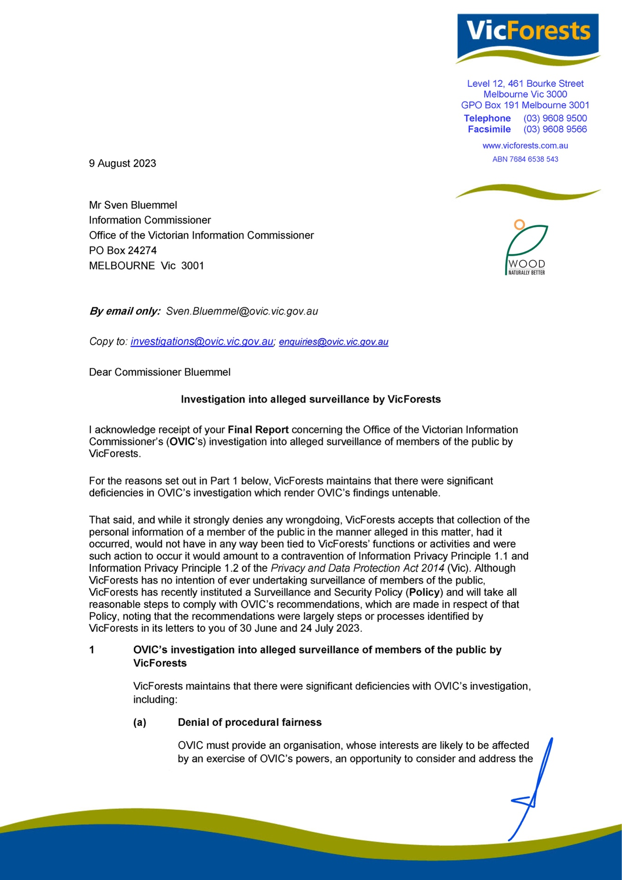
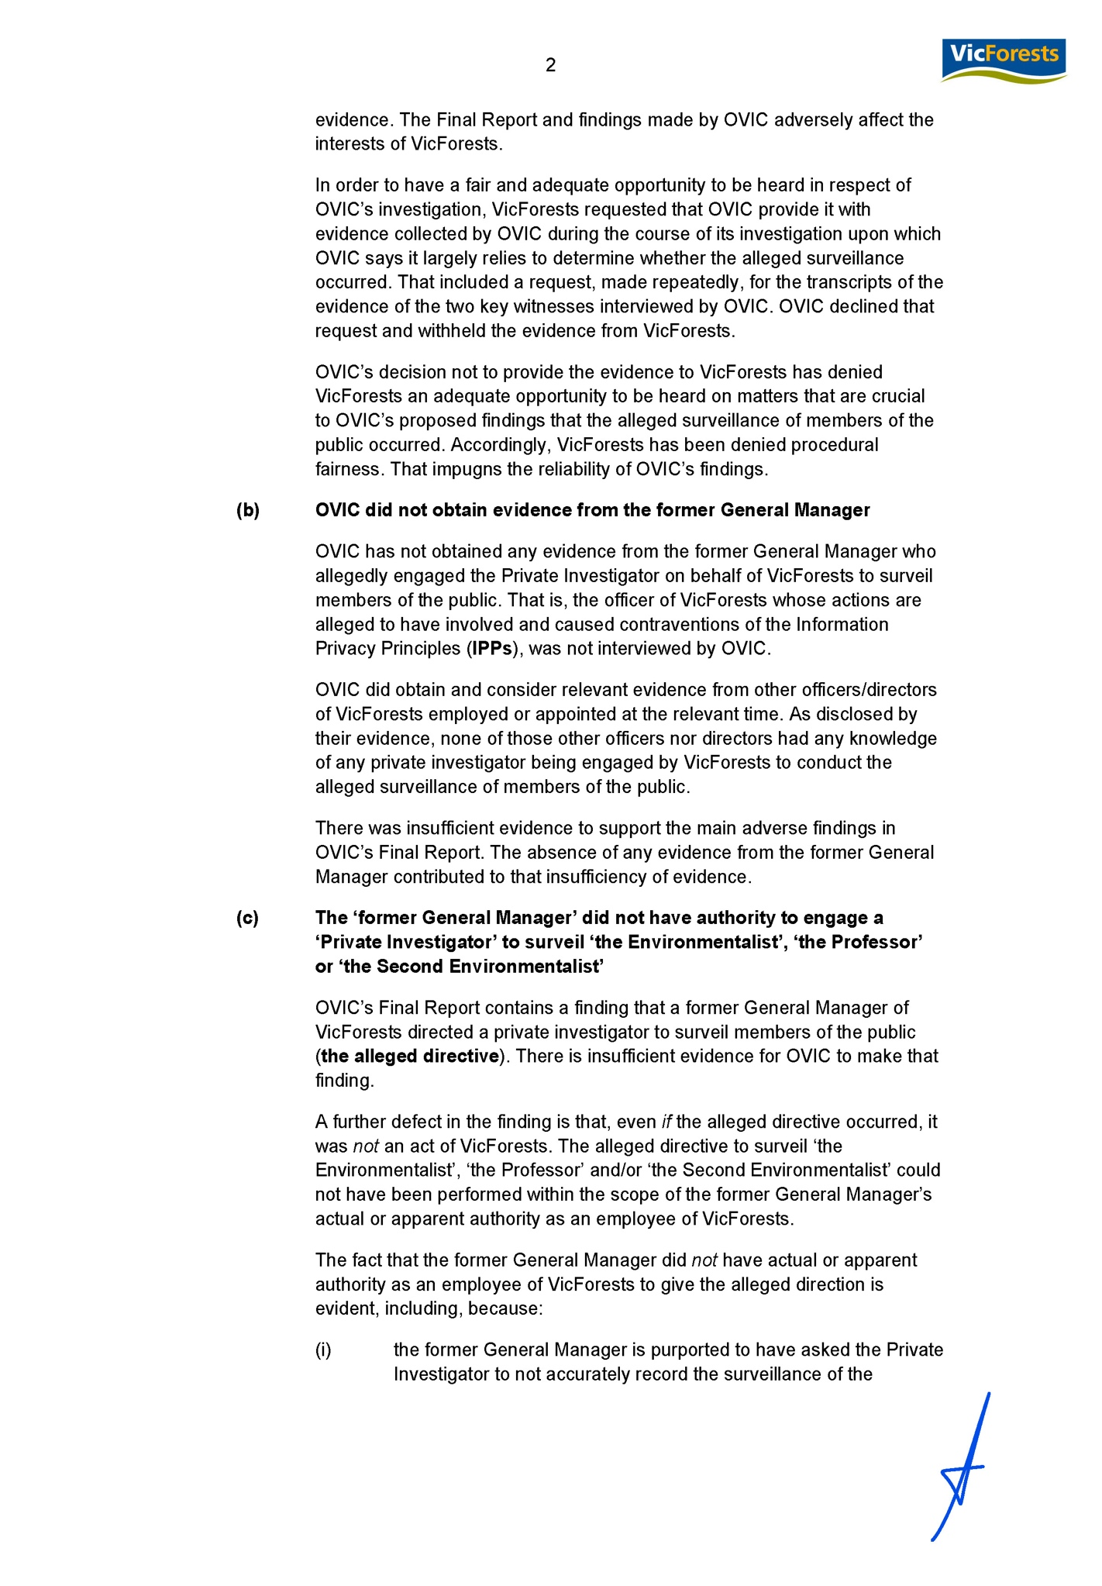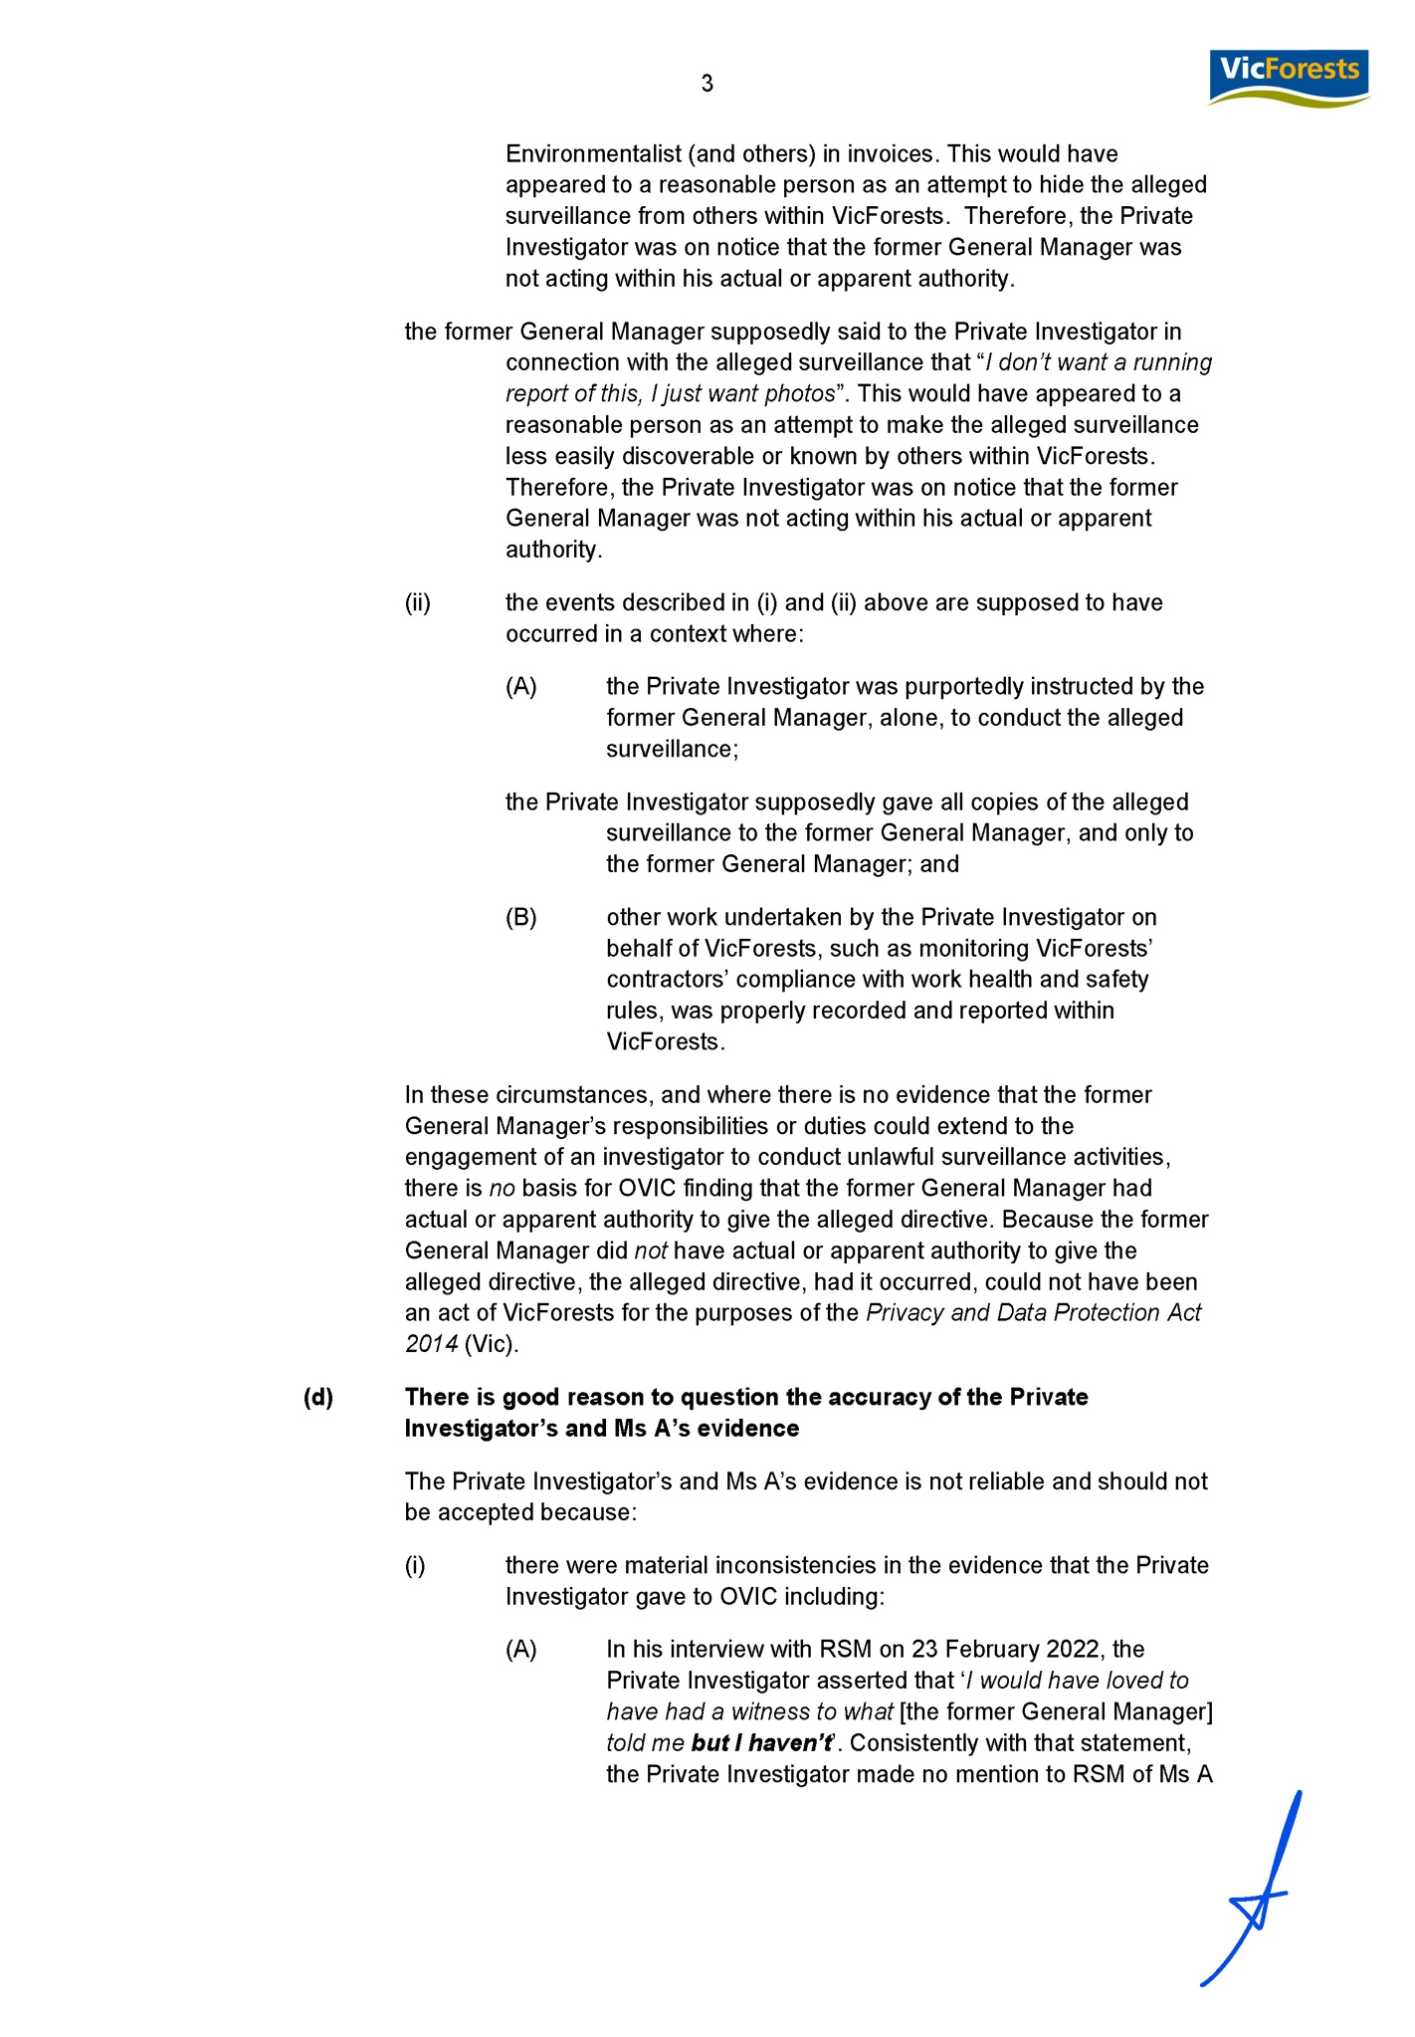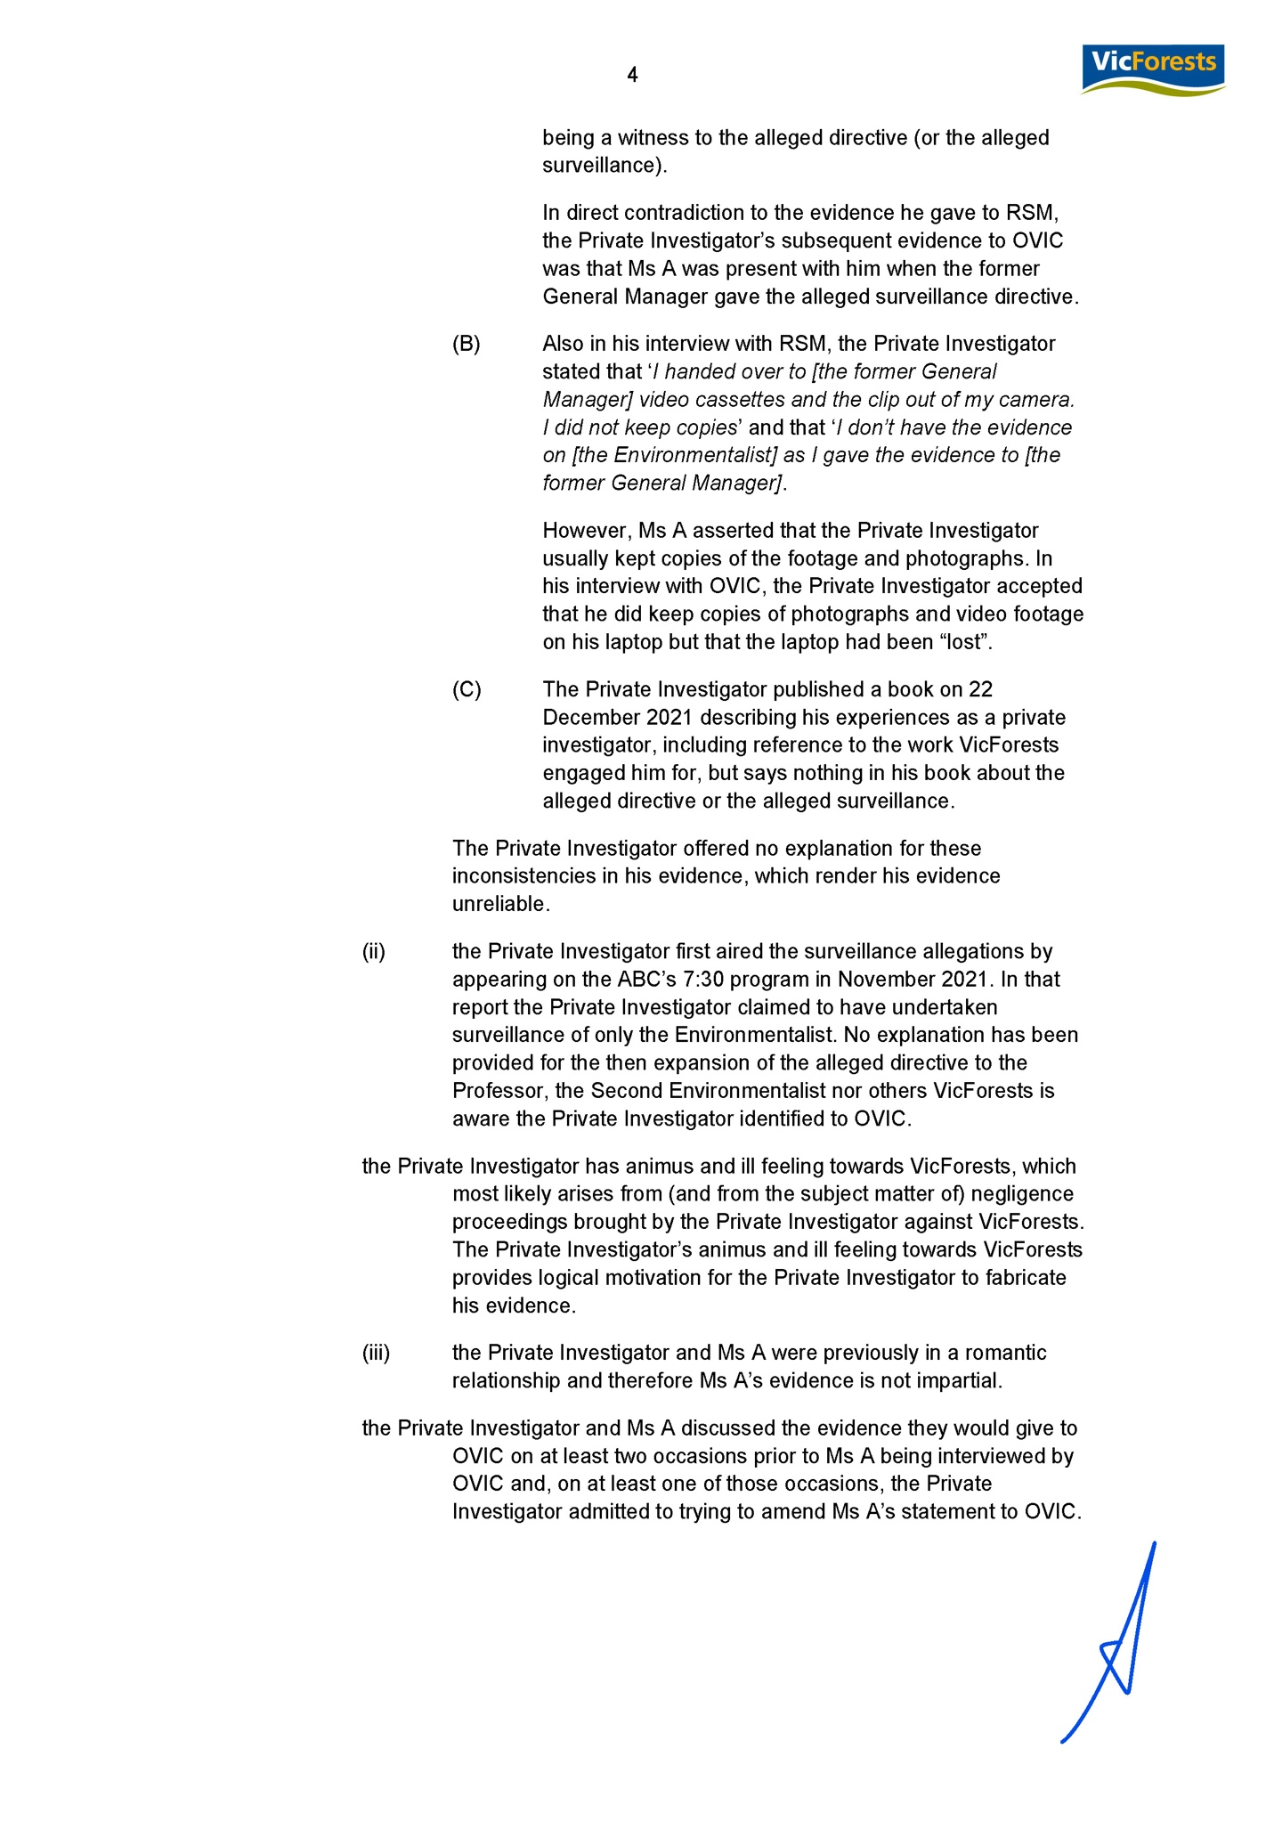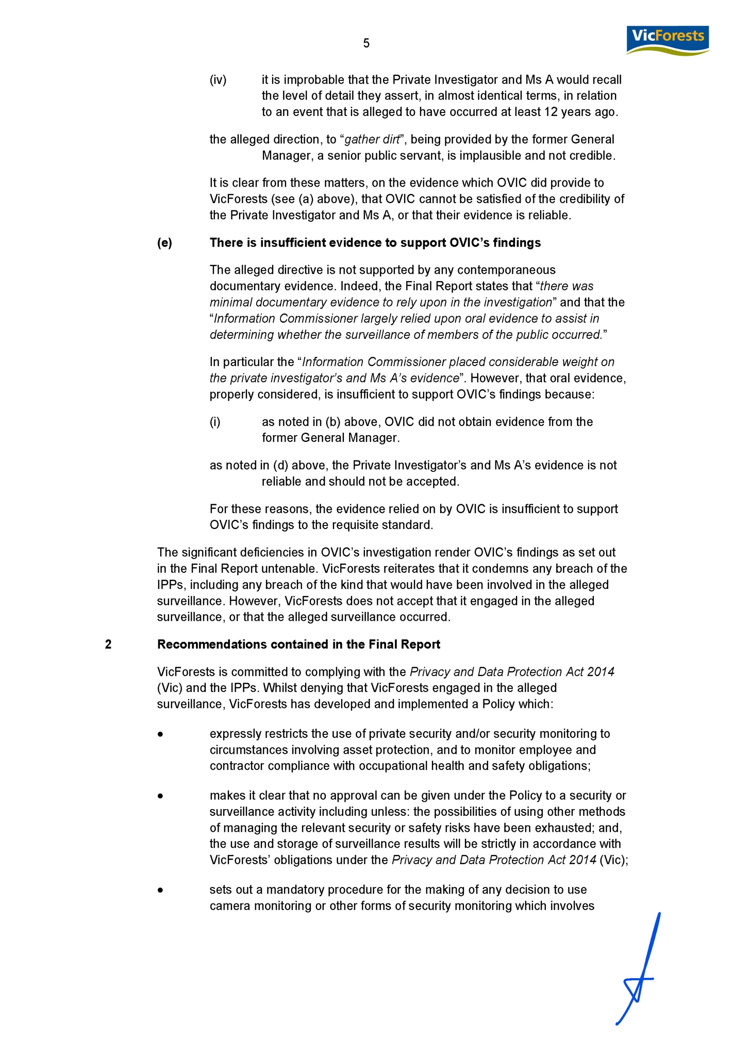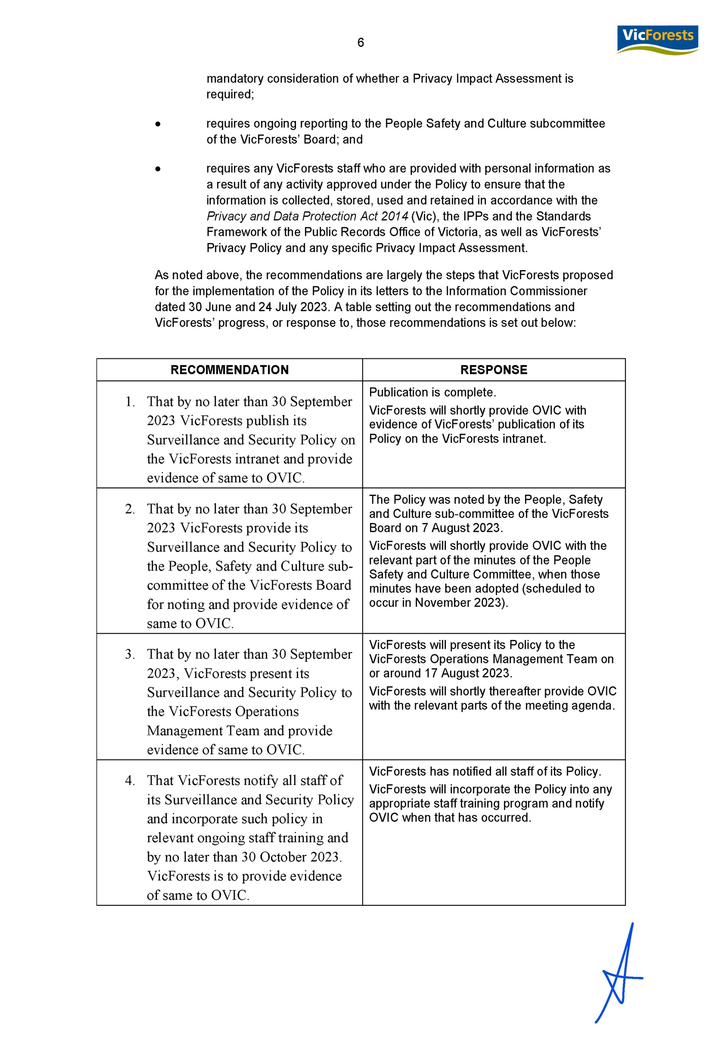

www.ovic.vic.gov.au

https://www.vicforests.com.au/aboutus/about-us-home
Section 20 of the PDP Act sets out that an organisation must not do an act, or engage in a practice, that contravenes an IPP as set out in Schedule 1 of the PDP Act
The Information Privacy Principles are set out in schedule 1 to the Privacy and Data Protection Act 2014 (the PDP Act) which came into effect on 17 September 2014. Prior to this, the Information Privacy Principles were set out in Schedule 1 to the Information Privacy Act 2000 which was taken to be re-enacted by Schedule 1 to the PDP Act, as was the obligation to not do an act, or engage in a practice, that contravenes an IPP (see clause 4 of schedule 2 to the PDP Act).
IPP 1.1 and 1.2 in Schedule 1 to the PDP Act are identical to IPP 1.1 and 1.2 in Schedule 1 to the Information Privacy Act 2000 which was in force at the time of the alleged surveillance.
https://www.abc.net.au/news/2021-11-25/victoria-forests-agency-accused-of-spying-on-campaigner/100613342.
OVIC, Guiding Principles for surveillance, May 2022. Found at: https://ovic.vic.gov.au/privacy/resources-for-organisations/guiding-principles-for-surveillance/
OVIC, Guiding Principles for surveillance, May 2022. Found at: https://ovic.vic.gov.au/privacy/resources-for-organisations/guiding-principles-for-surveillance/.
https://www.vicforests.com.au/aboutus/about-us-home
An Order in Council is made when the Governor of Victoria exercises their power to act with the advice of the Victorian Executive Council to implement an aspect of an Act
Letter from VicForests to OVIC dated 30 May 2022
https://ovic.vic.gov.au/regulatory-action/regulatory-action-policy/
PDP Act, s 13(1)(c)
A skidway is a platform on which logs ready for sawing are piled: https://www.collinsdictionary.com/dictionary/english/skidway
For the avoidance of doubt, the Court documents do not detail the surveillance work of specific members of the public that was the subject of the Information Commissioner’s investigation.
While protesters are, of course, members of the public, surveillance of groups of protesters was not the subject of this investigation. Rather, when referring to ‘surveillance of members of the public’, this relates to specific surveillance targeted at particular individuals.
This refers to the principle set out by Dixon J in Briginshaw v Briginshaw (1938) 60 CLR 336 that more convincing evidence is required to meet the standard of proof where an allegation is particularly serious or unlikely to have occurred.
In addition to giving his evidence under oath the Information Commissioner informed the private investigator of his obligations under s122 of the PDP Act
Ms A gave evidence that she lives overseas and had not spoken to the private investigator for a number of years prior to OVIC’s investigation. During the investigation, the private investigator made contact with Ms A, by obtaining her contact details from her family member, to ask if she would be willing to give evidence to OVIC. Both gave evidence that the private investigator explained to Ms A the issues that OVIC was investigating and about which it sought to obtain information from Ms A.
Jurecek v Director, Transport Safety Victoria [2016] VSC 285, [111].
https://ovic.vic.gov.au/regulatory-action/regulatory-action-policy/
While not a statutory obligation, Privacy Impact Assessments are, and were at the relevant time, considered to be a fundamental component in the protection of individual privacy and were considered by the then Victorian Privacy Commissioner to be an expectation of Victorian government agencies.

