OFFICIAL
OFFICIAL
OFFICIAL

BACKGROUND

Cemetery information is important to the community and to the State. Not only does cemetery information commemorate the lives of community members but it also provides important genealogical records that preserve a profound and personal history of Australia. Following these steps will help to ensure the integrity and availability of these records for generations to come. These steps will also help to ensure that the confidentiality of sensitive information is adequately secured.
The following activities form the basis of good information security practice. These steps will support the effective and secure management of cemetery information.

To help protect cemetery information, it is good practice to know and document the following:
- The types of information your cemetery generates, holds and manages
- Where your information is located or stored
- Who is responsible for the different types of information
- How sensitive and/or important this information is
- Whether the information is suitable for unlimited public release or publication
Developing and maintaining an Information Asset Register (IAR) will help cemetery trusts keep a consistent record of its information for future generations.
OFFICIAL
Please note:
Please keep this document for your internal records. You may be requested to supply a copy to OVIC as required.
OVIC has marked this template as OFFICIAL. If you feel the entries in your Information Asset Register warrant a different marking, please contact the Information Security Unit at security@ovic.vic.gov.au or 1300 006 842 for guidance.

WHAT IS AN INFORMATION ASSET?
OFFICIAL
An information asset is described as a body of information, defined and practically managed so it can be understood, shared, protected and used to its full potential. Information assets support business processes and are stored across a variety of media and formats (i.e. both paper based as well as electronic material).
Information assets have a recognisable and manageable value, risk, content and lifecycle.
An information asset can be a specific report, meeting minutes, statements of accounts, a collection of reports, information about a specific function, subject or process.

HOW TO USE THIS GUIDE
This guide has been designed to support you in completing an IAR for your cemetery trust. This guide contains:
- a blank IAR template
- descriptions of each section of the register
- instructions on how to complete each section
- an example of a completed register that can be referred to as a guide
  - OVIC has provided some sample entries in the sample IAR that reflect the types of information a Cemetery Trust may hold.
To get started:
- Read the instructions on how to complete the register
- Carefully read the descriptions of each register section
- Complete the blank cemetery IAR
  - You can print this out and fill it in with a pen, or request a digital copy to complete on your computer by calling the Information Security Unit on 1300 006 842

OFFICIAL
- INSTRUCTIONS ON HOW TO COMPLETE AN INFORMATION ASSET REGISTER
OFFICIAL
OFFICIAL
1 | Read through this entire document before you start.
2 | Decide if your IAR will be stored/completed in hardcopy (paper) or softcopy (computer).
3 | Refer to the example IAR as you work through each section to develop your own IAR.
4 | Once you have completed your IAR, file/store it in a location that is accessible to anyone within the cemetery trust who may need it.
5 | Schedule an annual review with your relevant stakeholders to review currency and relevance of content and assets in the register.

If you would like more information,

contact the OVIC Information Security Unit on 1300 006 842
- DESCRIPTIONS OF EACH SECTION IN THE INFORMATION ASSET REGISTER
OFFICIAL

There are 12 sections to complete in the IAR. Each section has been given a corresponding letter to help you complete it. Read the section description and refer to the instructions on how to complete each section.

Section A: “What is the information asset name?”
Section Description
The name or title of the information asset, and a description of the contents or an outline of the components of that information asset.
How to complete this section:
- List the name of the information asset.
Handy Tip!
The information asset name should be meaningful to you and your cemetery trust. Use strong keywords which will help with searching for the asset in the register.

Section B: “What types of information are held in this information asset?”
Section Description
Provide a detailed description of the types of information in this asset.
How to complete this section:
- Describe the information types in this asset.
- Circle the relevant Yes or No boxes to indicate whether the asset contains any of the following information types (see Annex for definitions):
- Law Enforcement Data
- Financial information
- Health records
- Personal Information

- If you circled Yes to the asset containing personal information, you then need to indicate whether this asset contains sensitive personal information.
OFFICIAL
Sensitive Personal information means information that is also about someone’s
- racial or ethnic origin | - membership of a trade union
- political opinions | - sexual preferences or practices
- membership of a political association | - criminal record
- religious beliefs or affiliations | - philosophical beliefs
- membership of a professional or trade association
OFFICIAL
Handy Tip!
If you circled ‘Yes’ for any of these information types, you should consider any additional regulatory requirements surrounding the management of this information, and whether any additional protections are required for this material.

Section C: “Where do you store this information asset?”
Section Description
Describe the location where the information asset is most used and stored.
How to complete this section:
- List and describe the location of the information asset
  - This location may be a physical address (i.e., reference to filing cabinets at a specific physical location) and/or a digital location where the information is used and stored (e.g., computer systems, specific digital device)
Handy Tip!
When storing your information, think about potential environmental impacts to your information asset such as flood, fire, humidity, pests, as well as aspects that may impact the security of the information.

OFFICIAL

Section D: “What format is this information asset in?”
OFFICIAL
Section Description
Describe the format of the information asset.
How to complete this section:
- Circle whether the material is in:
- Soft/digital copy
- Hard/physical copy
- Both (soft and hard copy)

- Circle the format of the information:
- Documents | - Audio files
- Email | - Photos/Images
- Spreadsheets | - Other (specify)

Handy Tip!
A single information asset may be made up of records split across multiple formats.

Section E: “Who created this information asset?”
Section Description
The person or organisation responsible for creating the information asset.
How to complete this section:
- Fill in the name of the originator.
  - For example, your cemetery trust, or the Department of Health (DH)
Handy Tip!
Keep in mind that this person or organisation is also responsible for deciding the security value of the information, and whether it needs a protective marking.

OFFICIAL

Section F: “Who is the owner of this information asset?”
OFFICIAL
Section Description
This refers to the owner of the information asset. The owner is a nominated role or organisation that is accountable for the secure manage of the information asset.
How to complete this section:
- Note the role or position title of the individual (including the organisation and business unit)
Handy Tip!
Listing position titles (such as Chairperson or Secretary) rather than a full name where appropriate not only supports good information privacy but creates a ‘fixed’ point of responsibility in case individuals change roles or leave the business.

List any alternate contact methods for the owner (e.g., position-based email, phone).

Section G: “Who holds this information asset?”
Description
This refers to the position or organisation that manages and is responsible for the information asset on behalf of the owner.
How to complete this section:
- Outline who (i.e., role/title, business unit or agency) has custody of the information asset
Handy Tip!
‘Custody’ refers to the role who has the information asset in their care or control.

Keep in mind the Handy Tip from Section F and use the person’s role or title instead of their name.

OFFICIAL

Section H: “If the CONFIDENTIALITY of this information were compromised, would it cause…”
OFFICIAL
Description
This section asks you to assess the impact level if the Confidentiality of the information asset were compromised. The impact level should be in numerical form (i.e. 0, 1, 2, or 3 - where 0 is equal to no impact and 3 is equal to major impact)
How to complete this section:
- Conduct an assessment for each asset, focusing on the Confidentiality of the asset.
- Circle the impact level for each asset from the options in the register:
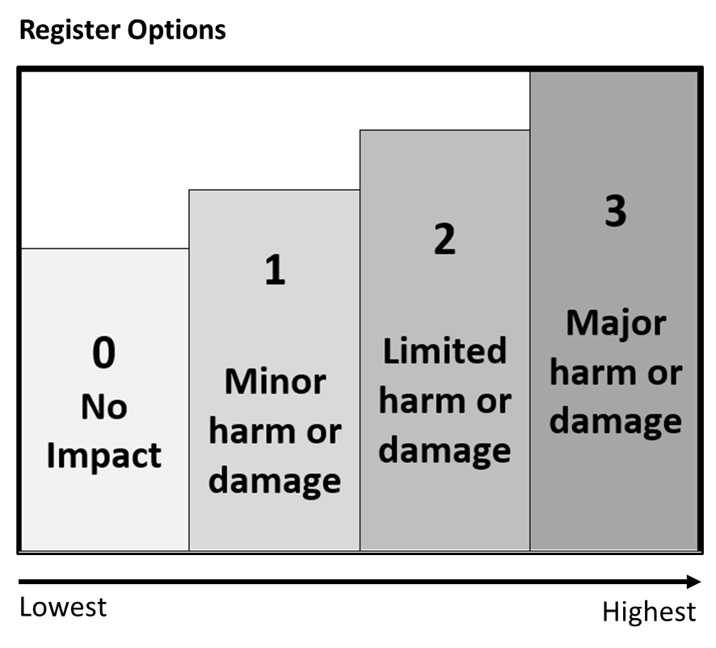 | Corresponding Impacts  0 – No impact  1 – Minor: Compromise of the information would be expected to cause minor harm/damage to organisations or individuals  2 – Limited: Compromise of the information would be expected to cause limited harm/damage to organisations or individuals  3 – Major: Compromise of the information would be expected to cause major harm/damage to organisations or individuals
For example, if the cemetery trust meeting minutes were exposed to people or parties who should not have had access to this material, this would be considered a compromise to the confidentiality of the information. The degree of harm/damage of this compromise is for the cemetery trust to determine based on their understanding of the content and context.
If you think your cemetery trust holds information with a Confidentiality level of 3, please contact the Information Security Unit on 1300 006 842.
OFFICIAL
Handy Tip!
When conducting your assessment, consider the Confidentiality aspects and attributes of the information asset and ask yourself:
“What would happen if:
    - an unauthorised person accessed this material, or
    - it was disclosed to someone who wasn’t supposed to see or hear it?”
“Would it result in some degree of harm or damage to government operations, organisations or individuals?”

Section I: “Based on your response to Section H, you will need to label your asset with the following labels:”
OFFICIAL
Description
Protective markings are security labels assigned to information. This label is directly linked to the Business Impact Level for Confidentiality (Section H) and are an easy and visual way to demonstrate a potential compromise to the confidentiality of the information.
How to complete this section:
- Based on the rating from Section H, circle the corresponding Protective Marking that you will label that information asset with.
  - If you circled 0, a protective marking is not required
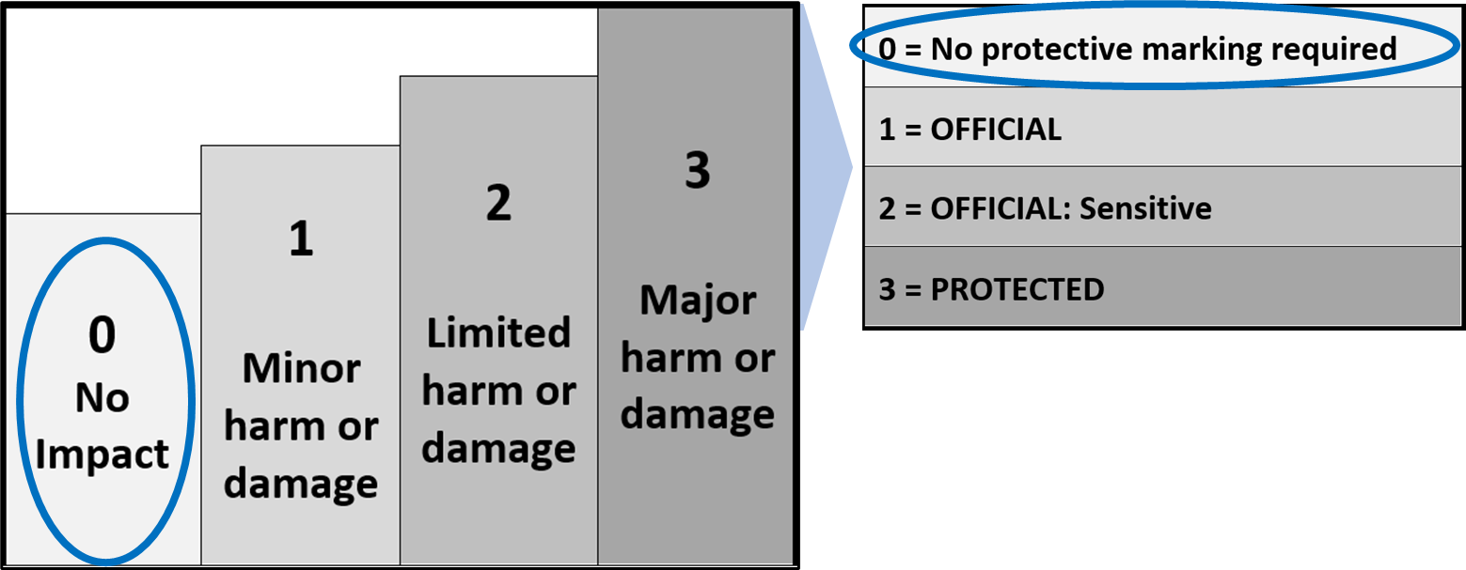
  - If you circled 1, the protective marking is OFFICIAL - you can choose to leave your documents unlabelled, or you can choose to include the OFFICIAL label
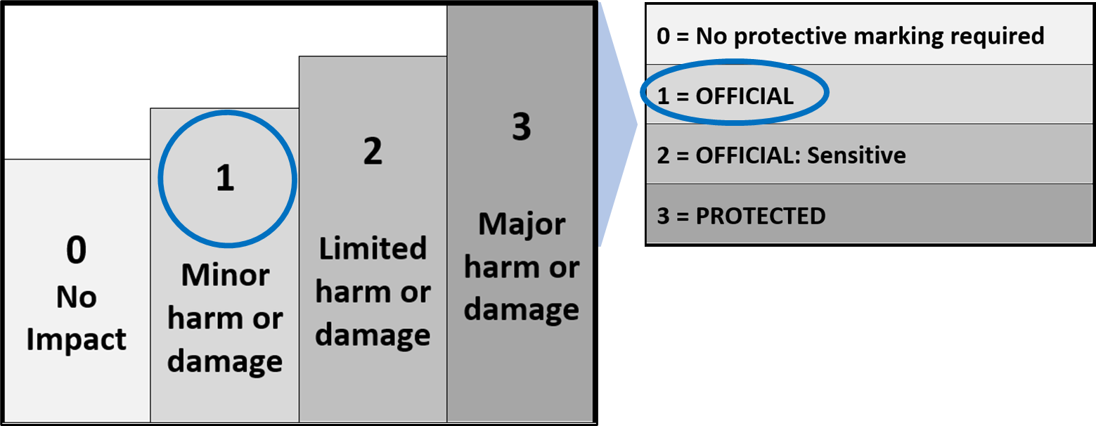

OFFICIAL
  - If you circled 2, the protective marking is OFFICIAL: Sensitive – your documents must be labelled with this label
OFFICIAL
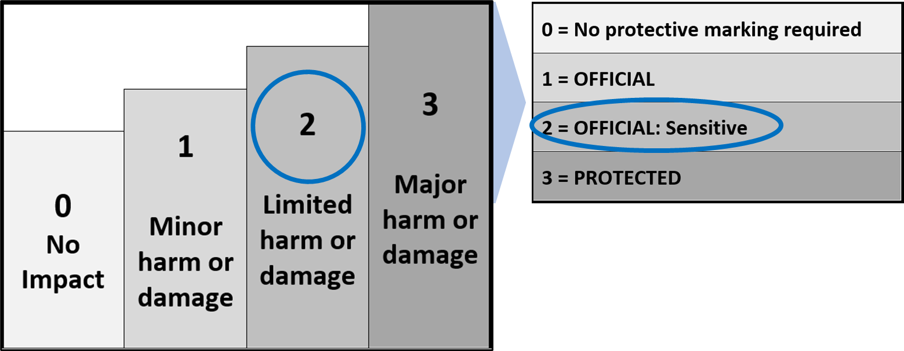
  - If you circled 3, the protective marking is PROTECTED – your documents must be labelled with this label. Remember, if you think your cemetery trust holds information with a Confidentiality level of 3, please contact the Information Security Unit on 1300 006 842
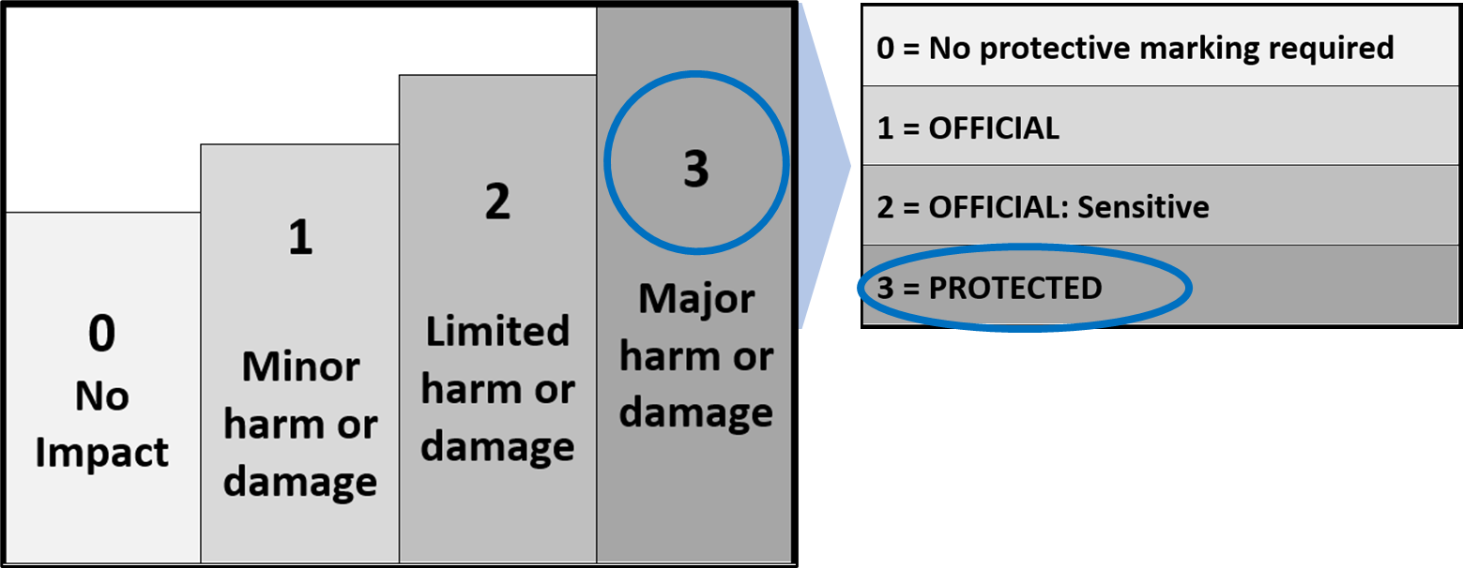

OFFICIAL

Section J: “If the INTEGRITY of this information were compromised, would it cause…”
OFFICIAL
Description
This section requires you to assess the impact level if the Integrity of the information asset were compromised.
The impact level should be in numerical form (i.e. 0, 1, 2, or 3 - where 0 is equal to no impact and 3 is equal to major impact)
How to complete this section:
- Conduct an assessment for each asset, focusing on the Integrity of the asset.
- Circle the impact level for each asset from the options in the register:
Corresponding Impacts
0 – No impact
1 – Minor: Compromise of the information would be expected to cause minor harm/damage to organisations or individuals
2 – Limited: Compromise of the information would be expected to cause limited harm/damage to organisations or individuals
3 – Major: Compromise of the information would be expected to cause major harm/damage to organisations or individuals
For example, if the Cemetery Trust meeting minutes were modified to say a decision was made when it wasn’t, this would be considered a compromise to the integrity of the information. The degree of harm/damage resulting from this compromise is for the cemetery trust to determine based on their understanding of the content and context.
Handy Tip!
When conducting your assessment, consider the Integrity aspects and attributes of the information asset and ask yourself:
“What would happen if the information were adjusted, modified, or changed without being authorised?”
“Would it result in some degree of harm or damage to government operations, organisations or individuals?”

OFFICIAL

Section K: “If the AVAILABILITY of this information were compromised, would it cause…”
OFFICIAL
OFFICIAL
Description
This section requires you to assess the impact level if the AVAILABILITY of the information asset were compromised.
The impact level should be in numerical form (i.e. 0, 1, 2, or 3 - where 0 is equal to no impact and 3 is equal to major impact)
How to complete this section:
- Conduct an assessment for each asset, focusing on the Availability of the asset.
- Circle the impact level for each asset from the options in the register:
Corresponding Impacts
0 – No impact
1 – Minor: Compromise of the information would be expected to cause minor harm/damage to organisations or individuals
2 – Limited: Compromise of the information would be expected to cause limited harm/damage to organisations or individuals
3 – Major: Compromise of the information would be expected to cause major harm/damage to organisations or individuals
For example, if the cemetery trust burial maps were unavailable, as a result of damage or loss, this would be considered a compromise to the availability of the information. The degree of harm/damage resulting from this compromise is for the cemetery trust to determine based on their understanding of the content and context.
Handy Tip!
When conducting your assessment, consider the Availability aspects and attributes of the information asset and ask yourself:
“What would happen if the information were rendered unavailable when it needs to be?”
“Would it result in some degree of harm or damage to government operations, organisations or individuals?”

OFFICIAL

Section L: “Is this information asset suitable for public release?”
OFFICIAL
Description
This section asks you to indicate whether the information asset has been authorised and is suitable for unlimited public release. This is based on an assessment of the individual merits and content of the information asset. If suitable, this section also asks you to record who has approved or authorised the unlimited release of the information asset, and the date the information asset was publicly released.
Some reasons where you might not release can be:
- reasons of privacy, | - other parties having rights over Intellectual Property,
- public safety, | - where there are legislative restrictions on release of the information before a certain date
- security and law enforcement, | - regulatory compliance
- public health,
Handy Tip!
You should consult with the creator (identified in Section E) of the individual records or associated information elements to determine whether the content is appropriate for unlimited public release.

How to complete this section:
- Circle Yes or No
If yes, you have deemed the information asset SUITABLE for unlimited public release.
- Write in the date that this version of the information asset was published/provided
- If yes, note the role or position title of the individual (including if relevant the organisation and unit who approved the release
If no, you have deemed the information asset NOT SUITABLE for unlimited public release.
- If no, explain why.
OFFICIAL
Handy Tip!
Where possible, only list position titles (such as Chairperson or Secretary) rather than their full name. This makes it easier if people move roles.

- EXAMPLE CEMETERY TRUST INFORMATION ASSET REGISTER
OFFICIAL

The following pages show an Example Cemetery IAR with prepopulated example fields.

The example pages are marked with this picture.

This booklet provides a blank register that you can use to fill out for your Information Assets. The register goes over 4 pages.

Each register only has space for 3 assets to be listed if printed in its current layout due to spacing. Please print out as many of the blank template pages as you need to allow for all your information assets to be captured.

OFFICIAL

OFFICIAL
EXAMPLES
ONLY
NAME | ABC Cemetery Trust
VERSION/DATE | Version 1.0 – 18th February 2021

OFFICIAL
A: What is the information asset name? | E.g. Meeting Agendas and Minutes |  |  | E.g. Cemetery Trust Manual |  |  | E.g. Abstract of Accounts
B: What types of information are held in this information asset?  - Please briefly describe  - Circle all that apply  If you circle ‘yes’ for any of these boxes, consider what additional regulations apply to this information, and if any additional protections are required | E.g. Agenda items and/or meeting notes taken by committee members, submissions relating to agenda items, working minutes including action items. Some agenda and minutes may contain Personal Information and Health Records. |  |  | E.g. Policies and procedures provided by DHHS (including iterative updates) |  |  | E.g. The report, known as the abstract of accounts, is to give a true and fair view of the financial position and performance of a trust, for the reporting period
 | Circle Y (yes) or N (no) to indicated whether the asset contains: |  |  | Circle Y (yes) or N (no) to indicated whether the asset contains: |  |  | Circle Y (yes) or N (no) to indicated whether the asset contains:
 | Law Enforcement Information? | Y | N | Law Enforcement Information? | Y | N | Law Enforcement Information? | Y | N
 | Financial Information? | Y | N | Financial Information? | Y | N | Financial Information? | Y | N
 | Health Records? | Y | N | Health Records? | Y | N | Health Records? | Y | N
 | Personal Information? | Y | N | Personal Information? | Y | N | Personal Information? | Y | N
 | If you circled ‘yes’ for personal information, does this include sensitive personal information? | Y | N | If you circled ‘yes’ for personal information, does this include sensitive personal information? | Y | N | If you circled ‘yes’ for personal information, does this include sensitive personal information? | Y | N
OFFICIAL
C: Where do you store this information asset? | E.g. Secure filing Cabinet at Address: 1234 Hoddle Street, Town, 5000 |  |  | E.g. A download is stored on Secretary's personal computer |  |  | E.g. Secure filing Cabinet at 1234 Hoddle Street, Town, 5000 AND Stored on Secretary's USB backup stick
D: What format is this information asset in?  (circle all that apply) | Soft | Hard | Both | Soft | Hard | Both | Soft | Hard | Both
 | Documents |  |  | Documents |  |  | Documents
 | Email |  |  | Email |  |  | Email
 | Spreadsheets |  |  | Spreadsheets |  |  | Spreadsheets
 | Audio |  |  | Audio |  |  | Audio
 | Photos/Images |  |  | Photos/Images |  |  | Photos/Images
 | Other (specify)  Retained in book format |  |  | Other (specify) |  |  | Other (specify)
E: Who created this information asset? | E.g. ABC Cemetery Trust |  |  | E.g. DH |  |  | E.g. ABC Cemetery Trust
F: Who is the owner of this information asset? | E.g. ABC Cemetery Trust |  |  | E.g. DHHS |  |  | E.g. ABC Cemetery Trust
G: Who holds this information asset? | E.g. ABC Cemetery Trust |  |  | E.g. ABC Cemetery Trust |  |  | E.g. DHHS
OFFICIAL
EXAMPLES
ONLY
OFFICIAL
EXAMPLES
ONLY

H: If the CONFIDENTIALITY of this information were compromised, would it cause:  (circle one) |  |  |  | 3  Major harm or damage |  |  |  | 3  Major harm or damage |  |  |  | 3  Major harm or damage
 |  |  | 2  Limited harm or damage |  |  |  | 2  Limited harm or damage |  |  |  | 2  Limited harm or damage
 |  | 1  Minor harm or damage |  |  |  | 1  Minor harm or damage |  |  |  | 1  Minor harm or damage
 | 0  No Impact |  |  |  | 0  No Impact |  |  |  | 0  No Impact
I: Based on your response to Section H, you will need to mark your asset with the following markers: | 0 = No protective marking required |  |  |  | 0 = No protective marking required |  |  |  | 0 = No protective marking required
 | 1 = OFFICIAL |  |  |  | 1 = OFFICIAL |  |  |  | 1 = OFFICIAL
 | 2 = OFFICIAL: Sensitive |  |  |  | 2 = OFFICIAL: Sensitive |  |  |  | 2 = OFFICIAL: Sensitive
 | 3 = PROTECTED |  |  |  | 3 = PROTECTED |  |  |  | 3 = PROTECTED

J: If the INTEGRITY of this information were compromised, would it cause:  (circle one) |  |  |  | 3  Major harm or damage |  |  |  | 3  Major harm or damage |  |  |  | 3  Major harm or damage
 |  |  | 2  Limited harm or damage |  |  |  | 2  Limited harm or damage |  |  |  | 2  Limited harm or damage
 |  | 1  Minor harm or damage |  |  |  | 1  Minor harm or damage |  |  |  | 1  Minor harm or damage
 | 0  No Impact |  |  |  | 0  No Impact |  |  |  | 0  No Impact

OFFICIAL
OFFICIAL

EXAMPLES
ONLY

K: If the AVAILABILITY of this information were compromised, would it cause:  (circle one) |  |  |  | 3  Major harm or damage |  |  |  | 3  Major harm or damage |  |  |  | 3  Major harm or damage
 |  |  | 2  Limited harm or damage |  |  |  | 2  Limited harm or damage |  |  |  | 2  Limited harm or damage
 |  | 1  Minor harm or damage |  |  |  | 1  Minor harm or damage |  |  |  | 1  Minor harm or damage
 | 0  No Impact |  |  |  | 0  No Impact |  |  |  | 0  No Impact

L: Is this asset suitable for public release? | YES | NO | YES | NO | YES | NO
 | If suitable for public release, who approved it?  e.g. As the minutes are a matter of public record, they may need to be produced as evidence of trust decisions – public release to be assessed on a base-by-case basis. |  | If suitable for public release, who approved it?  e.g. DHHS |  | If suitable for public release, who approved it?  e.g. Supplied to DHHS as part of the financial year reporting cycle.
 | Date of Approval: e.g. N/A |  | Date of Approval: e.g. November 2017 |  | Date of Approval: e.g. N/A

ACTIVITY: Blank Cemetery Trust IAR (4 pages)
OFFICIAL
OFFICIAL
Use the following template to complete your Information Asset Register. Print as many copies as you need to capture all of your information assets.
NAME
VERSION/DATE

A: What is the asset name?
B: What types of information are held in this asset?

- Please briefly describe
- Circle all that apply
If you circle ‘yes’ for any of these boxes, consider what additional regulations apply to this information, and if any additional protections are required.

 | Circle Y (yes) or N (no) to indicated whether the asset contains: |  |  | Circle Y (yes) or N (no) to indicated whether the asset contains: |  |  | Circle Y (yes) or N (no) to indicated whether the asset contains:
 | Law Enforcement Information? | Y | N | Law Enforcement Information? | Y | N | Law Enforcement Information? | Y | N
 | Financial Information? | Y | N | Financial Information? | Y | N | Financial Information? | Y | N
 | Health Records? | Y | N | Health Records? | Y | N | Health Records? | Y | N
 | Personal Information? | Y | N | Personal Information? | Y | N | Personal Information? | Y | N
 | If you circled ‘yes’ for personal information, does this include sensitive personal information? | Y | N | If you circled ‘yes’ for personal information, does this include sensitive personal information? | Y | N | If you circled ‘yes’ for personal information, does this include sensitive personal information? | Y | N

OFFICIAL
OFFICIAL

C: Where do you store this information asset?
D: What format is this information asset in?  (circle all that apply) | Soft | Hard | Both | Soft | Hard | Both | Soft | Hard | Both
 | Documents |  |  | Documents |  |  | Documents
 | Email |  |  | Email |  |  | Email
 | Spreadsheets |  |  | Spreadsheets |  |  | Spreadsheets
 | Audio |  |  | Audio |  |  | Audio
 | Photos/Images |  |  | Photos/Images |  |  | Photos/Images
 | Other (specify) |  |  | Other (specify) |  |  | Other (specify)
E: Who created this information asset?
F: Who is the legal owner of this information asset?
G: Who holds this information asset?
OFFICIAL
OFFICIAL
H: If the CONFIDENTIALITY of this information were compromised, would it cause:  (circle one) |  |  |  | 3  Major harm or damage |  |  |  | 3  Major harm or damage |  |  |  | 3  Major harm or damage
 |  |  | 2  Limited harm or damage |  |  |  | 2  Limited harm or damage |  |  |  | 2  Limited harm or damage
 |  | 1  Minor harm or damage |  |  |  | 1  Minor harm or damage |  |  |  | 1  Minor harm or damage
 | 0  No Impact |  |  |  | 0  No Impact |  |  |  | 0  No Impact
I: Based on your response to Section H, you will need to mark your asset with the following markers: | 0 = No protective marking required |  |  |  | 0 = No protective marking required |  |  |  | 0 = No protective marking required
 | 1 = OFFICIAL |  |  |  | 1 = OFFICIAL |  |  |  | 1 = OFFICIAL
 | 2 = OFFICIAL: Sensitive |  |  |  | 2 = OFFICIAL: Sensitive |  |  |  | 2 = OFFICIAL: Sensitive
 | 3 = PROTECTED |  |  |  | 3 = PROTECTED |  |  |  | 3 = PROTECTED

J: If the INTEGRITY of this information were compromised, would it cause:  (circle one) |  |  |  | 3  Major harm or damage |  |  |  | 3  Major harm or damage |  |  |  | 3  Major harm or damage
 |  |  | 2  Limited harm or damage |  |  |  | 2  Limited harm or damage |  |  |  | 2  Limited harm or damage
 |  | 1  Minor harm or damage |  |  |  | 1  Minor harm or damage |  |  |  | 1  Minor harm or damage
 | 0  No Impact |  |  |  | 0  No Impact |  |  |  | 0  No Impact

OFFICIAL
K: If the AVAILABILITY of this information were compromised, would it cause:  (circle one) |  |  |  | 3  Major harm or damage |  |  |  | 3  Major harm or damage |  |  |  | 3  Major harm or damage
 |  |  | 2  Limited harm or damage |  |  |  | 2  Limited harm or damage |  |  |  | 2  Limited harm or damage
 |  | 1  Minor harm or damage |  |  |  | 1  Minor harm or damage |  |  |  | 1  Minor harm or damage
 | 0  No Impact |  |  |  | 0  No Impact |  |  |  | 0  No Impact
OFFICIAL
L: Is this information asset suitable for public release? | YES | NO | YES | NO | YES | NO
 | If suitable for public release, who approved it? |  | If suitable for public release, who approved it? |  | If suitable for public release, who approved it?
 | Date of Approval: |  | Date of Approval: |  | Date of Approval:

OFFICIAL

ACTIVITY: Blank Cemetery Trust IAR (4 pages) Page ___ of ___
OFFICIAL
Use the following template to complete your Information Asset Register. Print as many copies as you need to capture all of your information assets.
NAME
VERSION/DATE

A: What is the asset name?
B: What types of information are held in this asset?

- Please briefly describe
- Circle all that apply
If you circle ‘yes’ for any of these boxes, consider what additional regulations apply to this information, and if any additional protections are required.

 | Circle Y (yes) or N (no) to indicated whether the asset contains: |  |  | Circle Y (yes) or N (no) to indicated whether the asset contains: |  |  | Circle Y (yes) or N (no) to indicated whether the asset contains:
 | Law Enforcement Information? | Y | N | Law Enforcement Information? | Y | N | Law Enforcement Information? | Y | N
 | Financial Information? | Y | N | Financial Information? | Y | N | Financial Information? | Y | N
 | Health Records? | Y | N | Health Records? | Y | N | Health Records? | Y | N
 | Personal Information? | Y | N | Personal Information? | Y | N | Personal Information? | Y | N
 | If you circled ‘yes’ for personal information, does this include sensitive personal information? | Y | N | If you circled ‘yes’ for personal information, does this include sensitive personal information? | Y | N | If you circled ‘yes’ for personal information, does this include sensitive personal information? | Y | N

OFFICIAL
OFFICIAL

C: Where do you store this information asset?
D: What format is this information asset in?  (circle all that apply) | Soft | Hard | Both | Soft | Hard | Both | Soft | Hard | Both
 | Documents |  |  | Documents |  |  | Documents
 | Email |  |  | Email |  |  | Email
 | Spreadsheets |  |  | Spreadsheets |  |  | Spreadsheets
 | Audio |  |  | Audio |  |  | Audio
 | Photos/Images |  |  | Photos/Images |  |  | Photos/Images
 | Other (specify) |  |  | Other (specify) |  |  | Other (specify)
E: Who created this information asset?
F: Who is the legal owner of this information asset?
G: Who holds this information asset?
OFFICIAL
OFFICIAL
H: If the CONFIDENTIALITY of this information were compromised, would it cause:  (circle one) |  |  |  | 3  Major harm or damage |  |  |  | 3  Major harm or damage |  |  |  | 3  Major harm or damage
 |  |  | 2  Limited harm or damage |  |  |  | 2  Limited harm or damage |  |  |  | 2  Limited harm or damage
 |  | 1  Minor harm or damage |  |  |  | 1  Minor harm or damage |  |  |  | 1  Minor harm or damage
 | 0  No Impact |  |  |  | 0  No Impact |  |  |  | 0  No Impact
I: Based on your response to Section H, you will need to mark your asset with the following markers: | 0 = No protective marking required |  |  |  | 0 = No protective marking required |  |  |  | 0 = No protective marking required
 | 1 = OFFICIAL |  |  |  | 1 = OFFICIAL |  |  |  | 1 = OFFICIAL
 | 2 = OFFICIAL: Sensitive |  |  |  | 2 = OFFICIAL: Sensitive |  |  |  | 2 = OFFICIAL: Sensitive
 | 3 = PROTECTED |  |  |  | 3 = PROTECTED |  |  |  | 3 = PROTECTED

J: If the INTEGRITY of this information were compromised, would it cause:  (circle one) |  |  |  | 3  Major harm or damage |  |  |  | 3  Major harm or damage |  |  |  | 3  Major harm or damage
 |  |  | 2  Limited harm or damage |  |  |  | 2  Limited harm or damage |  |  |  | 2  Limited harm or damage
 |  | 1  Minor harm or damage |  |  |  | 1  Minor harm or damage |  |  |  | 1  Minor harm or damage
 | 0  No Impact |  |  |  | 0  No Impact |  |  |  | 0  No Impact

OFFICIAL
K: If the AVAILABILITY of this information were compromised, would it cause:  (circle one) |  |  |  | 3  Major harm or damage |  |  |  | 3  Major harm or damage |  |  |  | 3  Major harm or damage
 |  |  | 2  Limited harm or damage |  |  |  | 2  Limited harm or damage |  |  |  | 2  Limited harm or damage
 |  | 1  Minor harm or damage |  |  |  | 1  Minor harm or damage |  |  |  | 1  Minor harm or damage
 | 0  No Impact |  |  |  | 0  No Impact |  |  |  | 0  No Impact

L: Is this information asset suitable for public release? | YES | NO | YES | NO | YES | NO
 | If suitable for public release, who approved it? |  | If suitable for public release, who approved it? |  | If suitable for public release, who approved it?
 | Date of Approval: |  | Date of Approval: |  | Date of Approval:

OFFICIAL

ACTIVITY: Blank Cemetery Trust IAR (4 pages) Page ___ of ___
OFFICIAL
the following template to complete your Information Asset Register. Print as many copies as you need to capture all of your information assets.
NAME
VERSION/DATE

A: What is the asset name?
B: What types of information are held in this asset?

- Please briefly describe
- Circle all that apply
If you circle ‘yes’ for any of these boxes, consider what additional regulations apply to this information, and if any additional protections are required.

 | Circle Y (yes) or N (no) to indicated whether the asset contains: |  |  | Circle Y (yes) or N (no) to indicated whether the asset contains: |  |  | Circle Y (yes) or N (no) to indicated whether the asset contains:
 | Law Enforcement Information? | Y | N | Law Enforcement Information? | Y | N | Law Enforcement Information? | Y | N
 | Financial Information? | Y | N | Financial Information? | Y | N | Financial Information? | Y | N
 | Health Records? | Y | N | Health Records? | Y | N | Health Records? | Y | N
 | Personal Information? | Y | N | Personal Information? | Y | N | Personal Information? | Y | N
 | If you circled ‘yes’ for personal information, does this include sensitive personal information? | Y | N | If you circled ‘yes’ for personal information, does this include sensitive personal information? | Y | N | If you circled ‘yes’ for personal information, does this include sensitive personal information? | Y | N

OFFICIAL
OFFICIAL

C: Where do you store this information asset?
D: What format is this information asset in?  (circle all that apply) | Soft | Hard | Both | Soft | Hard | Both | Soft | Hard | Both
 | Documents |  |  | Documents |  |  | Documents
 | Email |  |  | Email |  |  | Email
 | Spreadsheets |  |  | Spreadsheets |  |  | Spreadsheets
 | Audio |  |  | Audio |  |  | Audio
 | Photos/Images |  |  | Photos/Images |  |  | Photos/Images
 | Other (specify) |  |  | Other (specify) |  |  | Other (specify)
E: Who created this information asset?
F: Who is the legal owner of this information asset?
G: Who holds this information asset?
OFFICIAL
OFFICIAL
H: If the CONFIDENTIALITY of this information were compromised, would it cause:  (circle one) |  |  |  | 3  Major harm or damage |  |  |  | 3  Major harm or damage |  |  |  | 3  Major harm or damage
 |  |  | 2  Limited harm or damage |  |  |  | 2  Limited harm or damage |  |  |  | 2  Limited harm or damage
 |  | 1  Minor harm or damage |  |  |  | 1  Minor harm or damage |  |  |  | 1  Minor harm or damage
 | 0  No Impact |  |  |  | 0  No Impact |  |  |  | 0  No Impact
I: Based on your response to Section H, you will need to mark your asset with the following markers: | 0 = No protective marking required |  |  |  | 0 = No protective marking required |  |  |  | 0 = No protective marking required
 | 1 = OFFICIAL |  |  |  | 1 = OFFICIAL |  |  |  | 1 = OFFICIAL
 | 2 = OFFICIAL: Sensitive |  |  |  | 2 = OFFICIAL: Sensitive |  |  |  | 2 = OFFICIAL: Sensitive
 | 3 = PROTECTED |  |  |  | 3 = PROTECTED |  |  |  | 3 = PROTECTED

J: If the INTEGRITY of this information were compromised, would it cause:  (circle one) |  |  |  | 3  Major harm or damage |  |  |  | 3  Major harm or damage |  |  |  | 3  Major harm or damage
 |  |  | 2  Limited harm or damage |  |  |  | 2  Limited harm or damage |  |  |  | 2  Limited harm or damage
 |  | 1  Minor harm or damage |  |  |  | 1  Minor harm or damage |  |  |  | 1  Minor harm or damage
 | 0  No Impact |  |  |  | 0  No Impact |  |  |  | 0  No Impact

OFFICIAL
K: If the AVAILABILITY of this information were compromised, would it cause:  (circle one) |  |  |  | 3  Major harm or damage |  |  |  | 3  Major harm or damage |  |  |  | 3  Major harm or damage
 |  |  | 2  Limited harm or damage |  |  |  | 2  Limited harm or damage |  |  |  | 2  Limited harm or damage
 |  | 1  Minor harm or damage |  |  |  | 1  Minor harm or damage |  |  |  | 1  Minor harm or damage
 | 0  No Impact |  |  |  | 0  No Impact |  |  |  | 0  No Impact
OFFICIAL
L: Is this information asset suitable for public release? | YES | NO | YES | NO | YES | NO
 | If suitable for public release, who approved it? |  | If suitable for public release, who approved it? |  | If suitable for public release, who approved it?
 | Date of Approval: |  | Date of Approval: |  | Date of Approval:

OFFICIAL

ACTIVITY: Blank Cemetery Trust IAR (4 pages) Page ___ of ___
OFFICIAL
Use the following template to complete your Information Asset Register. Print as many copies as you need to capture all of your information assets.
NAME
VERSION/DATE

A: What is the asset name?
B: What types of information are held in this asset?

- Please briefly describe
- Circle all that apply
If you circle ‘yes’ for any of these boxes, consider what additional regulations apply to this information, and if any additional protections are required.

 | Circle Y (yes) or N (no) to indicated whether the asset contains: |  |  | Circle Y (yes) or N (no) to indicated whether the asset contains: |  |  | Circle Y (yes) or N (no) to indicated whether the asset contains:
 | Law Enforcement Information? | Y | N | Law Enforcement Information? | Y | N | Law Enforcement Information? | Y | N
 | Financial Information? | Y | N | Financial Information? | Y | N | Financial Information? | Y | N
 | Health Records? | Y | N | Health Records? | Y | N | Health Records? | Y | N
 | Personal Information? | Y | N | Personal Information? | Y | N | Personal Information? | Y | N
 | If you circled ‘yes’ for personal information, does this include sensitive personal information? | Y | N | If you circled ‘yes’ for personal information, does this include sensitive personal information? | Y | N | If you circled ‘yes’ for personal information, does this include sensitive personal information? | Y | N

OFFICIAL
OFFICIAL

C: Where do you store this information asset?
D: What format is this information asset in?  (circle all that apply) | Soft | Hard | Both | Soft | Hard | Both | Soft | Hard | Both
 | Documents |  |  | Documents |  |  | Documents
 | Email |  |  | Email |  |  | Email
 | Spreadsheets |  |  | Spreadsheets |  |  | Spreadsheets
 | Audio |  |  | Audio |  |  | Audio
 | Photos/Images |  |  | Photos/Images |  |  | Photos/Images
 | Other (specify) |  |  | Other (specify) |  |  | Other (specify)
E: Who created this information asset?
F: Who is the legal owner of this information asset?
G: Who holds this information asset?
OFFICIAL
OFFICIAL
H: If the CONFIDENTIALITY of this information were compromised, would it cause:  (circle one) |  |  |  | 3  Major harm or damage |  |  |  | 3  Major harm or damage |  |  |  | 3  Major harm or damage
 |  |  | 2  Limited harm or damage |  |  |  | 2  Limited harm or damage |  |  |  | 2  Limited harm or damage
 |  | 1  Minor harm or damage |  |  |  | 1  Minor harm or damage |  |  |  | 1  Minor harm or damage
 | 0  No Impact |  |  |  | 0  No Impact |  |  |  | 0  No Impact
I: Based on your response to Section H, you will need to mark your asset with the following markers: | 0 = No protective marking required |  |  |  | 0 = No protective marking required |  |  |  | 0 = No protective marking required
 | 1 = OFFICIAL |  |  |  | 1 = OFFICIAL |  |  |  | 1 = OFFICIAL
 | 2 = OFFICIAL: Sensitive |  |  |  | 2 = OFFICIAL: Sensitive |  |  |  | 2 = OFFICIAL: Sensitive
 | 3 = PROTECTED |  |  |  | 3 = PROTECTED |  |  |  | 3 = PROTECTED

J: If the INTEGRITY of this information were compromised, would it cause:  (circle one) |  |  |  | 3  Major harm or damage |  |  |  | 3  Major harm or damage |  |  |  | 3  Major harm or damage
 |  |  | 2  Limited harm or damage |  |  |  | 2  Limited harm or damage |  |  |  | 2  Limited harm or damage
 |  | 1  Minor harm or damage |  |  |  | 1  Minor harm or damage |  |  |  | 1  Minor harm or damage
 | 0  No Impact |  |  |  | 0  No Impact |  |  |  | 0  No Impact

OFFICIAL
K: If the AVAILABILITY of this information were compromised, would it cause:  (circle one) |  |  |  | 3  Major harm or damage |  |  |  | 3  Major harm or damage |  |  |  | 3  Major harm or damage
 |  |  | 2  Limited harm or damage |  |  |  | 2  Limited harm or damage |  |  |  | 2  Limited harm or damage
 |  | 1  Minor harm or damage |  |  |  | 1  Minor harm or damage |  |  |  | 1  Minor harm or damage
 | 0  No Impact |  |  |  | 0  No Impact |  |  |  | 0  No Impact
OFFICIAL
L: Is this information asset suitable for public release? | YES | NO | YES | NO | YES | NO
 | If suitable for public release, who approved it? |  | If suitable for public release, who approved it? |  | If suitable for public release, who approved it?
 | Date of Approval: |  | Date of Approval: |  | Date of Approval:

OFFICIAL

ACTIVITY: Blank Cemetery Trust IAR (4 pages) Page ___ of ___
OFFICIAL
Use the following template to complete your Information Asset Register. Print as many copies as you need to capture all of your information assets.
NAME
VERSION/DATE

A: What is the asset name?
B: What types of information are held in this asset?

- Please briefly describe
- Circle all that apply
If you circle ‘yes’ for any of these boxes, consider what additional regulations apply to this information, and if any additional protections are required.

 | Circle Y (yes) or N (no) to indicated whether the asset contains: |  |  | Circle Y (yes) or N (no) to indicated whether the asset contains: |  |  | Circle Y (yes) or N (no) to indicated whether the asset contains:
 | Law Enforcement Information? | Y | N | Law Enforcement Information? | Y | N | Law Enforcement Information? | Y | N
 | Financial Information? | Y | N | Financial Information? | Y | N | Financial Information? | Y | N
 | Health Records? | Y | N | Health Records? | Y | N | Health Records? | Y | N
 | Personal Information? | Y | N | Personal Information? | Y | N | Personal Information? | Y | N
 | If you circled ‘yes’ for personal information, does this include sensitive personal information? | Y | N | If you circled ‘yes’ for personal information, does this include sensitive personal information? | Y | N | If you circled ‘yes’ for personal information, does this include sensitive personal information? | Y | N

OFFICIAL
OFFICIAL

C: Where do you store this information asset?
D: What format is this information asset in?  (circle all that apply) | Soft | Hard | Both | Soft | Hard | Both | Soft | Hard | Both
 | Documents |  |  | Documents |  |  | Documents
 | Email |  |  | Email |  |  | Email
 | Spreadsheets |  |  | Spreadsheets |  |  | Spreadsheets
 | Audio |  |  | Audio |  |  | Audio
 | Photos/Images |  |  | Photos/Images |  |  | Photos/Images
 | Other (specify) |  |  | Other (specify) |  |  | Other (specify)
E: Who created this information asset?
F: Who is the legal owner of this information asset?
G: Who holds this information asset?
OFFICIAL
OFFICIAL
H: If the CONFIDENTIALITY of this information were compromised, would it cause:  (circle one) |  |  |  | 3  Major harm or damage |  |  |  | 3  Major harm or damage |  |  |  | 3  Major harm or damage
 |  |  | 2  Limited harm or damage |  |  |  | 2  Limited harm or damage |  |  |  | 2  Limited harm or damage
 |  | 1  Minor harm or damage |  |  |  | 1  Minor harm or damage |  |  |  | 1  Minor harm or damage
 | 0  No Impact |  |  |  | 0  No Impact |  |  |  | 0  No Impact
I: Based on your response to Section H, you will need to mark your asset with the following markers: | 0 = No protective marking required |  |  |  | 0 = No protective marking required |  |  |  | 0 = No protective marking required
 | 1 = OFFICIAL |  |  |  | 1 = OFFICIAL |  |  |  | 1 = OFFICIAL
 | 2 = OFFICIAL: Sensitive |  |  |  | 2 = OFFICIAL: Sensitive |  |  |  | 2 = OFFICIAL: Sensitive
 | 3 = PROTECTED |  |  |  | 3 = PROTECTED |  |  |  | 3 = PROTECTED

J: If the INTEGRITY of this information were compromised, would it cause:  (circle one) |  |  |  | 3  Major harm or damage |  |  |  | 3  Major harm or damage |  |  |  | 3  Major harm or damage
 |  |  | 2  Limited harm or damage |  |  |  | 2  Limited harm or damage |  |  |  | 2  Limited harm or damage
 |  | 1  Minor harm or damage |  |  |  | 1  Minor harm or damage |  |  |  | 1  Minor harm or damage
 | 0  No Impact |  |  |  | 0  No Impact |  |  |  | 0  No Impact

OFFICIAL
K: If the AVAILABILITY of this information were compromised, would it cause:  (circle one) |  |  |  | 3  Major harm or damage |  |  |  | 3  Major harm or damage |  |  |  | 3  Major harm or damage
 |  |  | 2  Limited harm or damage |  |  |  | 2  Limited harm or damage |  |  |  | 2  Limited harm or damage
 |  | 1  Minor harm or damage |  |  |  | 1  Minor harm or damage |  |  |  | 1  Minor harm or damage
 | 0  No Impact |  |  |  | 0  No Impact |  |  |  | 0  No Impact
OFFICIAL
L: Is this information asset suitable for public release? | YES | NO | YES | NO | YES | NO
 | If suitable for public release, who approved it? |  | If suitable for public release, who approved it? |  | If suitable for public release, who approved it?
 | Date of Approval: |  | Date of Approval: |  | Date of Approval:
OFFICIAL

ANNEX
OFFICIAL

Definitions as per the Acts
OFFICIAL

Law Enforcement Data - Privacy and Data Protection Act, 2014 (Vic)
Law enforcement data means any information obtained, received or held by Victoria Police—
- for the purpose of one or more of its, or any other law enforcement agency's law enforcement functions or activities; or
- for the enforcement of laws relating to the confiscation of the proceeds of crime; or
- in connection with the conduct of proceedings commenced, or about to be commenced, in any court or tribunal; or
- for the purposes of its community policing functions;

Health Information - Health Records Act, 2001 (Vic)
Health information means—
- information or an opinion about—
  - the physical, mental, or psychological health (at any time) of an individual; or
  - a disability (at any time) of an individual; or
  - an individual's expressed wishes about the future provision of health services to him or her; or
  - a health service provided, or to be provided, to an individual— that is also personal information; or
- other personal information collected to provide, or in providing, a health service; or
- other personal information about an individual collected in connection with the donation, or intended donation, by the individual of his or her body parts, organs or body substances; or
- other personal information that is genetic information about an individual in a form which is or could be predictive of the health (at any time) of the individual or of any of his or her descendants—
but does not include health information, or a class of health information or health
information contained in a class of documents, that is prescribed as exempt health information for the purposes of this Act generally or for the purposes of specified provisions of this Act

Personal Information - Privacy and Data Protection Act, 2014 (Vic)
Personal information means information or an opinion (including information or an opinion forming part of a database), that is recorded in any form and whether true or not, about an individual whose identity is apparent, or can reasonably be ascertained, from the information or opinion, but does not include information of a kind to which the Health Records Act 2001 applies;

Financial Information - Financial Management Act, 1994 (Vic)
Whilst not explicitly defined in the Financial Management Act 1994, ‘financial information’ refers to any data, facts or other objectively verifiable material, no matter how it is recorded or stored, which relates to financial matters.
OFFICIAL

More information
Contact OVIC at security@ovic.vic.gov.au if you would like to discuss this information asset register.

Further Information

Contact Us
t: 1300 00 6842
e: security@ovic.vic.gov.au
w: ovic.vic.gov.au
OFFICIAL

