The State of Freedom of Information
in Victoria
A special look at FOI in Victoria from 2019 to 2021
April 2022

The State of Freedom of Information in Victoria: A special look at FOI in Victoria from 2019 to 2021
Contents
Introduction 3
Background to the special report 4
What we reviewed 4
Consistency of data 5
Overview of the data 5
Data with significant or moderate change 5
Data with less significant change 10
Key themes from the data 12
Impact of the COVID-19 pandemic 12
FOI demand is overwhelming agency resourcing 12
Agencies are taking longer to make FOI decisions 13
Agencies are increasingly relying on exceptions to refuse FOI requests 14
Looking forward 15
Appendix: Tables of FOI data from 2019 to 2021 16
Requests received 16
Decision making 16
Reviews 18
Complaints 18
Costs 19

Introduction
Providing public access to government-held information is essential for the long-term health of a democratic society. Public transparency is crucial for demonstrating integrity, being accountable and earning trust.
The Freedom of Information Act 1982 (Vic) (FOI Act) provides the public with the right to access documents held by Victorian public sector agencies subject to limited exceptions and exemptions necessary to protect essential public, commercial, and private interests.
Challenges associated with administering the FOI Act have increased in recent years, including: the continuing increase in the number of freedom of information (FOI) requests made to agencies, inadequate resourcing by agencies for FOI functions, the increasing complexity in FOI requests, and the 30 day statutory timeframe to process an FOI request combined with other resource-intensive legislative requirements, such as third party consultation.
This has led to a number of trends, including:
- increased delays in the ability and capability of agencies to process FOI requests within statutory timeframes and, in some cases, have resulted in significant backlogs and delays in FOI decisions;
- an increase in complaints made to OVIC about delays and issues with handling of FOI requests; and
- the increasing use by agencies of the power under section 25A(5) to categorically refuse an FOI request without identifying or processing any documents.
The COVID-19 pandemic exacerbated these trends as public sector employees were required to work remotely. This raised additional challenges including:
- reduced resourcing for FOI functions and the re-prioritisation of the processing of FOI requests (e.g., where staff were diverted to assist with COVID-19 related activities and staff requiring leave);
- delays in accessing hard copy documents when no or few staff were permitted to attend the office or responsible agency officers were not available to retrieve and search for documents;
- lack of immediate access to IT systems and equipment, limitations in the adaptability of record keeping systems and processes to remote working, and the need to quickly adapt to working electronically; and
- an increase in large and complex FOI requests made to agencies, including requests for information related to health measures and government decision making in relation to the COVID-19 pandemic, as media and the public understandably wished to make sense of government responses to an unprecedented combination of circumstances.
Notwithstanding these COVID-19 related FOI challenges, FOI analysis continues to show the FOI Act no longer provides an optimal legislative scheme for the timely disclosure of information held by government. The FOI Act needs to be updated to reflect modern public administration and the digital information environment.

Background to the special report
The Office of the Victorian Information Commissioner (OVIC) reports annually to Parliament on the operation of the FOI Act. In preparing these annual reports, OVIC collects data through an electronic survey from around 1,000 agencies subject to the FOI Act. OVIC uses this data to report on the state of FOI in Victoria for the financial year, and in some instances to provide multi-year comparisons to illustrate trends.
In February 2020, OVIC published its first State of FOI in Victoria report. The report provides a five-year overview of the state of FOI in Victoria from 2014 to 2019 by examining data relating to FOI requests received, agency decision making, OVIC reviews and complaints received, and the costs and challenges associated with administering the FOI Act.
Since OVIC published the State of FOI in Victoria report, there have been significant changes to the working environment of the Victorian public sector largely due to the COVID-19 pandemic. These changes include:
- a shift to remote working including a transition to electronic operations;
- deploying staff to pandemic-related positions; and
- an increase in the public’s interest in better understanding and scrutinising health measures and government decision making in relation to the COVID-19 pandemic.
This special report examines FOI data from 2019 to 2021 to identify emerging themes amidst these significant changes. While this report considers three years of FOI data only, many of the trends identified existed before the pandemic. However, the pandemic intensified these existing challenges.
The purpose of this special report is to contribute to a greater understanding by the Victorian Parliament, agencies, and the public of the operation of FOI in Victoria during the COVID-19 pandemic, and how information access rights can be better promoted and protected during times of crisis.

What we reviewed
This report was compiled by reviewing existing FOI data held by OVIC for the purpose of preparing its annual reports. The Appendix to this special report includes 15 tables of data used to compile this report. The review examines FOI data from 2019 to 2021 relating to:
Requests received – the number of FOI requests received by agencies, the percentage of personal and non-personal requests, and the top five agencies that received the highest number of FOI requests;
Decision making – the number of FOI decisions agencies made, the timeliness of agency decision making, the outcomes of agency decision making (the breakdown of decisions to grant access in full, grant access in part, or refuse access in full), and the most commonly used exemptions by agencies to refuse access to documents;
Reviews – the number of reviews received by OVIC and the Victorian Civil and Administrative Tribunal (VCAT), and the outcomes of review decisions (the breakdown of OVIC review decisions that differed from the original FOI decision compared with the decisions which upheld the original decision);
Complaints – the number and nature of complaints received from the public by OVIC, and the number of agencies that were the subject of a complaint;
Costs – the cost to FOI applicants of applying for access to documents under the FOI Act, including application fees and access charges, and the cost to agencies in administering the FOI Act; and
Challenges – the main challenges agencies experienced in administering the FOI Act.

Consistency of data
The data relied on in this report was provided by approximately 1,000 agencies subject to the FOI Act. The data relates to FOI requests that met the definition of a request under section 17 of the FOI Act. Section 17 requires that an FOI request be made in writing, provide sufficient information to enable the identification of the document sought and be accompanied by an application fee, unless the application fee is waived or reduced by the agency.
Unless otherwise cited, all data relates to agency FOI matters and was identified, collated, and reported by each agency. The data reflects the information held and reported by agencies, and agencies are responsible for the accuracy of the data provided to OVIC.

Overview of the data
In reviewing the data, OVIC analysed 16 data points and looked at whether the data showed significant deviation from the trends identified in our 2020 State of FOI in Victoria Report. From 2019 to 2021, there were some significant changes in FOI data and some less significant changes.
The following section outlines data that experienced significant or moderate change from 2019 to 2021 including:
- the use of exceptions to refuse to process an FOI request under sections 25A(1) and 25A(5);
- complaints;
- agency decision making;
- the top 5 most commonly used exemptions relied on by agencies; and
- reviews received by OVIC.
The report then briefly outlines the remaining data points that experienced less significant change.

Data with significant or moderate change

Use of sections 25A(1) and 25A(5) (Table 9)
Section 25A(1) of the FOI Act may be relied on by an agency to refuse access to documents in accordance with an FOI request without processing the request where the agency is satisfied the work involved in processing the request would substantially and unreasonably divert its resources from its other operations.
Section 25A(5) provides that an agency may refuse access to documents in accordance with a request without having identified any or all of the documents, if it is apparent from the nature of the request the documents would be exempt, and where removal of the exempt material would not facilitate release of the documents, or if it is clear the applicant does not seek an edited copy of the documents.
The use of sections 25A(1) and 25A(5) is significant as an agency may categorically refuse an FOI request without identifying or assessing any or all of the requested documents.
Between 2019 and 2021, agency reliance on section 25A(5) almost tripled. The percentage of section 25A(5) decisions against all decisions where access was denied in full also increased from 10% to 30%. This indicates that, proportionally, agencies are relying on section 25A(5) more, outside of any increase in the number of FOI requests received by agencies. Further, the use by agencies of section 25A(5) has overtaken their use of section 25A(1).
The number of times section 25A(1) was relied on by agencies also increased, but not as much. The number of times agencies relied on section 25A(1) increased by 12%. The percentage of 25A(1) decisions against all decisions where access was denied increased from 24% to 28%.
Figure 1: the use of section 25A
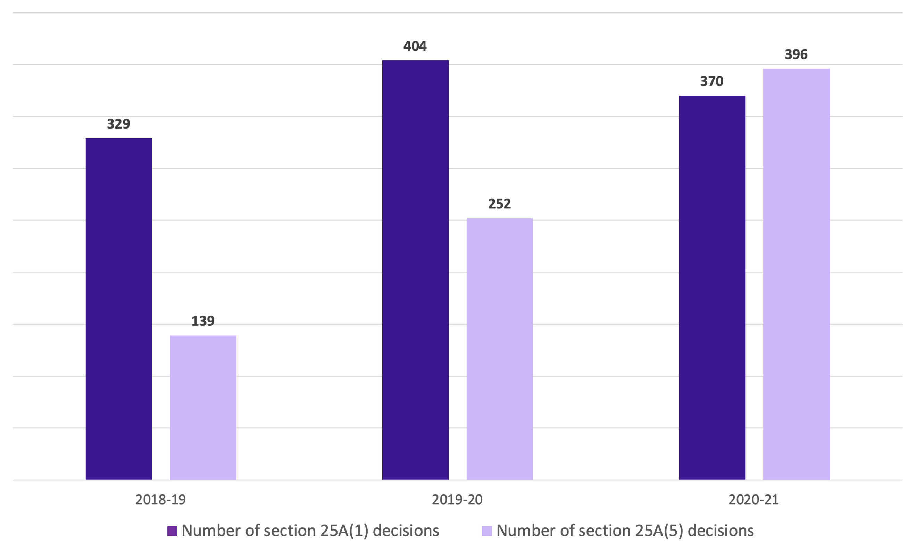

Complaints (Table 12)
The number of complaints OVIC received from members of the public between 2019 and 2021 increased by 46%. The number of agencies to which complaints related also increased by over 4%. We attribute this increase to delays to the COVID-19 pandemic, increasing FOI workloads for agencies, and the reduced statutory timeframes in which they are required to make a decision on an FOI request.
For example, OVIC’s 2020-21 Annual Report notes that of the complaints received in 2020-21, 479 concerned agency delays in making FOI decisions within statutory or agreed timeframes. Challenges associated with the COVID-19 pandemic had a significant impact on some agencies being able to meet their statutory obligations.
Figure 2: Complaints
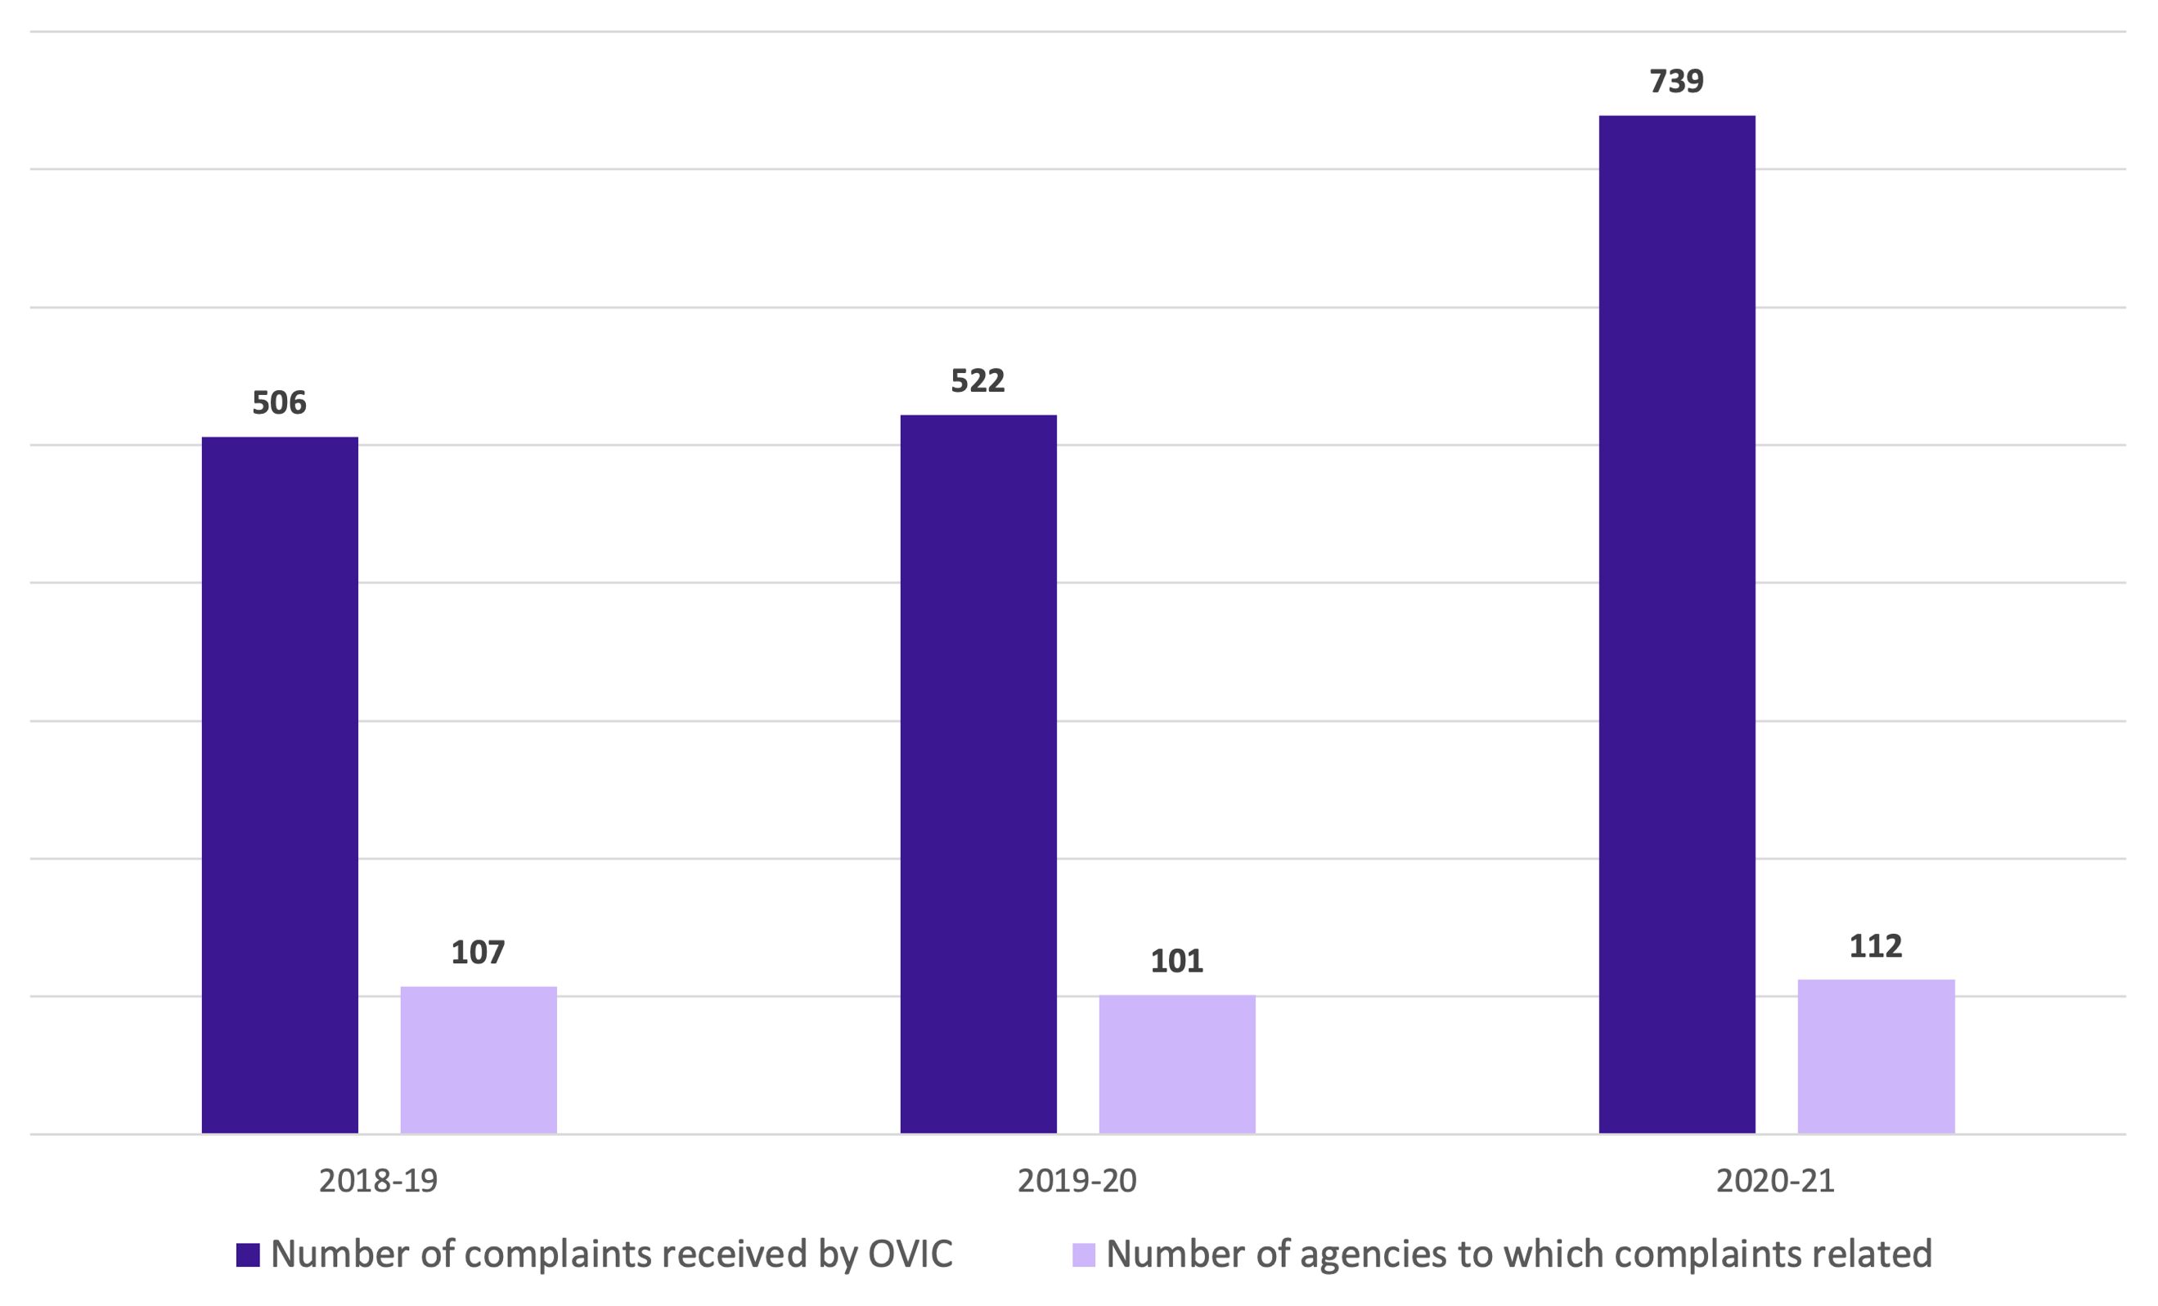

FOI decision making (Table 6 and Table 7)
Between 2019 and 2021, full access decisions increased by around 1.2%, part access decisions decreased by around 1.2%, and access refused in full decisions stayed the same overall. Interestingly, this deviates from a trend identified in our 2020 State of FOI in Victoria report, which showed a decrease in the percentage of full access decisions compared to all decisions.
This change may be due to decision making trends across certain sectors. For example, the overall slight increase in full access decisions may be attributed to the:
- increase in full access decisions made by departments (which increased by 14.69%) and law enforcement and emergency agencies (which increased by 13.24%);
- slight decrease in full access decisions made by health agencies (which decreased by 1.76%); and
- decrease in full access decisions made by statutory authorities (which decreased by 21.59%).
Figure 3: FOI decision making
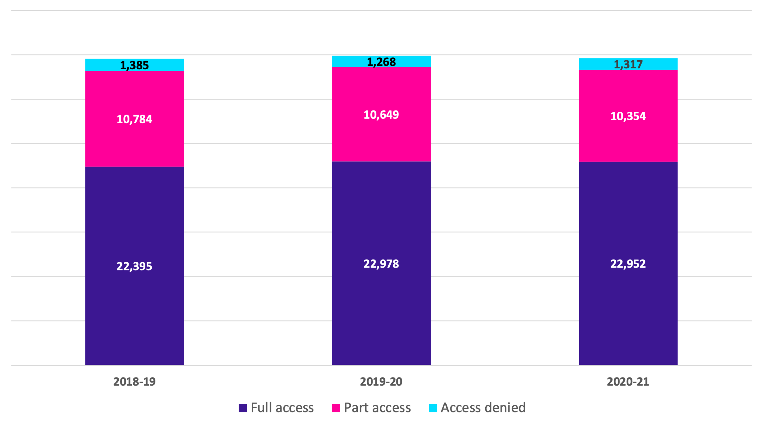

Top 5 most commonly used exemptions (Table 8)
There were some changes in the exemptions most commonly relied upon by agencies between 2019 and 2021. Five exemptions under the FOI Act account for around 88% of all exemptions cited by agencies:
- section 33(1): the protection of an individual’s personal affairs information;
- section 38: where a secrecy or confidentiality provision in legislation, other than the FOI Act, prohibits the disclosure of information;
- section 35(1): the protection of information obtained by an agency in confidence;
- section 30(1): internal working documents containing opinions, advice or recommendations where it would be contrary to the public interest for those documents to be released; and
- section 31(1): law enforcement documents where disclosure would prejudice a fair trial, an agency’s statutory functions or proper enforcement of the law.
The use of:
- section 33(1) decreased by approximately 13.80%;
- section 30(1) increased by approximately 11.13%;
- section 31(1) fluctuated with an overall increase of approximately 9.22%;
- section 35(1) decreased by approximately 4.22%; and
- section 38 decreased by approximately 2.37%.
OVIC’s 2020-21 Annual Report notes there was a substantial decrease in the use of the exemption under section 33(1) by agencies. We consider this trend is likely due to the significant increase in outstanding FOI requests reported in that year (i.e., FOI requests received by an agency, but not finalised by 30 June 2021). Given section 33(1) is the most common exemption relied on, an increase in the number of FOI requests remaining to be finalised represents a decrease in the number of agency decisions made and may explain the reduction in the use of section 33(1).
Figure 4: Top 5 most commonly used exemptions
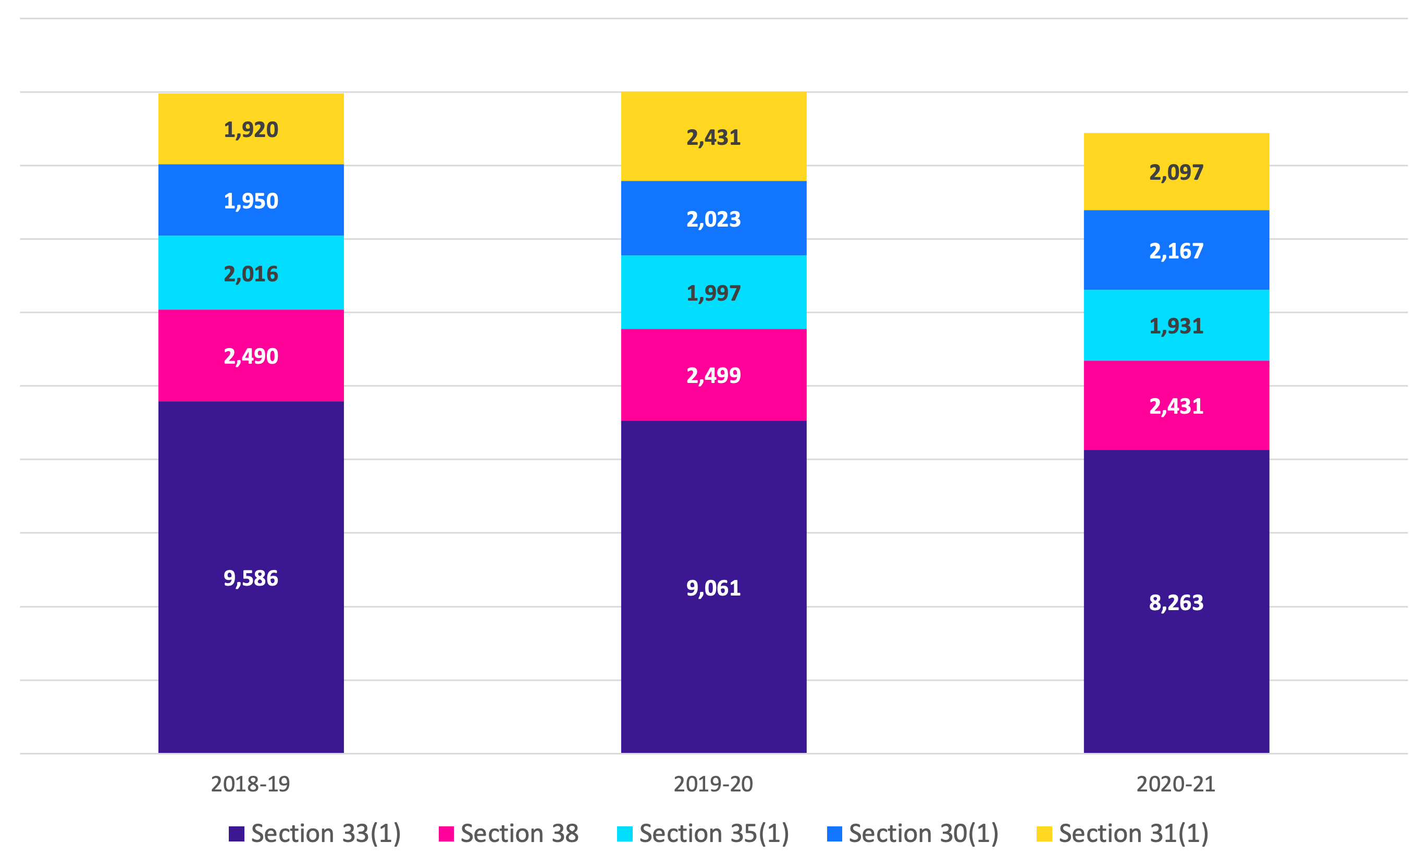

Number of VCAT reviews (Table 10)
The number of VCAT review applications received between 2019 and 2021 increased overall by over 54%. In its 2020-21 Annual Report, VCAT notes it saw an increase in FOI review applications as government agencies come under heavy public scrutiny during the pandemic. The increase in VCAT appeals could also be attributed to:
- the decrease in agency FOI decisions being made within statutory timeframes which gives rise to an applicant’s right to apply to VCAT for review of the agency’s ‘deemed refusal’ of their FOI request;
- where OVIC does not make a review decision within statutory or agreed timeframes, the applicant has a right to apply to VCAT for review of OVIC’s ‘deemed refusal’ of their FOI request;
- temporary impediments to OVIC’s ability to attend agency offices to inspect documents subject to review which resulted in OVIC not being able to progress certain reviews prior to this issue being rectified by the passing of the COVID-19 Omnibus (Emergency Measures) (Integrity Entities) Regulations 2020 which allowed us to receive documents from agencies electronically; and
- the increase in the number of OVIC review decisions that differ from the original agency decision, which may have resulted in more agencies applying to VCAT seeking review of OVIC’s decision.
Figure 5: Number of VCAT and OVIC reviews
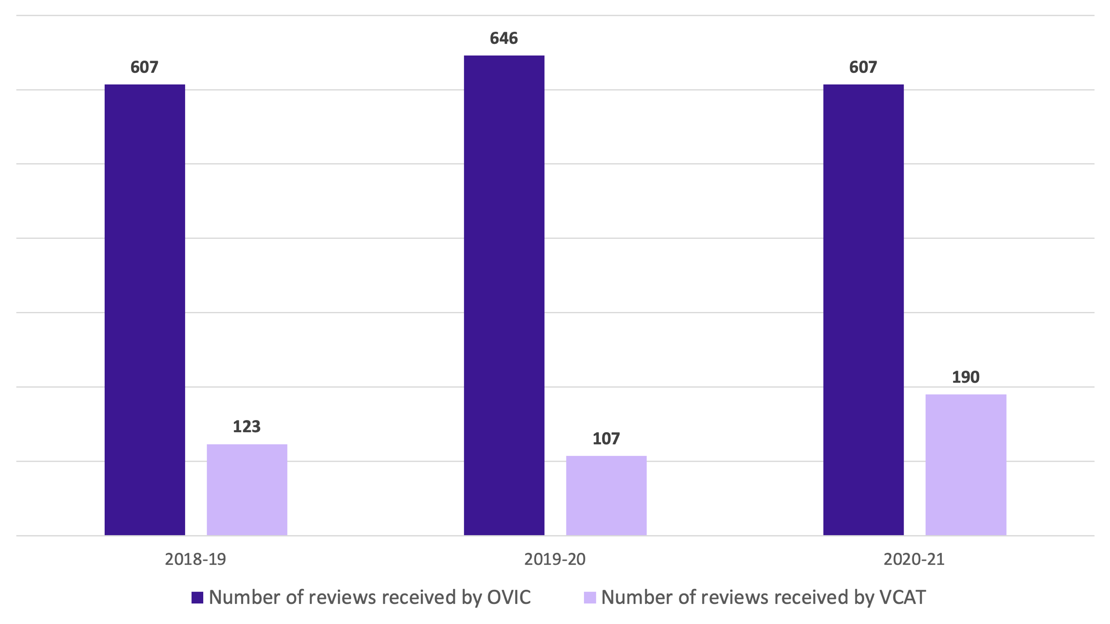

Data with less significant change
- Number of requests received (Table 1): The number of FOI requests received by agencies continued to increase by an average of 2.89% each year between 2019 and 2021.
- Sources of FOI requests (Table 2): Agencies continued to receive a higher proportion of personal requests (68.93% on average over the three years) compared with non-personal requests (31.07% on average).
- Agencies that received the most FOI requests (Table 3): Victoria Police continued to receive the highest number FOI requests out of all agencies, and health agencies continued to comprise the remainder of the top 5. The dominance of health and law enforcement sectors in the top 5 is not surprising given the high proportion of personal requests agencies receive each year and the strong public facing presence of these sectors.
- Number of FOI decisions made and decision makers (Table 4): The number of FOI decisions that agencies made stayed relatively stable between 2019 and 2021, increasing slightly by 1%. While the number of FOI decision makers for all agencies increased by around 7.72% between 2019 and 2021, the growing number of FOI requests that agencies received meant that the FOI workload per decision maker increased slightly by approximately 0.89%.
- Timeliness of decision making (Table 5): Timeliness of agency decision making decreased between 2019 to 2021 from 82.62% to 79.26%, meaning agencies continued to take longer to process and respond to FOI requests. The percentage of requests processed in more than 45 days also increased between 2019 and 2021 from 4.69% to 11%.
- Review outcomes where a formal decision is made (Table 11): The percentage of OVIC review decisions that agreed with the agency’s decision decreased from 50.24% in 2018-19 to 42% in 2020-21. This shows a continuing trend in OVIC decisions disagreeing with original agency FOI decisions, which may include the disclosure of more information than the original decision.
- Cost to applicants (application fees) (Table 13): While the actual amount of application fees collected between 2019 and 2021 increased from $816,273.24 to $892,067.74, this is likely due to the overall increase in FOI requests received by agencies. The percentage of application fees collected compared with fees waived or reduced stayed relatively stable with an overall slight decrease in fees collected from 72.55% to 71.30%.
- Cost to applicants (access charges) (Table 14): The actual amount of access charges collected by agencies between 2019 and 2021 increased from $922,902.00 to $958,127.56. The percentage of access charges collected versus those waived also increased slightly from 83.48% to 84.08%.
- Cost to agencies (Table 15): The cost to agencies in administering the FOI Act relates to the salary range of agency staff involved in making FOI decisions and the percentage of their time spent on FOI activities (rounded to the nearest 5%). OVIC’s annual FOI survey collects data on staff directly involved in processing FOI requests only, not those less directly involved (for example, in reviewing decisions, searching for documents, and reporting on other FOI activities).
  - The cost to agencies in administering the FOI Act increased by approximately 16.43% from $22,008,625.00 in 2018-19 to $25,625,450.00 in 2020-21. This is despite a drop in 2019-20 to $19,286,925.00. The cost to agencies in administering the FOI Act continues to significantly outweigh the total amount of fees and charges collected by agencies. For example, in 2020-21, agencies collected $1,850,195.30 in application fees and access charges compared with $25,625,450.00 spent by agencies in administering the FOI Act.
- Challenges in administering the FOI Act: Between 2019 and 2021, agencies continued to highlight difficulties in administering the FOI Act relating to:
  - staffing and costs;
  - increasing FOI workloads due to the growing number of FOI requests received and the nature of requests becoming more complex and voluminous; and
  - the 30 day statutory timeframe within which an agency must process an FOI request.
In addition to this, agencies reported the following challenges:
  - the diversion of staff to COVID-19 related activities, staff requiring access to leave entitlements, and staff working flexibly around caring responsibilities during the COVID-19 pandemic;
  - the requirement for staff to work remotely, including a hindered ability to conduct searches for and access hard copy documents; and
  - limits to current record keeping and IT systems and equipment that adversely impact upon the processing of FOI requests. For example, some agencies noted delays in transitioning to a digital work environment, such as a lack of available laptops for staff and shifting from hard copy document files to digital operations.

Key themes from the data
The COVID-19 pandemic intensified existing challenges for the administration of the FOI Act in Victoria. The large FOI workload continues to overwhelm agency resources. This workload, combined with the 30 day statutory timeframe for processing an FOI request and impacts from the COVID-19 pandemic, contributed to further delays in decision making and timeliness, an increasing number of FOI complaints received from the public by OVIC, and a stronger reliance by agencies on the use of exceptions to categorically refuse FOI requests.

Impact of the COVID-19 pandemic
Agencies advised the COVID-19 pandemic impacted their operations in the following ways:
- Diverting staff to respond to COVID-19 related activities reduced FOI resourcing. It also reduced resourcing in other business units which impacted document searching capabilities and timely responses to requests for information.
- Accessing documents remotely was not possible for some documents (for example, hard copy documents or documents in record management systems without remote access).
- Limitations in the adaptability of record keeping processes and IT systems adversely impacted the processing of FOI requests whilst working remotely.
- Promoting FOI as a priority (particularly for document searches) was difficult because agency officers were busy responding to matters related to the pandemic.
- An increase in FOI requests, including topical requests related to COVID-19, put a strain on resourcing.
The impact of the COVID-19 pandemic also presented challenges to agencies in meeting their obligations under the FOI Professional Standards.
OVIC supported agencies by taking a flexible approach to enforcement under the FOI Act, especially regarding minor breaches of the Professional Standards and those attributable to the impact of the COVID-19 pandemic. OVIC also published COVID-19 FAQs for agencies and members of the public.

FOI demand is overwhelming agency resourcing
The number of FOI requests agencies receive continued to increase at a consistent rate of just under 3% each year from 2019 to 2021.
In 2020-21, agencies received 42,249 requests, which is the highest number of FOI requests ever received. This is also more than any other Australian jurisdiction. For example, in 2020-21, Commonwealth agencies received 34,797 requests.
This continuing increase in FOI requests creates an unsustainable burden on agencies to process more FOI requests with limited resources. For example, despite a 7.72% increase in the number of FOI decision makers from 2019 to 2021, FOI workload still increased slightly by 0.89%.
On average, each decision maker (in relation to all agencies) has 65.7 requests per year to process. The workload for the top 30 agencies (which receive approximately 85% of all FOI requests) is even higher, with an average of 171.2 requests per year per decision maker.
The nature of FOI requests, such as large or complex requests or requests involving third party consultation, can also impact FOI resources. In OVIC’s 2020-21 Annual Report, agencies reported that third party consultation requirements increased their administrative workload significantly and has led to delays in finalising decisions due to the time it takes to receive responses from consultation with third parties.
In the same year, OVIC’s 2020-21 Annual Report noted there was a substantial decrease in the number of times section 33(1) of the FOI Act was relied on. This is likely due to the significant increase in the number of requests that had been received by agencies, but not yet finalised by 30 June. Given section 33(1) is the most exemption relied on by agencies, an increase in the number of outstanding requests may explain the reduction in the use of section 33(1).
OVIC’s 2020-21 Annual Report also noted agencies reported a record number of 6,064 outstanding FOI requests. This is a significant increase when compared to an average of 3,370 outstanding requests in the four preceding years.
Decision making data further illustrates the strain that agencies are under in respect to meeting their FOI obligations. The number of decisions that agencies made between 2019 and 2021 increased by an average of 0.56% per year. However, the number of requests agencies received increased by an average of 2.89% per year.
This FOI demand has flow on effects such as decreased timeliness in FOI decision making and changes to agency decision making.

Agencies are taking longer to make FOI decisions
Timeliness in agency FOI decision making continued to decline. Between 2019 and 2021, agencies made 80.43% of decisions within time, which is a decline of around 8% from 2014 to 2019 when 88.45% of decisions were made on time.
From May 2020 to December 2021, OVIC's resource – Template 12: Request for extension of time was viewed 19,037 times. This was the third highest viewed webpage during this period, which indicates delays in timeliness are commonly experienced by agencies.
In 2020-21, OVIC received 739 complaints from the public, with 479 complaints concerning agency delays in making an FOI decision within statutory or agreed timeframes. Challenges associated with the COVID-19 pandemic had a significant impact on some agencies being able to meet their statutory obligations under the FOI Act. A significant number of delay complaints received by OVIC relate to Victoria Police, which has a large backlog of more than 2,000 outstanding FOI requests. The reasons for this backlog of FOI requests include insufficient resources, increased number of FOI requests, and the impact of COVID-19 (including diversion of agency staff).
In September 2021, the Victorian Information Commissioner tabled a report regarding his own-motion investigation looking at impediments to five agencies providing timely FOI decisions and information release. The investigation identified several factors contributing to delayed information release in Victoria including resourcing and efficiency issues, FOI performance reporting and monitoring, inadequate engagement with FOI applicants, briefing of agency executives and ministers on topical FOI requests made to agencies, and legislative impediments to timely decision making.

Agencies are increasingly relying on exceptions to refuse FOI requests
The number of times section 25A(5) was cited by agencies nearly tripled. The percentage of section 25A(5) decisions against all decisions where access was refused also increased from 10% to 30%. This indicates that, proportionally, agencies are relying on section 25A(5) more in their decision making, outside of any increase in the number of FOI requests being received. The use of section 25A(5) has overtaken the use of section 25A(1).
There has also been an increase in the number of review applications OVIC received involving section 25A(5). For example, review decisions concerning section 25A(5) accounted for around 4% of all OVIC review decisions in 2019 compared to 11% in 2021. OVIC has also increasingly varied the original FOI agency on review regarding section 25A(5) reviews. For example, in 2019 OVIC varied 17% of section 25A(5) decisions compared to 32% of decisions in 2021.
The number of times section 25A(1) was cited also increased but not as significantly as section 25A(5). The number of times agencies cited section 25A(1) increased by 12%. The percentage of 25A(1) decisions against all decisions where access was denied increased from 24% to 28%.
The increased use of section 25A(1) and section 25A(5) may be due to:
- the nature of requests agencies received between 2019 and 2021 (for example, requests that were obviously exempt from the face of the FOI request or voluminous in nature); and/or
- large and increasing FOI workloads which may be prompting agencies to identify ways to decrease their workloads by relying on exceptions that do not require them to identify and assess documents.

Looking forward
The data in this report highlights that the COVID-19 pandemic intensified existing challenges for agencies administering the FOI Act. This is due to increasing FOI workloads, further strained FOI resources, and difficulties in processing requests in the move by agency staff to working from home and digital operations.
While a number of the challenges and changes associated with the COVID-19 pandemic have become normalised, it is likely the pandemic or other future crises will have the potential to impact on the ability of Victorian public sector agencies to meet their FOI obligations.
OVIC encourages agencies to build resilience in how they provide public access to government-held information such as:
- Appropriately resource access to information functions – access to information is a central function in all agencies. Principal officers must ensure their agency has the necessary resources and procedures in place to meet their statutory obligations under the FOI Act (Professional Standard 9.1) and should return diverted FOI staff to their roles as soon as practicable. It is also recommended that agencies review and consider the workload of their FOI staff to determine if further resources are required to meet statutory obligations under the FOI Act.
- Be open by design through proactive and informal release – provide access to information outside of the formal FOI Act process wherever possible to reduce the need for formal FOI requests (for example, through reviewing the documents held and providing for alternative access to them, outside of FOI).
  - Increasingly, governments in Australia and around the world are recognising and promoting proactive and informal release of information as an important way to:
    - inform the community and increase public participation;
    - build trust and confidence;
    - improve service delivery; and
    - improve efficiency in FOI administration.
- Take a customer service approach to FOI – engage with applicants early to ascertain what documents or information they are seeking, be transparent with applicants about the time needed to respond to requests, what the likely outcome will be, and whether the applicant can access the information elsewhere.
- Design new systems and processes with transparency in mind – agencies must still have regard to their FOI obligations and should keep transparency at the forefront when adopting new technology or implementing new processes and programs to make sure the public’s right to information is upheld. This includes making decision making documents and advice received by decision makers publicly available on a proactive basis.
- Utilise OVIC’s resources – OVIC publishes a suite of guidance materials including practice notes and free online training modules, and hosts regular education and events designed for FOI officers across the Victorian public sector. We continue to add to our suite of materials, with new resources on proactive and informal release and Guidelines to the FOI Act being developed. OVIC also has an agency FOI information service, which provides agencies with free advice and guidance on administering the FOI Act.
OVIC will continue to monitor, examine, and report on FOI trends in Victorian agencies.

Appendix: Tables of FOI data from 2019 to 2021

Requests received
Table 1: Number of FOI requests received each year in Victoria from 2019 to 2021
 | 2018-19 | 2019-20 | 2020-21
Number of requests received | 38,876 | 40,951 | 42,249
Table 2: Sources of FOI requests from 2019 to 2021
 | 2018-19 | 2019-20 | 2020-21
% personal requests | 66.19% | 69.48% | 71.12%
% non-personal requests | 33.81% | 30.52% | 28.88%
Table 3: Top five agencies that received the most FOI requests from 2019 to 2021 and the number of FOI requests they received
2018-19 |  | 2019-20 |  | 2020-21
Agency | Number of requests | Agency | Number of requests | Agency | Number of requests
Victoria Police | 3,991 | Victoria Police | 4,095 | Victoria Police | 4,182
Alfred Health | 2,521 | Alfred Health | 2,659 | Alfred Health | 2,594
Melbourne Health | 2,344 | Melbourne Health | 2,509 | Melbourne Health | 2,566
Ambulance Victoria | 2,046 | Ambulance Victoria | 2,271 | Ambulance Victoria | 2,518
Monash Health | 1,827 | Department of Health and Human Services | 1,953 | Monash Health | 1,994

Decision making
Table 4: Number of FOI decisions made by agencies and agency decision makers from 2019 to 2021
 | 2018-19 | 2019-20 | 2020-21
Number of decisions made | 34,564 | 34,895 | 34,623
Number of decision makers – All agencies
Number of decision makers | 596 | 620 | 642
Number of total requests divided by number of decision makers for all agencies | 65.23 | 66.05 | 65.81
Number of decision makers – Top 30 agencies
Number of decision makers | 198 | 202 | 206
Number of requests received by top 30 agencies divided by number of decision makers for top 30 agencies | 167.37 | 173.74 | 172.41
Table 5: Timeliness of agency decision making from 2019 to 2021
 | 2018-19 | 2019-20 | 2020-21
% processed in 30 days or less (processed within the requirements of section 21) | 82.62% | 79.02% | 79.26%
% processed between 31 to 45 days | 12.69% | 13.20% | 9.75%
% processed in more than 45 days | 4.69% | 7.78% | 11%
Table 6: Breakdown of total FOI decisions from 2019 to 2021
 | 2018-19 | 2019-20 | 2020-21
Full access | 22,395 | 22,978 | 22,952
% full access | 64.79% | 65.85% | 66%
Part access | 10,784 | 10,649 | 10,354
% part access | 31.20% | 30.52% | 30%
Access denied | 1,385 | 1,268 | 1,317
% access denied | 4.01% | 3.63% | 4%
Table 7: Breakdown of FOI decisions by sector from 2019 to 2021
 | 2018-19 | 2019-20 | 2020-21
Health
% full access | 91.75% | 90.95% | 89.99%
% part access | 7.79% | 8.73% | 9.65%
% access denied | 0.45% | 0.32% | 0.36%
Government departments
% full access | 16.72% | 30.64% | 31.41%
% part access | 71.15% | 57.37% | 56.03%
% access denied | 12.14% | 12.00% | 12.55%
Law enforcement and emergency
% full access | 27.05% | 30.87% | 40.29%
% part access | 63.95% | 62.45% | 53.45%
% access denied | 8.99% | 6.68% | 6.26%
Statutory authorities
% full access | 38.66% | 22.12% | 17.07%
% part access | 56.39% | 72.70% | 78.20%
% access denied | 4.95% | 4.18% | 4.73%
Table 8: Exemptions most commonly cited in original decisions from 2019 to 2021 and the number of times exemptions were cited
 | 2018-19 | 2019-20 | 2020-21
Section 33(1) | 9,586 | 9,061 | 8,263
Section 38 | 2,490 | 2,499 | 2,431
Section 35(1) | 2,016 | 1,997 | 1,931
Section 30(1) | 1,950 | 2,023 | 2,167
Section 31(1) | 1,920 | 2,431 | 2,097
Table 9: Use of sections 25A(1) and 25A(5) in original decisions from 2019 to 2021
 | 2018-19 | 2019-20 | 2020-21
Number of section 25A(1) decisions | 329 | 404 | 370
Number of section 25A(5) decisions | 139 | 252 | 396

Reviews
Table 10: Number of review applications received by OVIC and VCAT from 2019 to 2021
 | 2018-19 | 2019-20 | 2020-21
Number of reviews received by OVIC | 607 | 646 | 607
Number of reviews received by VCAT | 123 | 107 | 190
Table 11: OVIC reviews outcomes where a formal decision is made from 2019 to 2021
 | 2018-19 | 2019-20 | 2020-21
Decision same | 213 | 211 | 158
% Same | 50.24% | 50% | 42%
Decision differed | 211 | 209 | 216
% Differed | 49.76% | 50% | 58%
Number of decisions made | 424 | 420 | 374

Complaints
Table 12: Number of complaints received by OVIC and the number of agencies to which complaints related from 2019 to 2021
 | 2018-19 | 2019-20 | 2020-21
Number of complaints received by OVIC | 506 | 522 | 739
Number of agencies to which complaints related | 107 | 101 | 112

Costs
Table 13: Application fees collected and waived and reduced from 2019 to 2021
 | 2018-19 | 2019-20 | 2020-21
Application fees collected | $816,273.24 | $874,024.71 | $892,067.74
% application fees collected | 72.55% | 72.05% | 71.30%
Application fees waived or reduced | $308,918.86 | $338,981.69 | $359,108.56
% application fees waived or reduced | 27.45% | 27.95% | 28.70%
Table 14: Access charges collected and waived from 2019 to 2021
 | 2018-19 | 2019-20 | 2020-21
Access charges collected | $922,902.00 | $909,024.92 | $958,127.56
% access charges collected | 83.48% | 83.49% | 84.08%
Access charges waived | $182,680.85 | $179,698.17 | $181,400.73
% access charges waived | 16.52% | 16.51% | 15.92%
Table 15: Effort cost to agencies to administer the FOI Act from 2019 to 2021
 |  | 2018-19 | 2019-20 | 2020-21
Total effort cost |  | $22,008,625.00 | $19,286,925.00 | $25,625,450.00
Total application fees and access charges collected |  | $1,739,175.24 | $1,783,049.63 | $1,850,195.30

While the FOI Act applies to agencies and Ministers, due to the relatively low number of FOI requests received by Ministers, this report refers to agencies. Therefore, a reference to an agency is also a reference to a Minister.
Section 25A(1)(a) of the FOI Act; section 25A(1) may also be applied, in the case of a Minister, where the Minister is satisfied that the work involved in processing the request would substantially and unreasonably interfere with the performance of the Minister’s functions, under section 25A(1)(b) of the FOI Act.
OVIC, 2020-21 Annual Report, page 76.
OVIC, 2020-21 Annual Report, page 105.
OVIC, 2020-21 Annual Report, page 105, https://ovic.vic.gov.au/wp-content/uploads/2021/10/OVIC-Annual-Report-2020-21-Digital.pdf.
Page 63.
OVIC gathered this information through its Annual Report surveys (refer to ‘Difficulties in Administrating the FOI Act’ in OVIC’s Annual Reports) and through its Public Access Agency Reference Group. The Public Access Agency Reference Group is intended to be a representative group of Victorian agencies across a range of different sectors, agency sizes, and geographical areas. For more information on the Reference Group, and to read meeting minutes from the Reference Group, refer to OVIC’s website: https://ovic.vic.gov.au/freedom-of-information/public-access-agency-reference-group/.
OVIC, 2020-21 Annual Report, page 86, https://ovic.vic.gov.au/wp-content/uploads/2021/10/OVIC-Annual-Report-2020-21-Digital.pdf.
Office of the Australian Information Commissioner, 2020-21 Annual Report, page 131, https://www.oaic.gov.au/__data/assets/pdf_file/0020/10829/oaic-annual-report-2020-21.pdf.
For example, the top 30 agencies received 84% of all requests in 2020-21: OVIC, 2020-21 Annual Report, page 107, https://ovic.vic.gov.au/wp-content/uploads/2021/10/OVIC-Annual-Report-2020-21-Digital.pdf.
OVIC, 2020-21 Annual Report, page 109, https://ovic.vic.gov.au/wp-content/uploads/2021/10/OVIC-Annual-Report-2020-21-Digital.pdf.
‘On time’ refers to within the statutory requirements of section 21; OVIC, State of FOI in Victoria Report, Decision Making: https://ovic.vic.gov.au/state-of-freedom-of-information-in-victoria/decision-making/.
OVIC, 2020-21 Annual Report, page 76, https://ovic.vic.gov.au/wp-content/uploads/2021/10/OVIC-Annual-Report-2020-21-Digital.pdf.
OVIC, Own motion investigation report: Impediments to timely FOI and information release, page 5.
This relates to where OVIC makes a formal review decision in relation to the review and does not include matters which OVIC informally resolves or where the agency made a fresh decision.
For example, see the Joint Statement developed by Australian Information Commissioners and Ombudsmen on the Statement of Principles to support proactive disclosure of government-held information: https://ovic.vic.gov.au/mediarelease/information-access-commissioners-and-ombudsmen-make-recommendations-to-support-open-by-design-principles/.

