Overview
OVIC’s information security efforts are supported by a range of partnering Victorian public sector (VPS) organisations.
A brief outline of these entities, including a summary of their functions and services and their relationship to the Framework and Standards is outlined below.
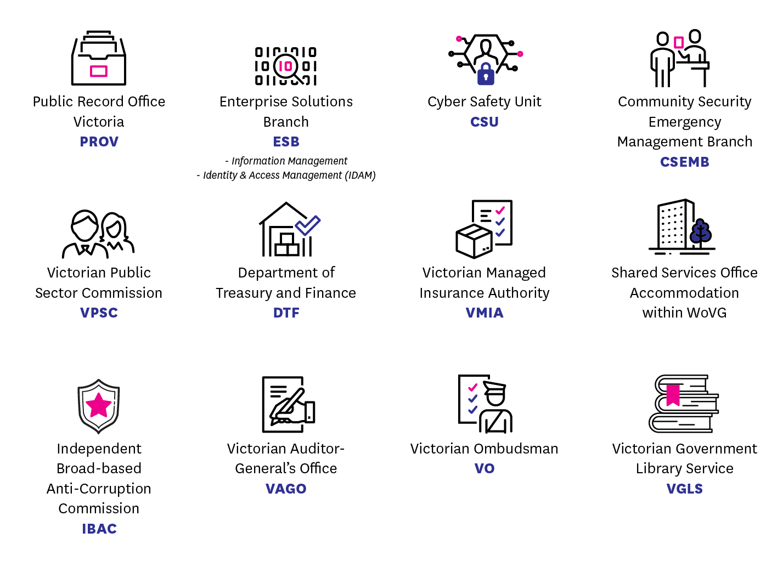

Entity | Description
Public Record Office Victoria (PROV) | Under the Public Records Act 1973, PROV is responsible for setting standards for recordkeeping which all Victorian public offices must comply with.  PROV issues standards regulating the creation, maintenance, security and disposal of public records in all formats. This includes standards specifying the minimum retention periods for different classes of records and those of permanent value which must be transferred to PROV custody.  PROV provides guidance on records management practices that supports the Standards.
Enterprise Solutions Branch (ESB)  Department of Premier and Cabinet | ESB issues the:  - Victorian Government Information Technology Strategy;  - Statements of Direction;  - Information Management Framework, including associated Statements of Direction, policies, standards and guidelines; and  - Workforce Identity and Access Management (IDAM) Statement of Direction and Strategy.  ESB is made up of a variety of functional areas including the strategy and policy team including:  - Information Management advisors who can assist organisations with guidance on the implementation of the information management related aspects of the Standards; and  - Identity and Access Management (IDAM) advisors who can assist organisations with guidance on identity and access management practices related to the Standards and IDAM technology policy and frameworks more broadly.
Cyber Safety Unit (CSU)  Department of Premier and Cabinet | CSU supports the Victorian Government to prepare, prevent and respond to cyber security incidents. CSU issues the:  - Victorian Government Cyber Security Strategy.  CSU is made up of a variety of functional areas including:  - Cyber Security team who provide guidance on the implementation of the ICT security, logical access management and disaster recovery related aspects of the Standards;  - Cyber Security Awareness team create and implement a of whole of Victorian Government cyber culture uplift and awareness programs; and  - Cyber Incident Response Service (CIRS) who provide assistance to VPS organisations when responding to cyber security incidents.  CSU can assist organisations by providing guidance on aspects of Standards 4 - Information Access, Standard 6 – Information Security Incident Management, Standard 7 – Information Security Aspects of Business Continuity and Disaster Recovery, and Standard 11 – Information Communications Technology (ICT) Security.
Community Security Emergency Management Branch (CSEMB)  Department of Premier and Cabinet | CSEMB leads a range of whole of Victorian Government security and emergency management policy, strategy and projects.  The CSEMB team lead and deliver protective security policy in relation to the application and use of the Australian Government’s Protective Security Policy Framework. CSEMB can assist with enquiries relating to matters of national interest and protecting national security information.  CSEMB facilitates and manages national security clearances for VPS staff, as outlined in the current Memorandum of Understanding for National Security Information and can also assist organisations by providing guidance on personnel security practices that supports Standard 10 – Personnel Security.
Victorian Public Sector Commission (VPSC) | The VPSC help strengthen public sector efficiency, effectiveness and capability by:  - assessing, researching and providing advice and support on issues relevant to public sector administration, governance, service delivery and workforce management and development;  - collecting and reporting on whole of government data; and  - conducting enquiries as directed under the Public Administration Act 2004 (Vic) by the Premier.  A central initiative of VPSC is to promote and apply the public sector values, and ensure governance, standards and equity are upheld and maintained.  The VPSC provides Human Resources managers and staff with information, tools and resources to assist them in their own roles and help them guide and inform employees within their organisation. The work that VPSC does supports Standard 10 – Personnel Security.
Victorian Ombudsman (VO) | The Ombudsman investigates complaints about actions or decisions made by Victorian public organisations (including government departments, statutory bodies, local councils and publicly funded community services). We also investigate allegations of improper conduct, made under the Public Interest Disclosure Act.  The Ombudsman's powers to conduct investigations are deliberately broad. The Ombudsman and OVIC work towards the same goal (keeping state and local government agencies accountable). The functions and powers of the Ombudsman broadly support the monitoring and assurance efforts of OVIC, whilst maintaining their independence.
Independent Broad-based Anti-Corruption Commission (IBAC) | As Victoria’s anti-corruption agency, IBAC:  - receives complaints and notifications of public sector corruption and police misconduct;  - investigates and exposes corruption and police misconduct; and  - informs the public sector and community about the risks and impacts of corruption and police misconduct, and how it can be prevented.  The functions and powers of IBAC are aligned with the objectives of the Framework and Standards, whilst maintaining their independence.
Department of Treasury and Finance (DTF) | DTF issues the:  - Standing Directions 2018 under the Financial Management Act 1994 (Vic), which sets the standard for financial management by Victorian government departments and agencies;  - Victorian Government Risk Management Framework (VGRMF) which supports risk management across Victorian government departments and agencies; and  - Asset management accountability framework.  DTF assists organisations by setting direction on risk management for the VPS, directly supporting Standard 3 – Information Security Risk Management.
Victorian Managed Insurance Authority (VMIA) | VMIA is the Victorian Government’s insurer and risk adviser, covering the people, places and projects that help Victorians thrive.  As the government’s insurer and risk adviser, VMIA assists its clients to put the VGRMF into practice. VMIA offers everything from risk advice and thought leadership, to coordinating risk prevention and recovery.  The team at VMIA can assist organisations by providing guidance and training on risk management practices that support Standard 3 – Information Security Risk Management and the general risk management approach of the Framework.
Victorian Auditor- General’s Office (VAGO) | The Auditor General is an independent oﬃcer of the Victorian Parliament, appointed to examine the management of resources within the public sector on behalf of Parliament and Victorians.  VAGO may conduct independent performance audits of any information security area, supporting the broader monitoring and assurance efforts of OVIC, whilst maintaining their independence.
Shared Services Office Accommodation within WoVG  Shared Services Provider (SSP) of Department of Treasury and Finance | SSP issues the Security Design Guide for Victoria’s State Owned and /or Occupied Office Accommodation Buildings 2007.  Shared services office accommodation guidelines and building standards reference:  - the principles of Crime Prevention Through Environmental Design (CPTED) which assist in the design and management of the physical environment;  - a range of risk management strategies drawing on defence-in-depth principles; and  - the use of recommended security hardware and technology installed in accordance with published guidelines (e.g. Australian Standards and Commonwealth’s Security Equipment Catalogue (SCEC)).  SSP’s Security team within DTF can assist organisations by providing guidance on the implementation of some aspects of Standard 12 – Physical Security for office accommodation.
Shared Service Library – Victorian Government Library Service (VGLS)  Department of Treasury and Finance | The VGLS enables Victorian Government staff and clients to gain access to information resources required to provide evidence-based information to deliver policy and research across government. This includes:  - access to collections of licensed electronic resources;  - enabling loans and documents from the Whole of Victorian Government library collection;  - assistance and research from a team of information professionals;  - an extensive information skills program; and  - access to a global network of libraries and suppliers.  VGLS clients have access to:  - print and online resources, including books, e-books, journals and reports not available elsewhere; and  - specialised databases containing subject specific journals, media, legal resources, standards and conference papers.

Further Information

Contact Us
t: 1300 00 6842
e: enquiries@ovic.vic.gov.au
w: ovic.vic.gov.au
Disclaimer
This fact sheet does not constitute legal advice and should not be used as a substitute for applying the provisions of the Freedom of Information Act 1982 Privacy and Data Protection Act 2014, or any other legal requirement, to individual cases.

CSU operates within ESB, with a specific focus on cyber safety

